WFH Attendance & Employee Monitoring System
End User Manual for Employees, Department Managers, HR Admins and System Admins


Dexa Group Software Engineer Technical Assessment
Author: Abdurrahman Khairi
Version 1.0, November 2026
© 2026 Abdurrahman Khairi. All Rights Reserved. Created strictly for Technical Assessment evaluation.

TABLE OF CONTENTS

TABLE OF CONTENTS 2
CHAPTER I GETTING STARTED AND THE SHARED INTERFACE 4
1.1 Demonstration Accounts 4
1.2 Light and Dark Mode 4
1.3 The Notification Bell 5
1.4 Pop-Up Messages in the Bottom Right Corner 6
1.5 Request an Account as a New Hire 7
1.6 Forgot Password 8
CHAPTER II EMPLOYEE MANUAL GUIDE 12
2.1 New User 12
2.1.1 Sign In for the First Time 12
2.1.2 6 Digit Email Verification Code 13
2.1.3 Fill the Code 14
2.1.4 Face Registration 15
2.1.5 When the Face is Refused 17
2.2 Personal Dashboard 18
2.3 Send WFH notice 19
2.4 Clock-In with the Live Camera 22
2.5 Using a Photo Upload when the Camera does not work 26
2.6 Clock-Out at The End of The Day 27
2.7 WFH Approval, Overtime & Leave Request 28
2.8 Contact Developer & Technical Support 30
2.9 Your Profile and Home Location 32
CHAPTER III DEPARTMENT MANAGER MANUAL GUIDE 34
3.1 Approval Page 34
3.2 The Manager’s WFH Notice goes to HR 34
3.3 Monitoring Team WFH Requests 36
3.4 Approval Request from the Email Link 36
CHAPTER IV HR ADMIN MANUAL GUIDE 40
4.1 Monitoring Attendance Across The Company 40
4.2 Checking a photo in the lightbox 41
4.3 Checking the Clock In Location 42
4.4 Export Payroll and Audit Reports 43
4.5 Manage The Employee Directory 45
4.6 Sibling Biometric Exemption 48
4.7 Deactivating and restoring an employee 49
4.8 Reviewing Account Requests and Leave Requests 51
CHAPTER V SYSTEM ADMIN MANUAL GUIDE 54
5.1 Sign-In Sytem Admin 54
5.2 Database Management 54
5.3 Editing records 56
5.4 Company policy, users and support tickets 57
CHAPTER VI PRACTICAL TROUBLESHOOTING 60
6.1 The browser blocks the camera 60
6.2 The face match keeps failing 60
6.3 Why the portal uses the server clock 60
6.4 Where Photos are Stored 60
6.5 Face Registration is Refused 61
6.6 An Email Does Not Arrive 61
6.7 Known Issues in this build 61

CHAPTER I
GETTING STARTED AND THE SHARED INTERFACE

Open the portal in Chrome or Edge at http://localhost:5173.
Sign in with your work email and password. The system decides which menu you see from your role, so two people can sign in on the same computer and get different screens.

Demonstration Accounts
Role | Name | Email | Password
System Admin | Abdurrahman Khairi | sysadmin@dexagroup.com | AdminDexa2026!
HR Admin | HR Admin One | admin.hrd@dexagroup.com | AdminDexa2026!
Department Manager (IT) | Manager One | manager.it@dexagroup.com | ManagerDexa2026!
Department Manager (Finance) | Manager Two | manager.finance@dexagroup.com | ManagerDexa2026!
Employee (new account) | Employee Four | employee.four@dexagroup.com | EmployeeDexa2026!
Employee | Employee One, Two and Three | employee.one@dexagroup.com and similar | EmployeeDexa2026!

To populate the database with demo data, execute the SQL script located at: "WFH-Monitoring-System\database\demo-data.sql”

Light and Dark Mode
Click the sun or moon button next to the clock in the top bar.
The whole portal switches between a dark navy theme and a white theme straight away, and your browser remembers the choice for next time. Nothing else on the page changes, so you can switch in the middle of any task.
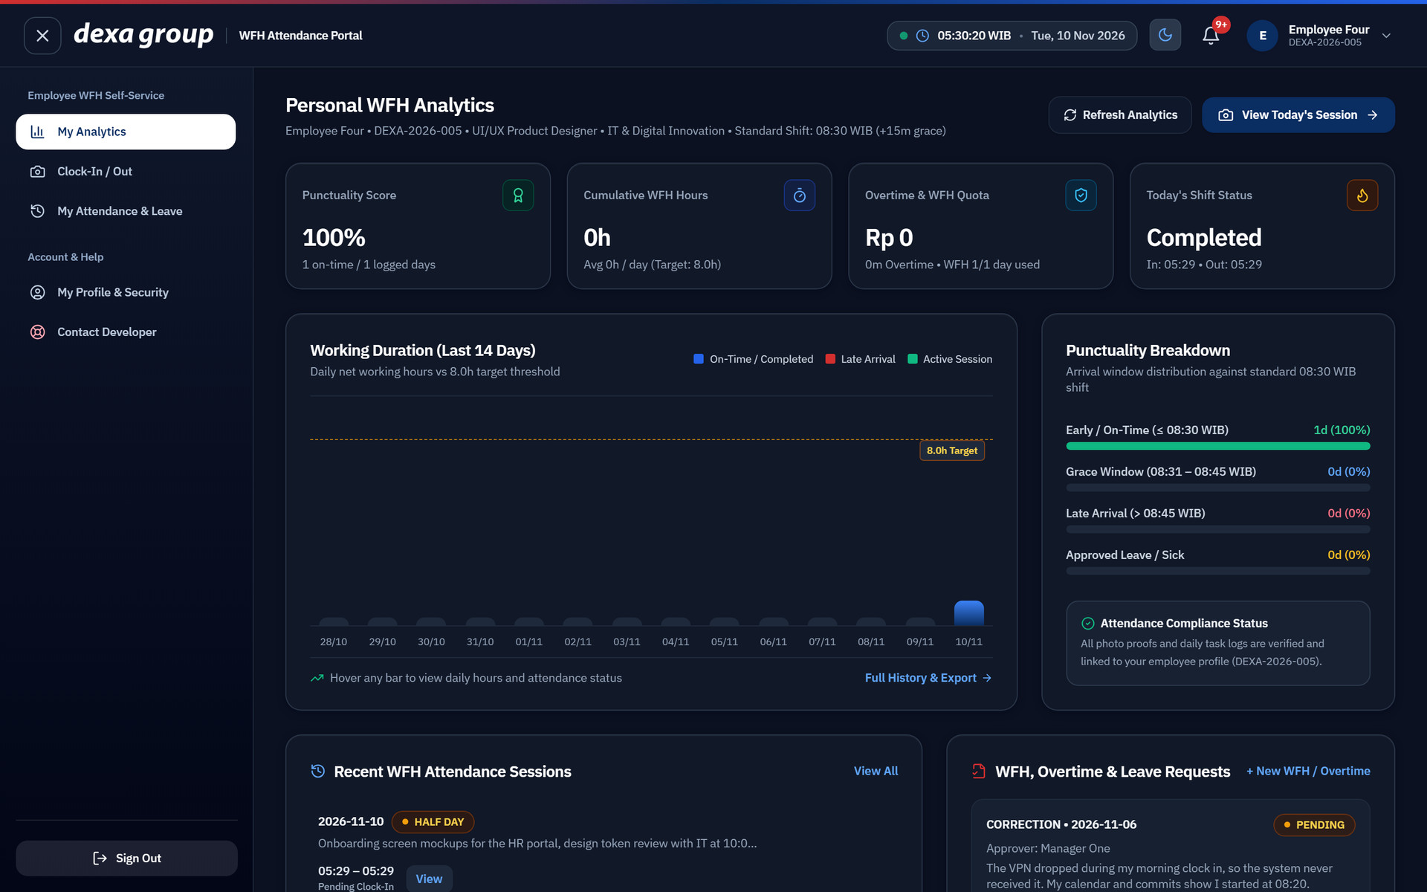
Figure 0.1: The Personal WFH Analytics page in dark mode.
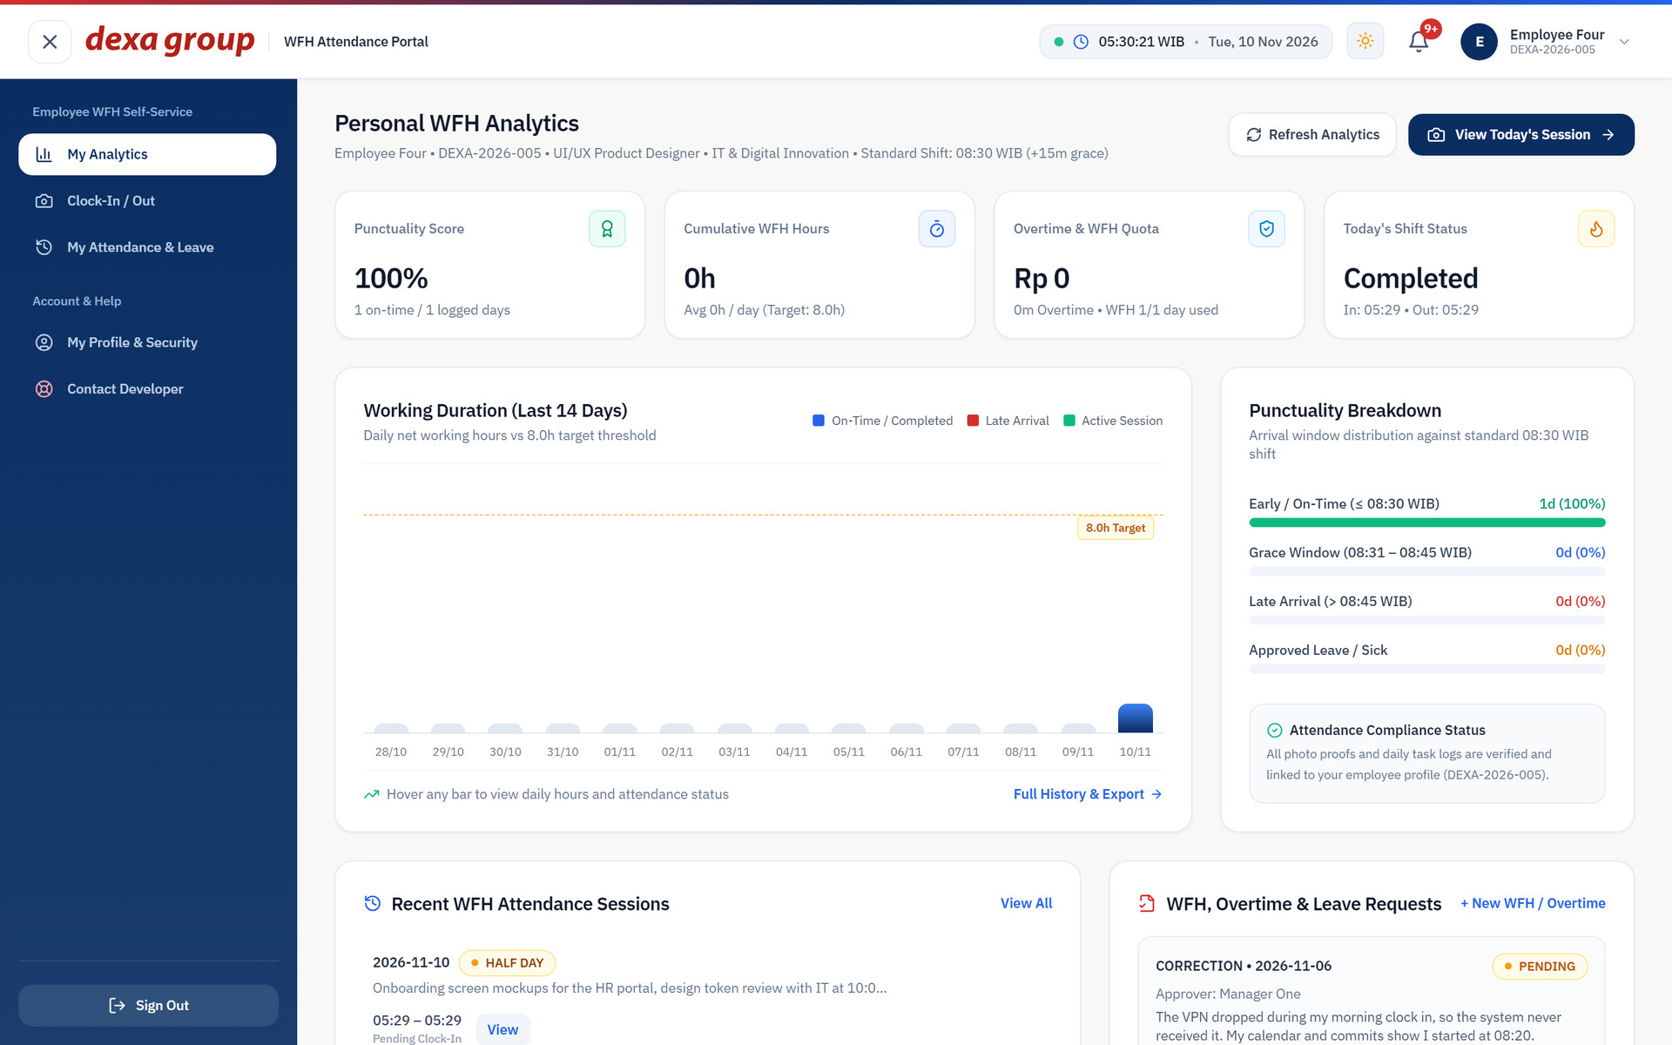
Figure 0.2: The same page after clicking the theme button, now in light mode.

The Notification Bell
Every action you take in the portal leaves a short entry in the notification bell at the top right. The red badge shows how many entries you have not read yet.
Click the bell to open the list.
Each entry tells you where the action happened, what happened, and why, written in plain words. Use Mark all as read or Clear history at the top of the list to tidy it up.
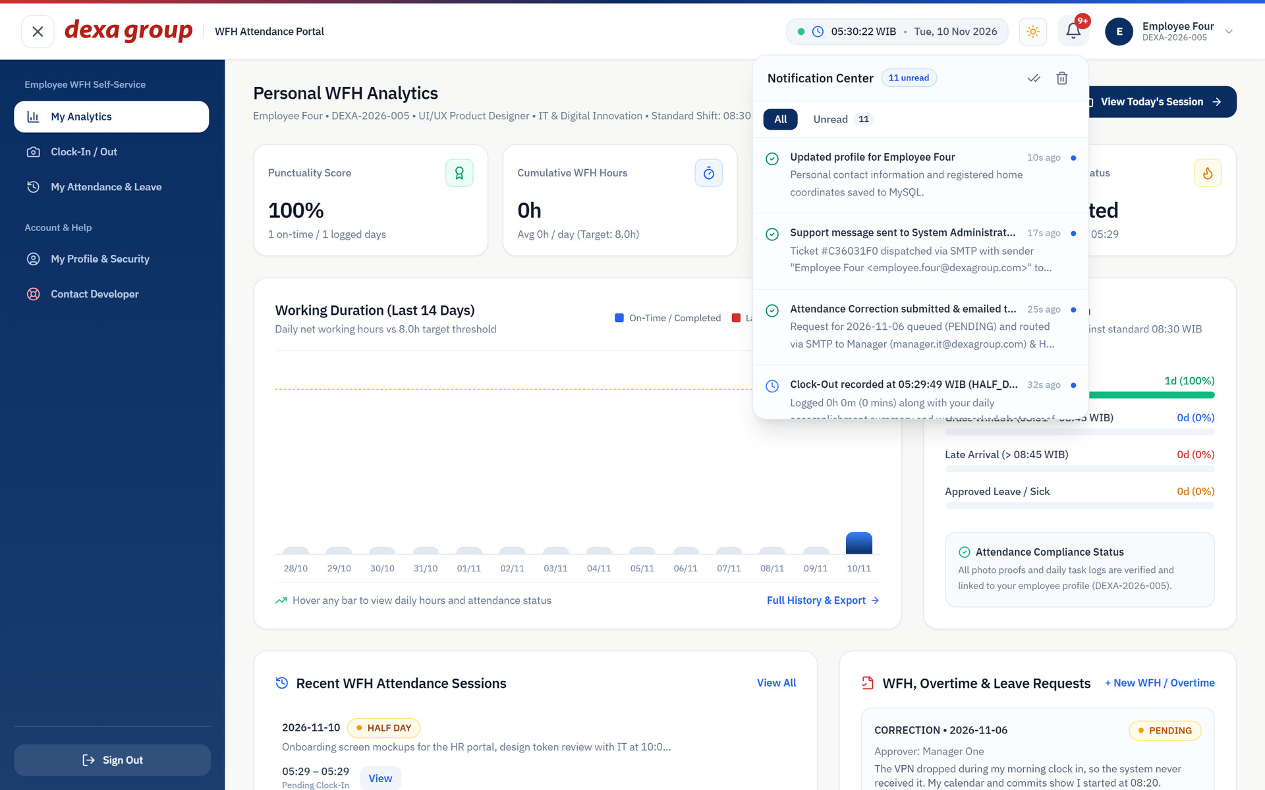
Figure 0.3: The notification list opened from the bell icon.

Pop-Up Messages in the Bottom Right Corner
Whenever you save something, send something, or hit an error, a small message slides in at the bottom right corner of the screen.
The message is a small dark card. A green tick and border means it worked, red means it failed, and blue is for information.
The message closes by itself after a few seconds, or you can click the small cross. The same message is also copied into the notification bell, so you can read it again later.
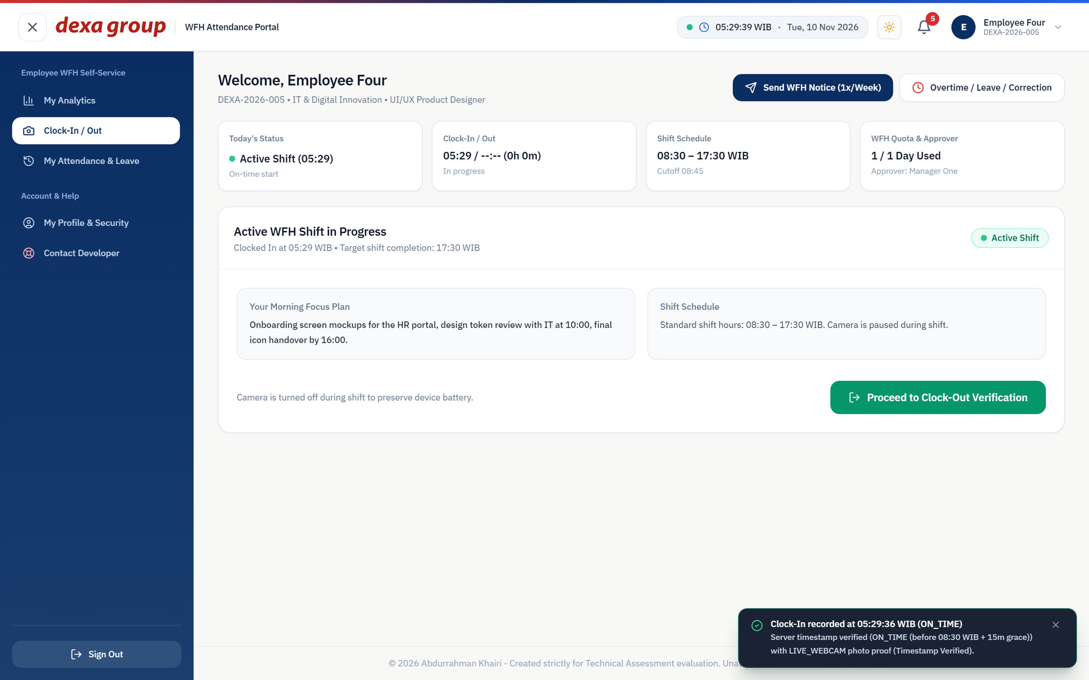
Figure 0.4: A message in the bottom right corner, with a green tick, confirms that the clock in was saved and shows the server time.

Request an Account as a New Hire
People who do not have an account yet can ask for one from the sign in page.
- On the sign in page, click Request an account under the Sign In button.
- Fill in your full name, your company email, your employee code (NIP) if you already have one, your phone number, your department, your position, and a short note for HR.
- Click Submit Request. The portal takes you back to the sign in page and shows a confirmation message.
- HR reviews the request on the Master Employees page (see Chapter IV). Once it is approved you receive a 6 digit code by email to activate the account.

Figure 0.5: The account request form filled in for a new hire.
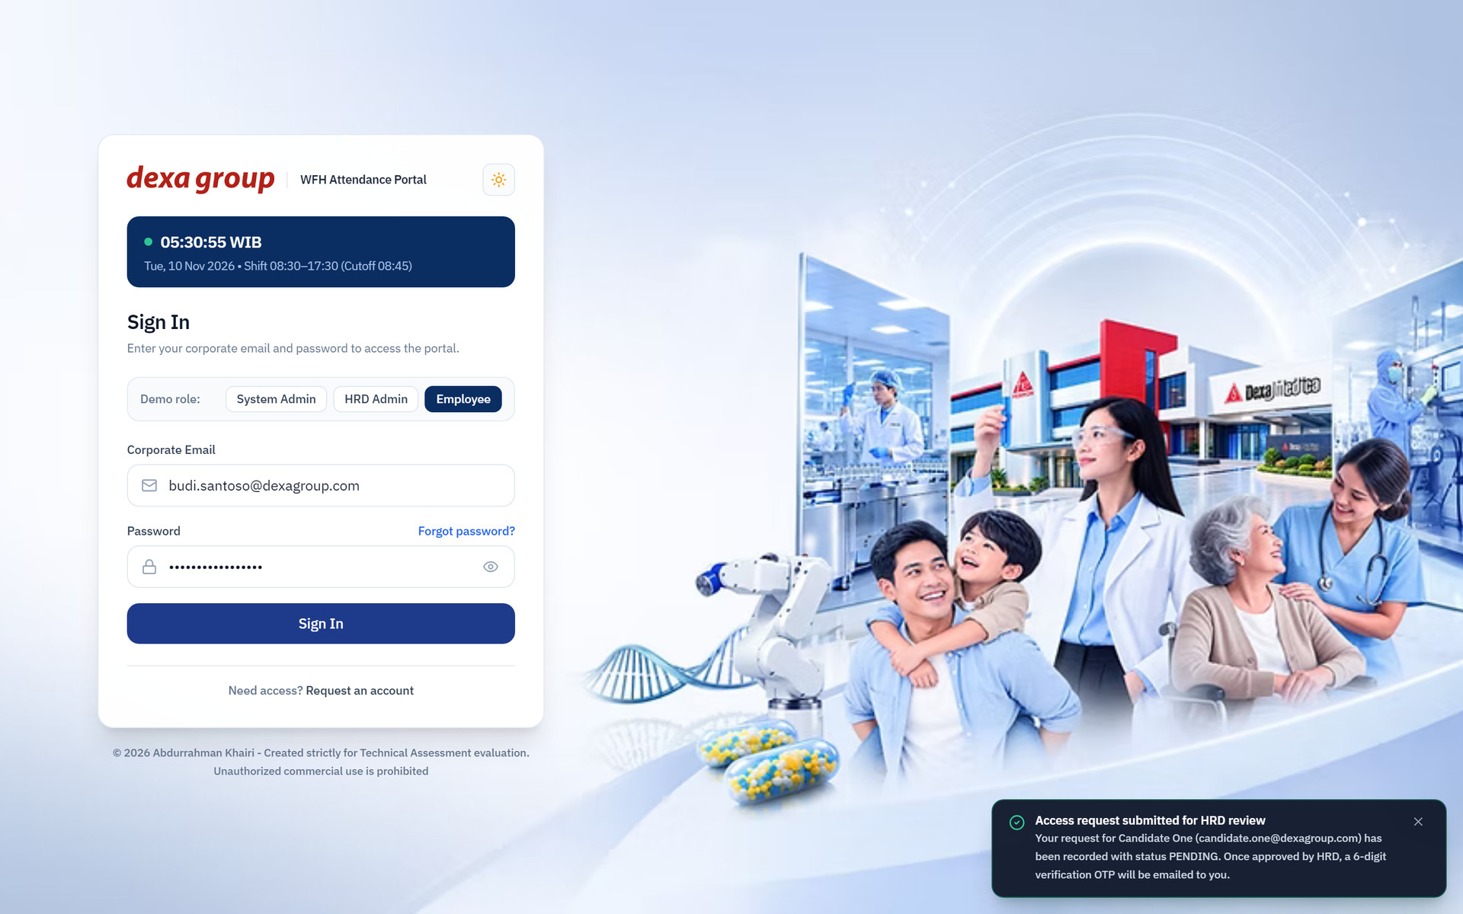
Figure 0.6: Back on the sign in page after the request was sent, with the confirmation message at the bottom right.

Forgot Password
If you no longer know your password, you can set a new one with a 6 digit code sent by email.
- On the sign in page, click Forgot password?.
- Type your registered corporate email and click Send Reset Code.
- Open the email with the subject Password Reset Verification Code and read the 6 digit code. It is valid for 15 minutes.
- Back in the portal, the Enter Reset Code screen is open. Type the code in the six boxes and your new password. The password needs at least 8 characters with letters and numbers.
- Click Reset Password. The portal returns to the sign in page, where you sign in with the new password.

Figure 0.7: The Reset Password page with the email filled in.
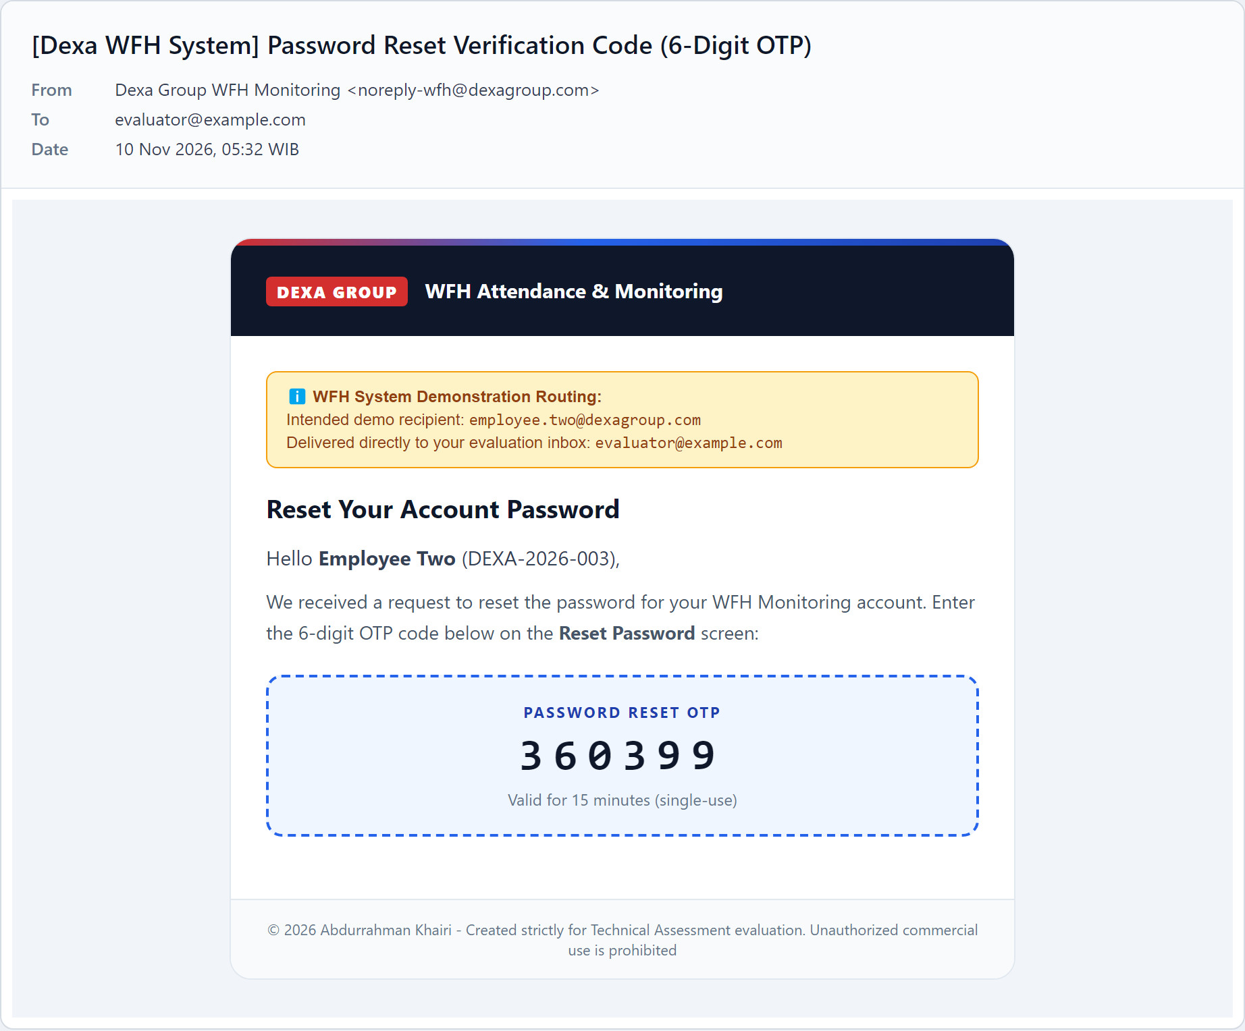
Figure 0.8: The password reset email with the 6 digit code.
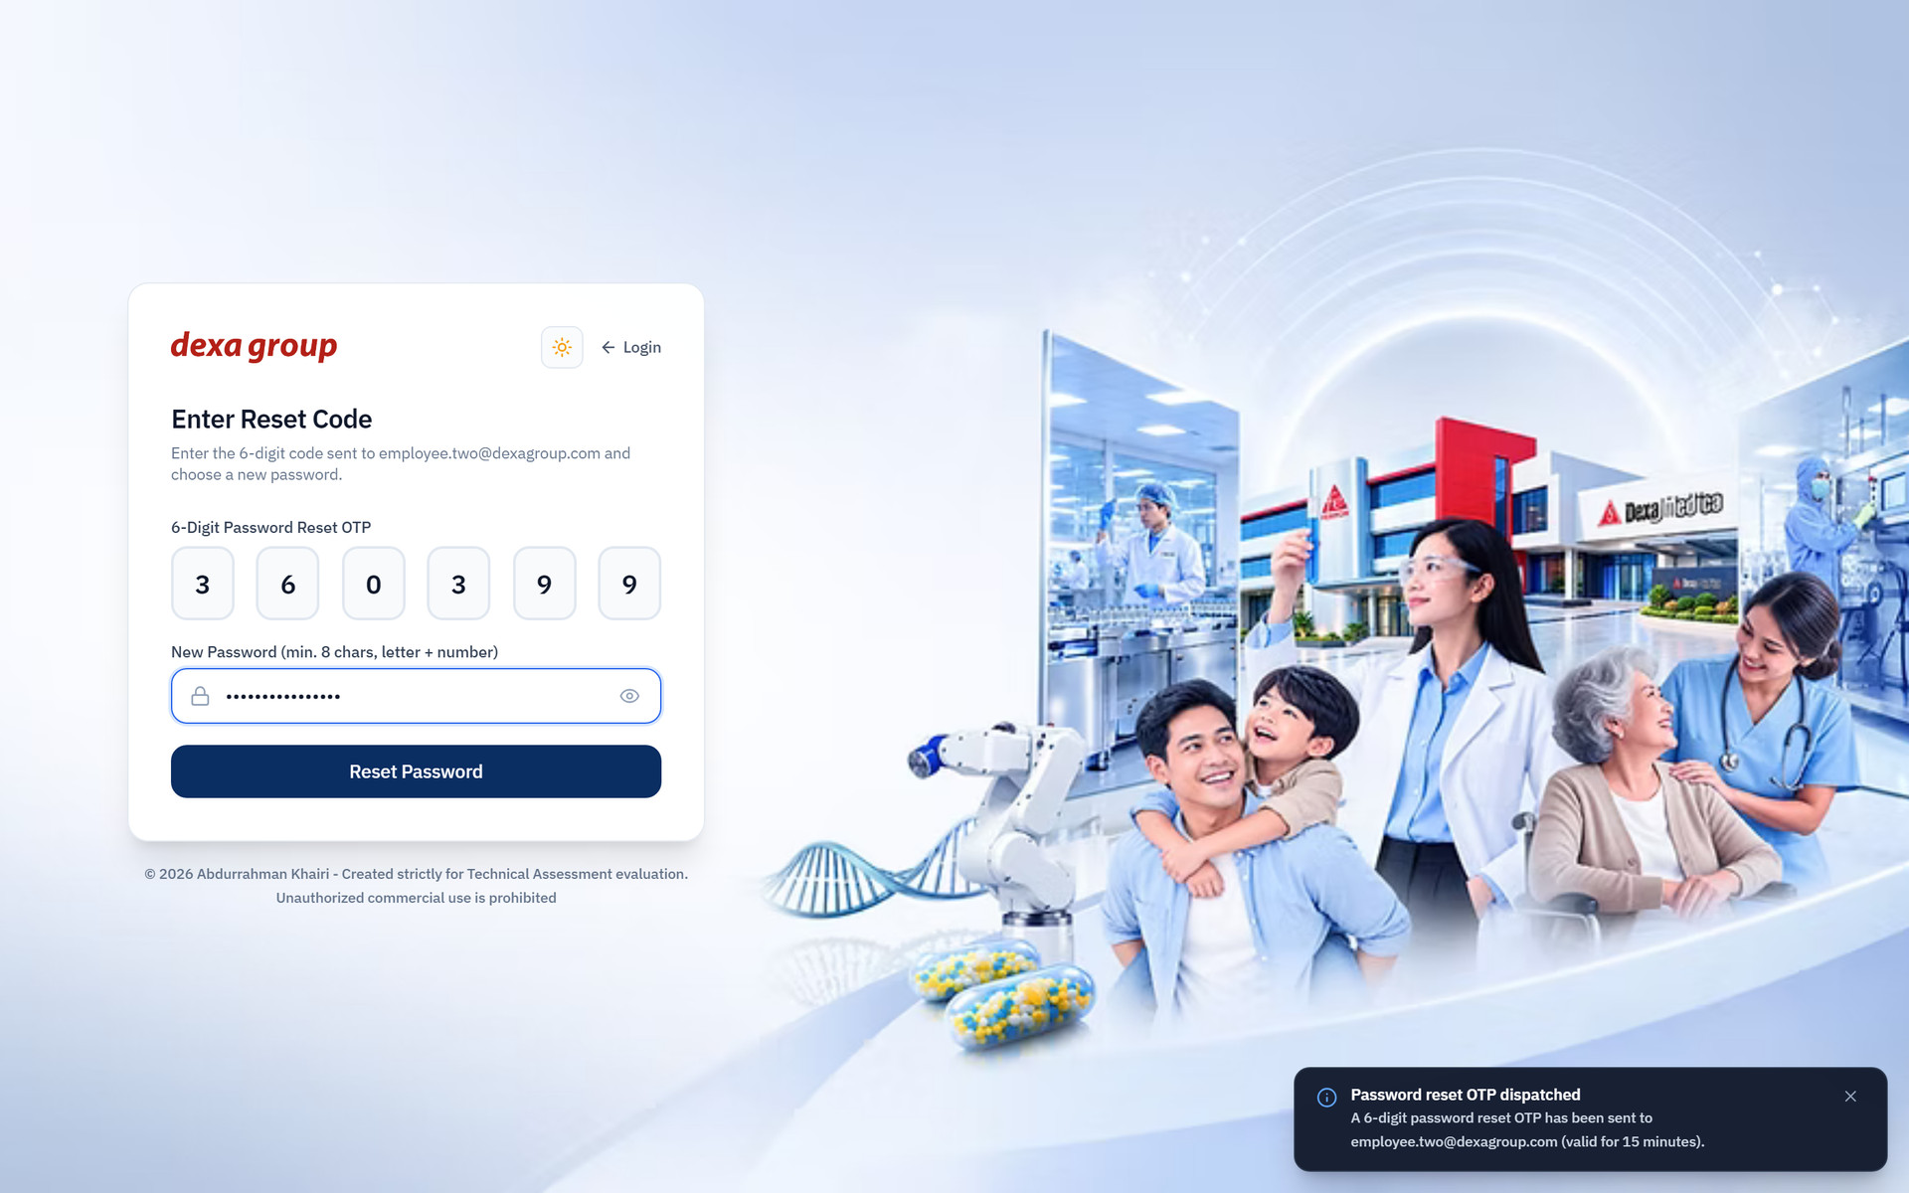
Figure 0.9: The code and the new password filled in.
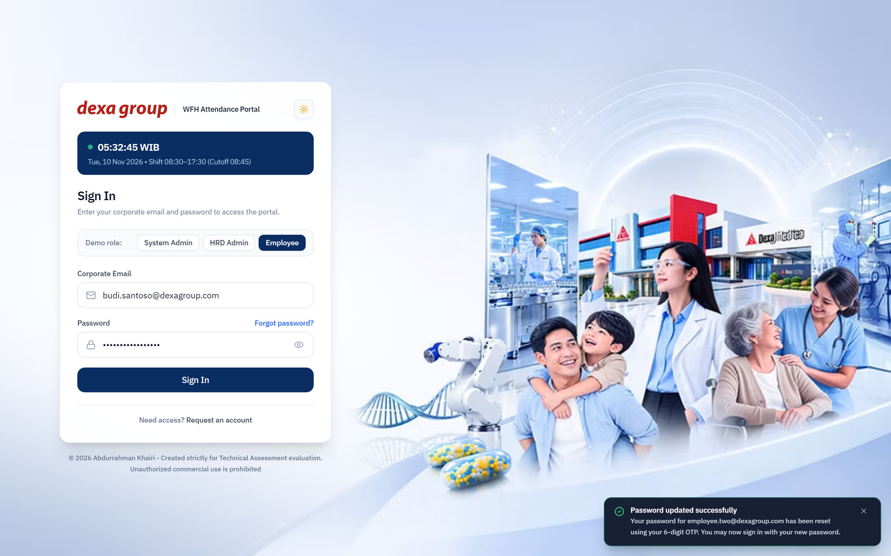
Figure 0.10: Back on the sign in page, a message confirms that the password was changed.

CHAPTER II
EMPLOYEE MANUAL GUIDE

This part follows Employee Four, a UI/UX designer in the IT department, through a first sign in and a full working day from home.

New User

Sign In for the First Time
- Type your work email and the password HR gave you, then click Sign In.
- If this is your first sign in, the portal does not let you in yet. It switches to the Verify First Time Login screen and sends a 6 digit code to your email. A blue message at the bottom right says the code is on its way.

Figure 1.1: The sign in page with the employee email and password filled in.
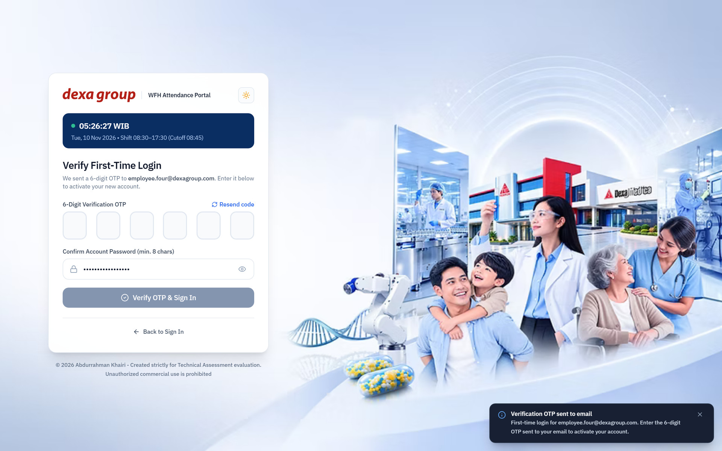
Figure 1.2: A new account is sent to the verification screen and the code goes out by email.

6 Digit Email Verification Code
Open your inbox. The portal sends email through the company SMTP account (Gmail or Outlook). In this test setup the demo accounts use @dexagroup.com addresses that cannot receive mail, so every message is forwarded to the evaluation inbox set in SMTP_OVERRIDE_RECIPIENT, with a yellow banner at the top naming the account it was meant for. Look for the message titled Verify Your New Employee Account. The code is printed in large digits in the middle of the email. It works for 15 minutes, and you get 5 tries.
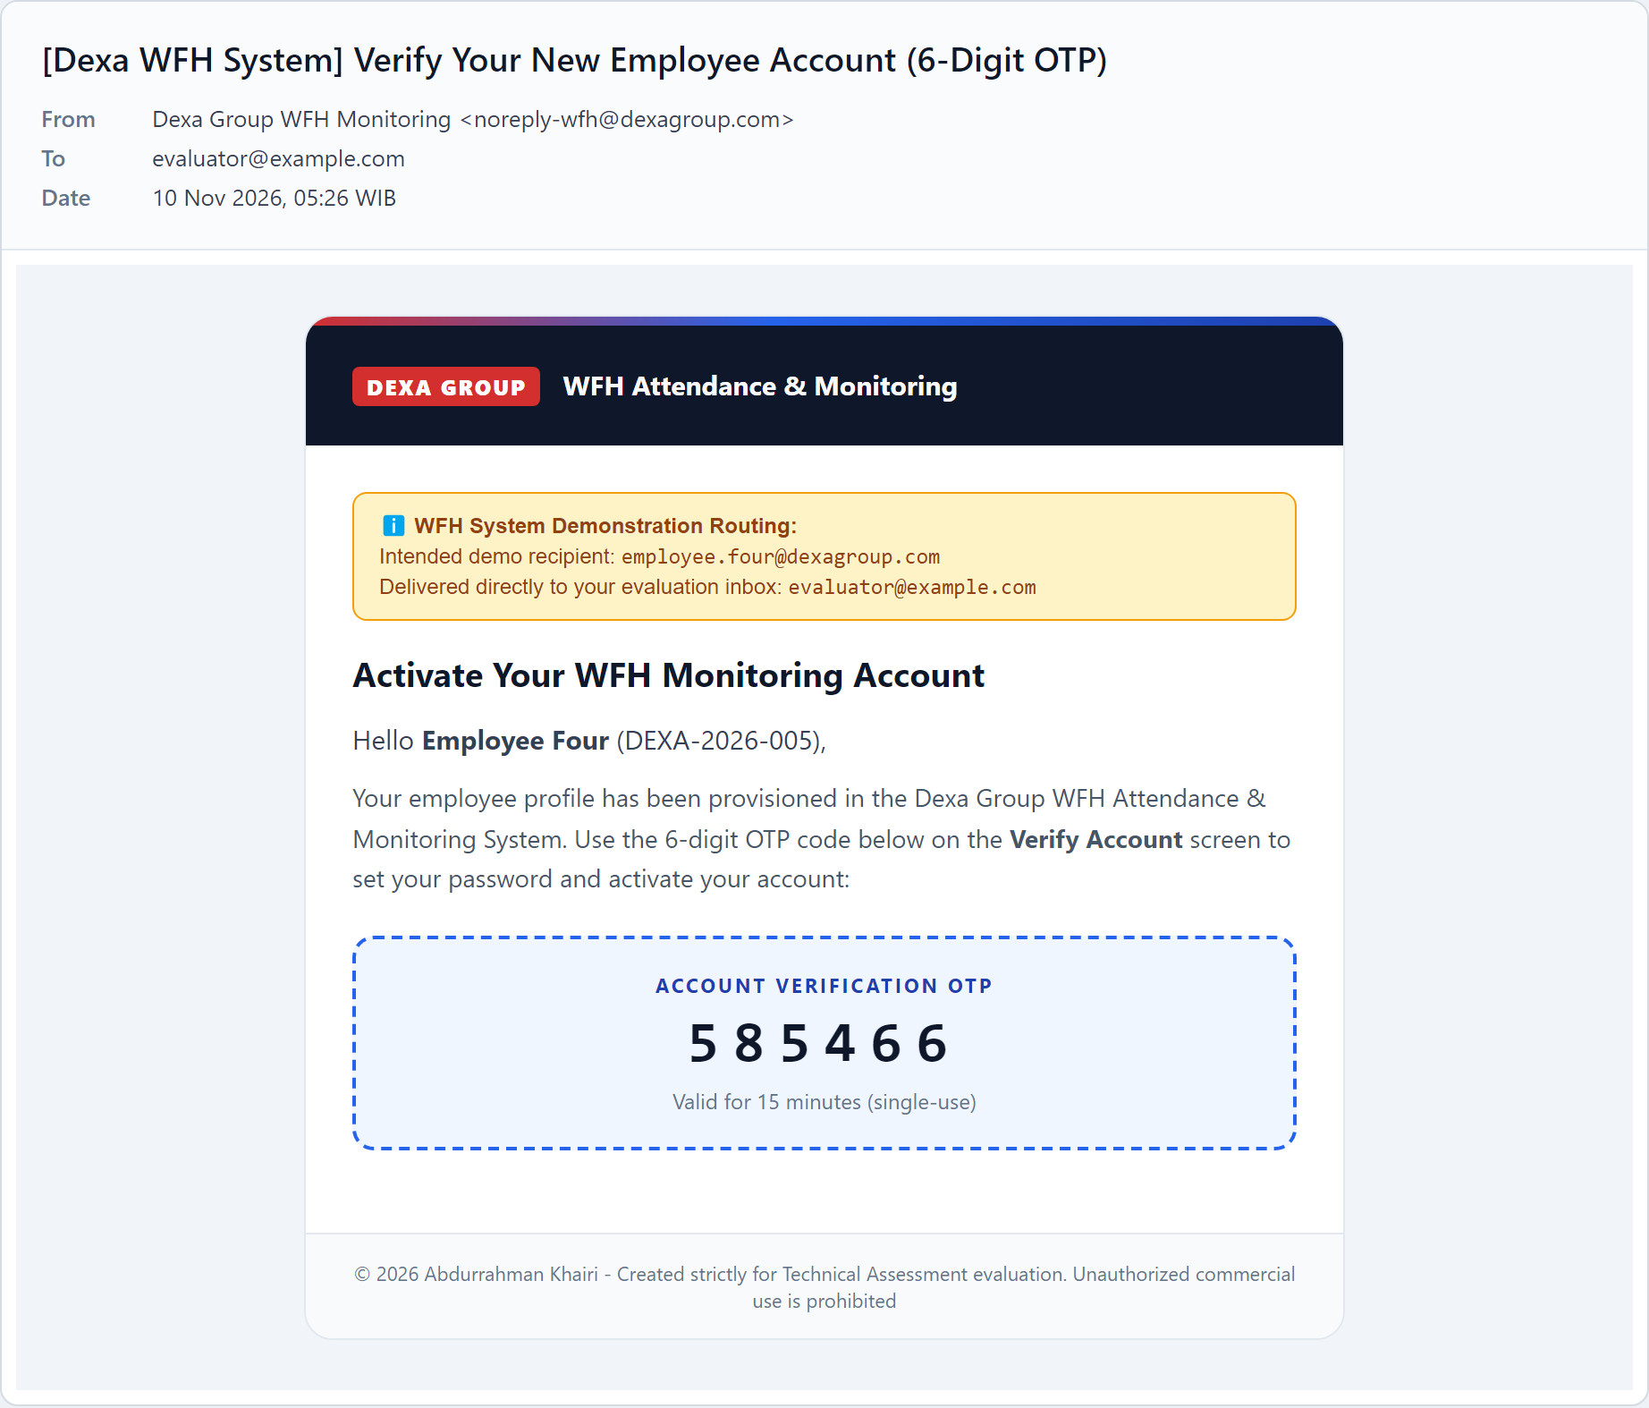
Figure 1.3: The verification email with the 6 digit code. The yellow banner shows it was meant for employee.four@dexagroup.com and was forwarded to the evaluation inbox.

Fill the Code
- Click the first box and type the six digits. The cursor moves to the next box on its own, and you can also paste the whole code at once.
- Check the password field. The password you type here becomes your account password, so change it now if you want a different one. It needs at least 8 characters.
- Click Verify OTP & Sign In. The account is activated and you are signed in.
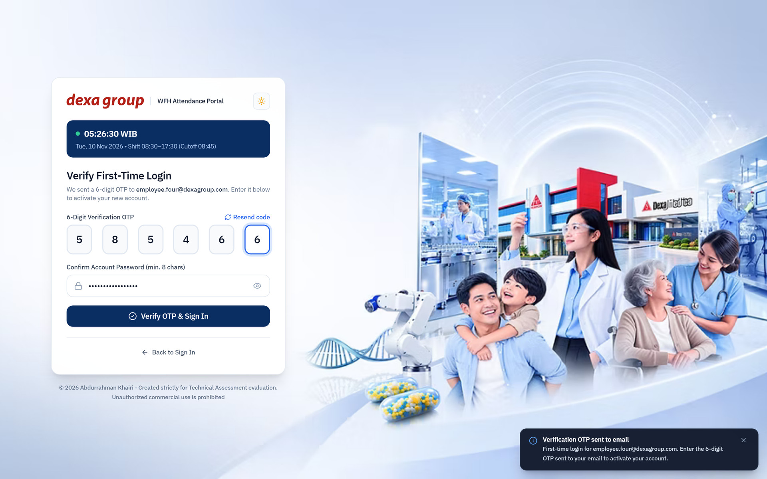
Figure 1.4: The code typed into the six boxes, ready to verify.

Face Registration
Before you can clock in, the system needs one clear photo of your face. It takes you to the Biometric Face Registration screen automatically, and you cannot open other pages until this step is done.
- Allow the browser to use your camera when it asks.
- Sit facing the screen in even light, with no mask, cap or sunglasses. Keep your face inside the round guide.
- Click Capture & Register Face. The picture freezes so you can check it.
- If you are happy with it, click Confirm & Register Face. Otherwise click Retake.
- The biometric service turns the photo into a 512 dimensional face signature and stores it with your profile. A green message confirms it and you land on the Clock In / Out page.
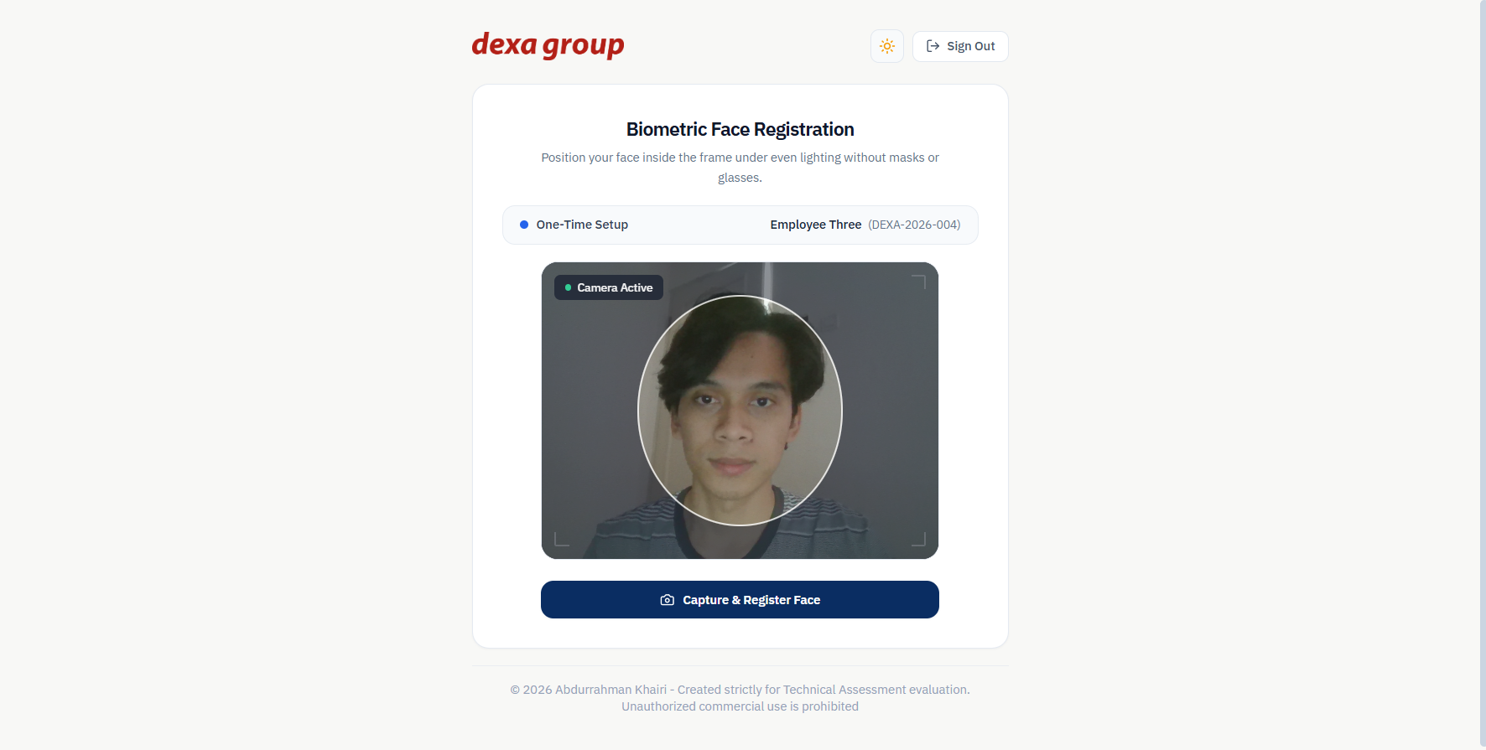
Figure 1.5: The live camera with the round face guide.
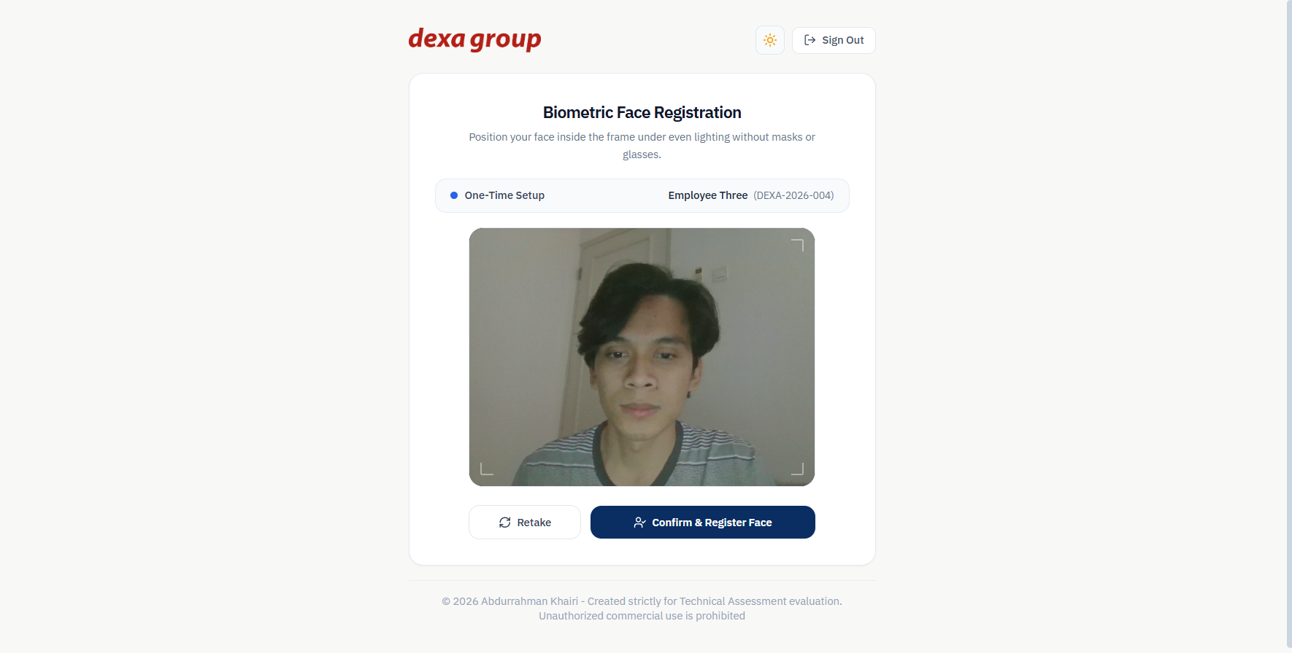
Figure 1.6: The captured photo, waiting for confirmation.
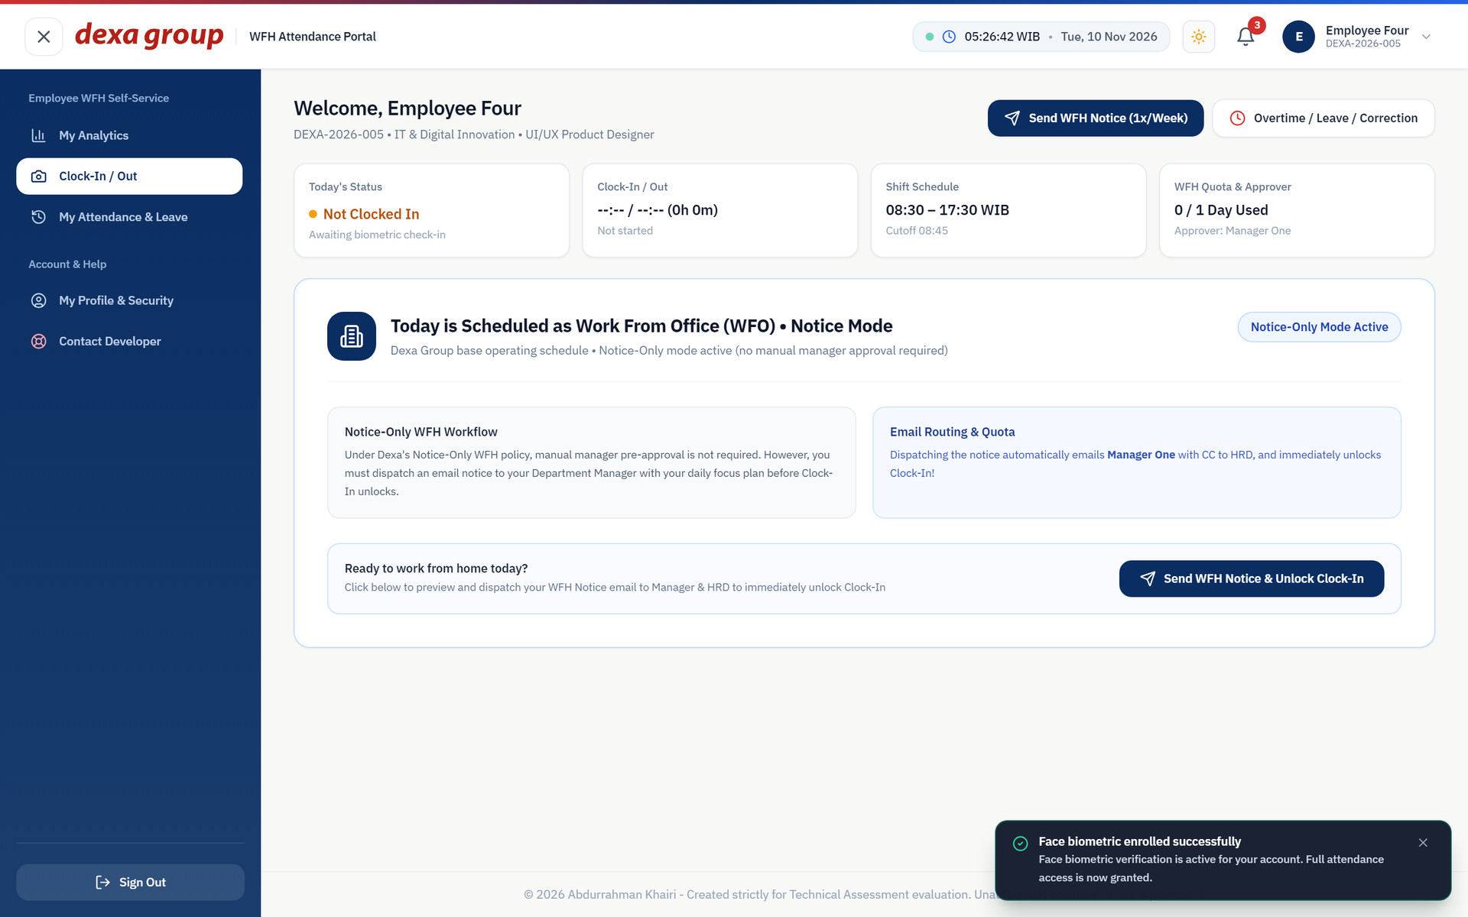
Figure 1.7: Registration done. The green message confirms the face was saved.
Note: Slow first registration
The very first face registration after the system starts can take a little longer, because the face engine loads its model into memory. If you see an error the first time, wait ten seconds and press Confirm again.

When the Face is Refused
Before it saves your face, the system compares it with the registered faces of every other active employee. What happens next depends on how similar the closest face is:
- Below 50 percent the face counts as unique and is saved.
- From 50 percent up to 90 percent the registration is refused with Biometric conflict detected. The message names the employee and the percentage. This is usually a sibling or a twin. Ask HR to switch on the Sibling Biometric Exemption for you (Chapter IV), then register again.
- At 90 percent or more the system treats it as the same face registered twice, and the exemption does not help.
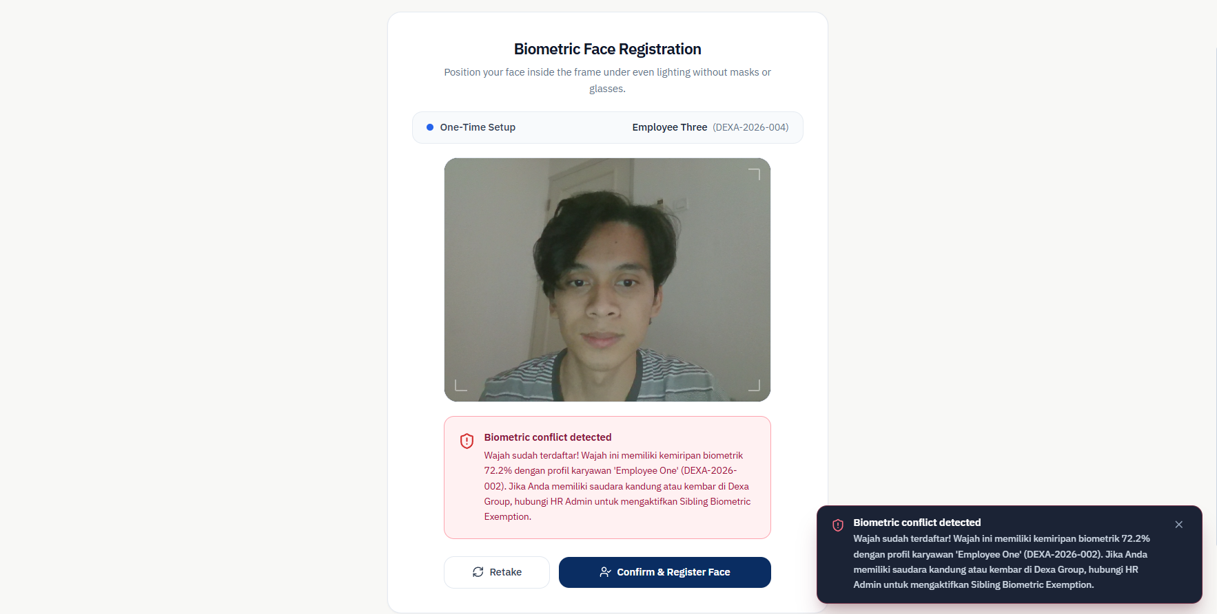
Figure 1.8: Employee Three’s registration is refused, because the face is 77.5 percent similar to Employee Four’s. The face used here is a test image made to resemble Employee Four.
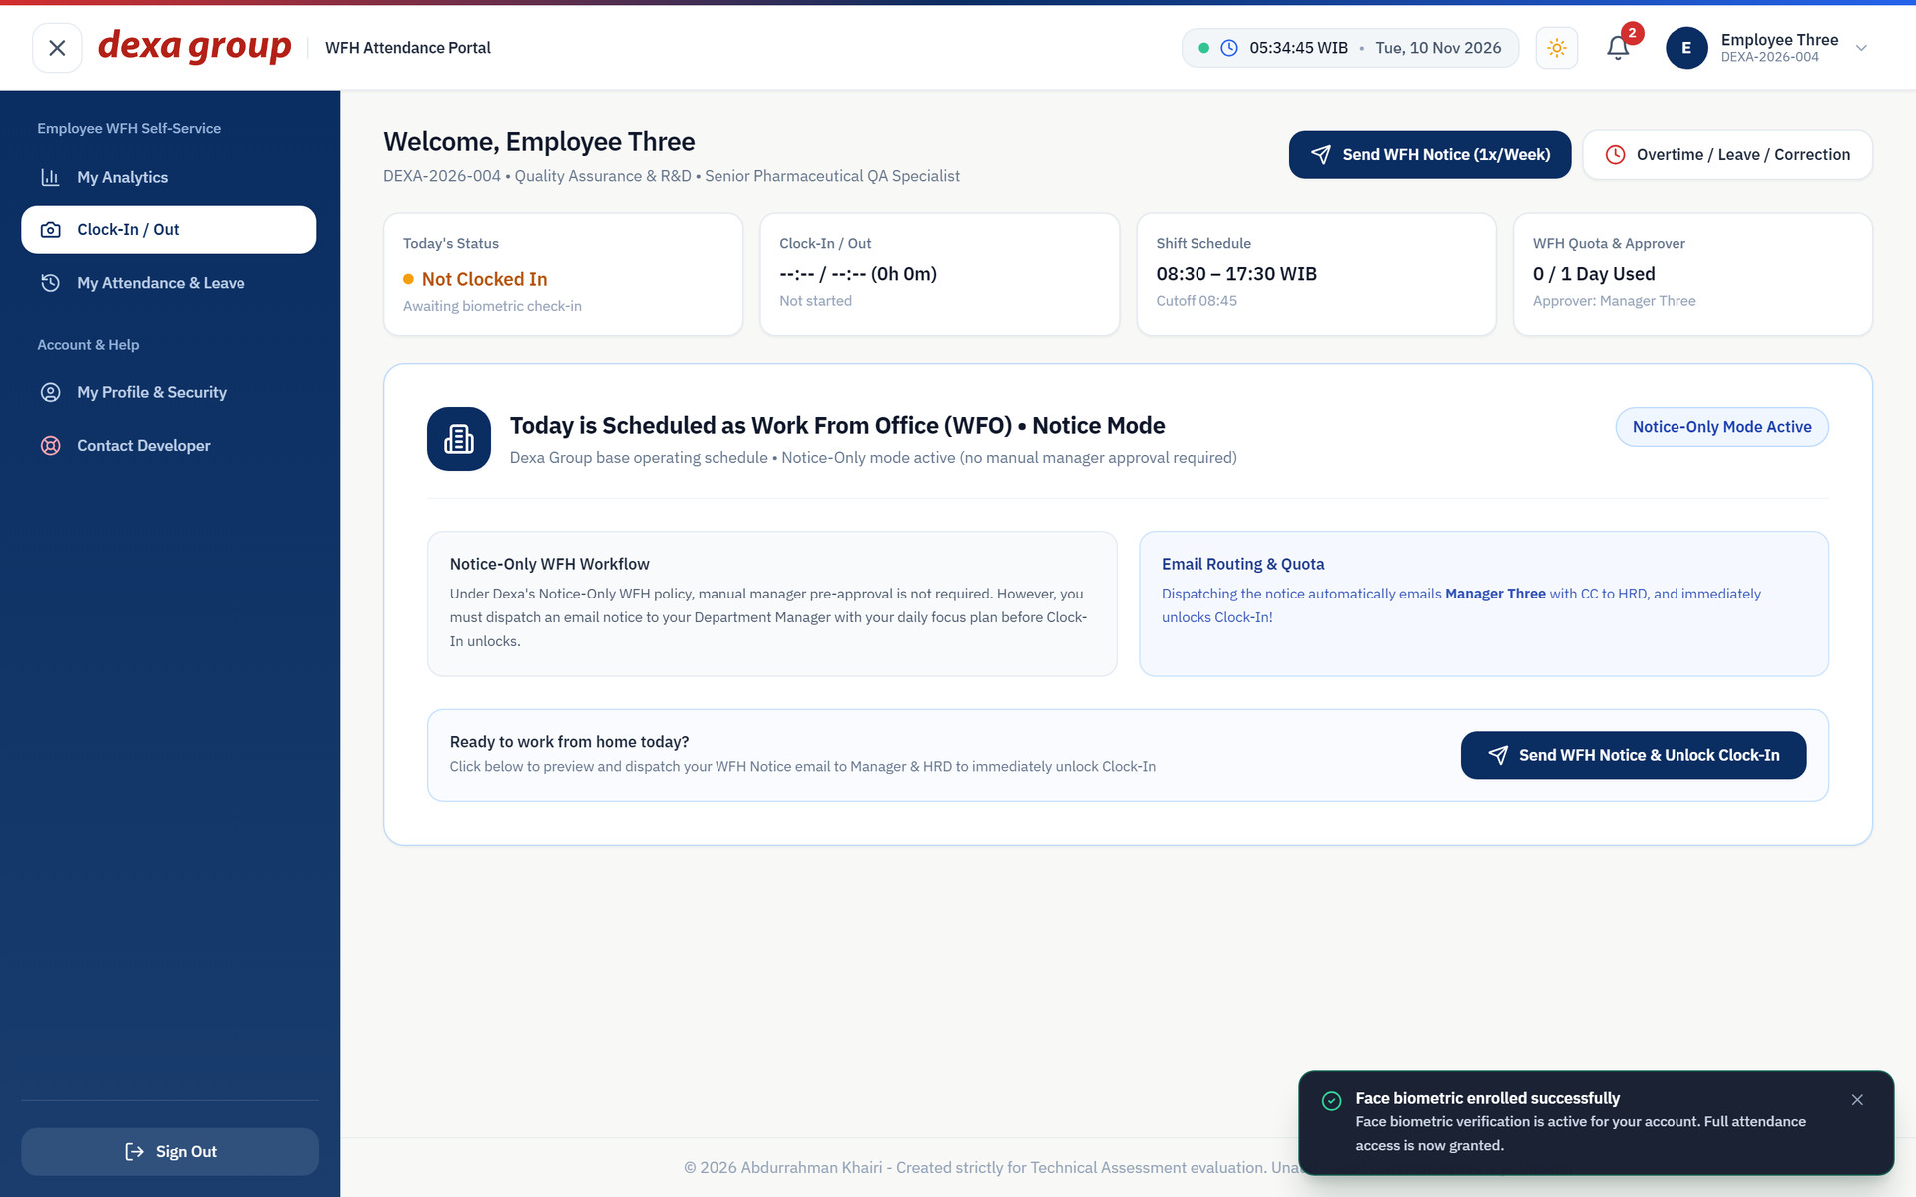
Figure 1.9: After HR switched on the exemption, the same face is accepted and the attendance page opens.

Personal Dashboard
Click My Analytics in the left menu.
The four cards at the top show your punctuality score, total WFH hours, overtime earnings with your weekly WFH quota, and today’s shift status. Below them, a bar chart shows your working hours for the last 14 days against an 8 hour target line. Blue bars are on time or completed days, red bars are late days, and green is a session still in progress. On the right, the Punctuality Breakdown splits your arrivals into on time, grace window, late, and leave. Further down you see your latest sessions and requests.
The portal uses the IBM Plex Sans typeface, and its numbers all have the same width. Times, hours and amounts therefore line up neatly in columns and cards.
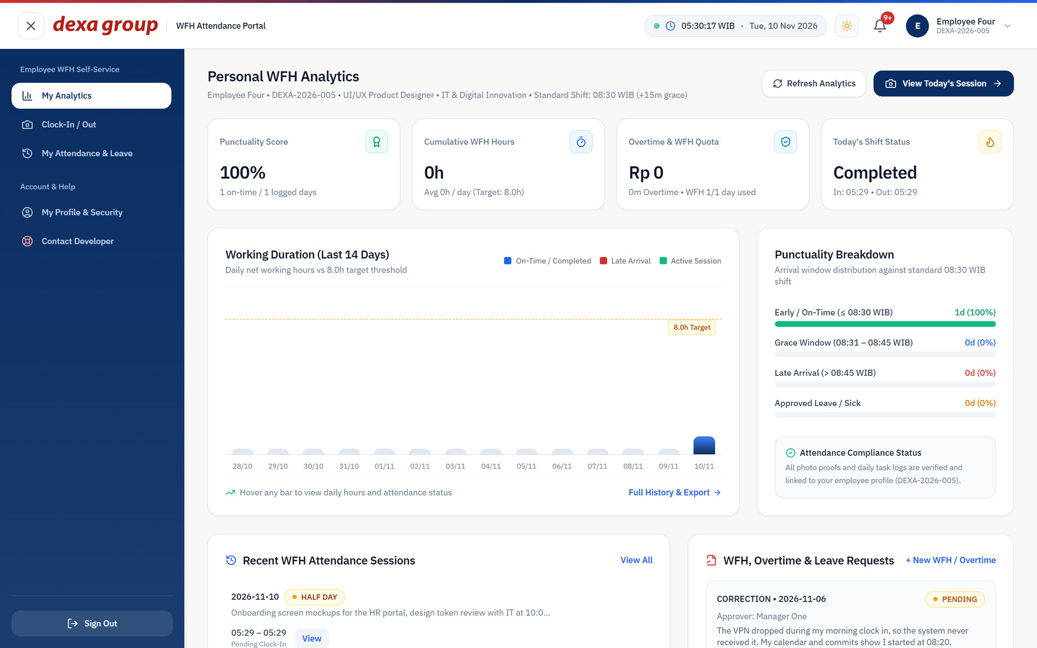
Figure 1.10: The Personal WFH Analytics dashboard after one completed session.

Send WFH notice
Dexa works from the office by default and allows one work from home day per week. Under the current company policy (Notice Only mode), you do not wait for approval. You send a notice with your plan for the day, and the clock in form unlocks straight away.
- Open Clock In / Out from the left menu. The page says today is scheduled as Work From Office and the clock in form is hidden. It only appears after you send the notice.
- Click Send WFH Notice & Unlock Clock In. A two step window opens.
- Step 1: check the date and type your focus plan for the day. Before 07:00 WIB the date box shows yesterday’s date, so change it to today. Then click Review WFH Notice Email.
- Step 2: the window shows the exact email that will be sent, including who receives it. Click Send WFH Notice & Unlock Clock In to send it.
- The clock in card appears with the label WFH Notice Dispatched, Ready for Clock In.
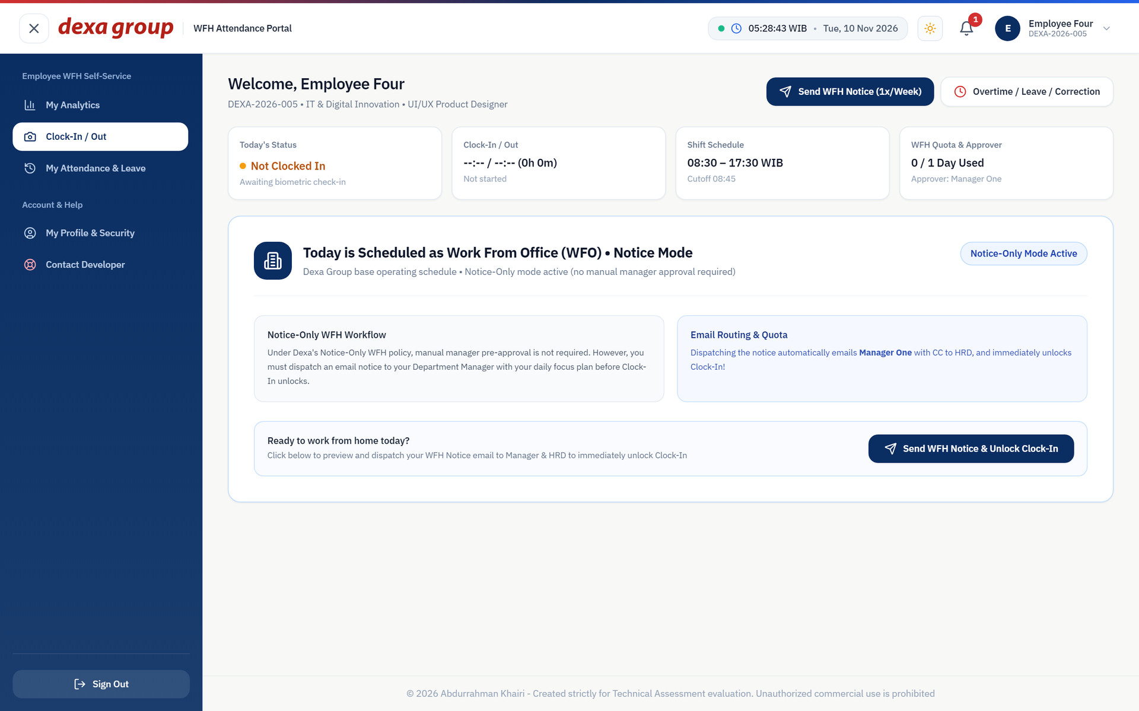
Figure 1.11: Before the notice: the page shows a work from office day and no clock in form.
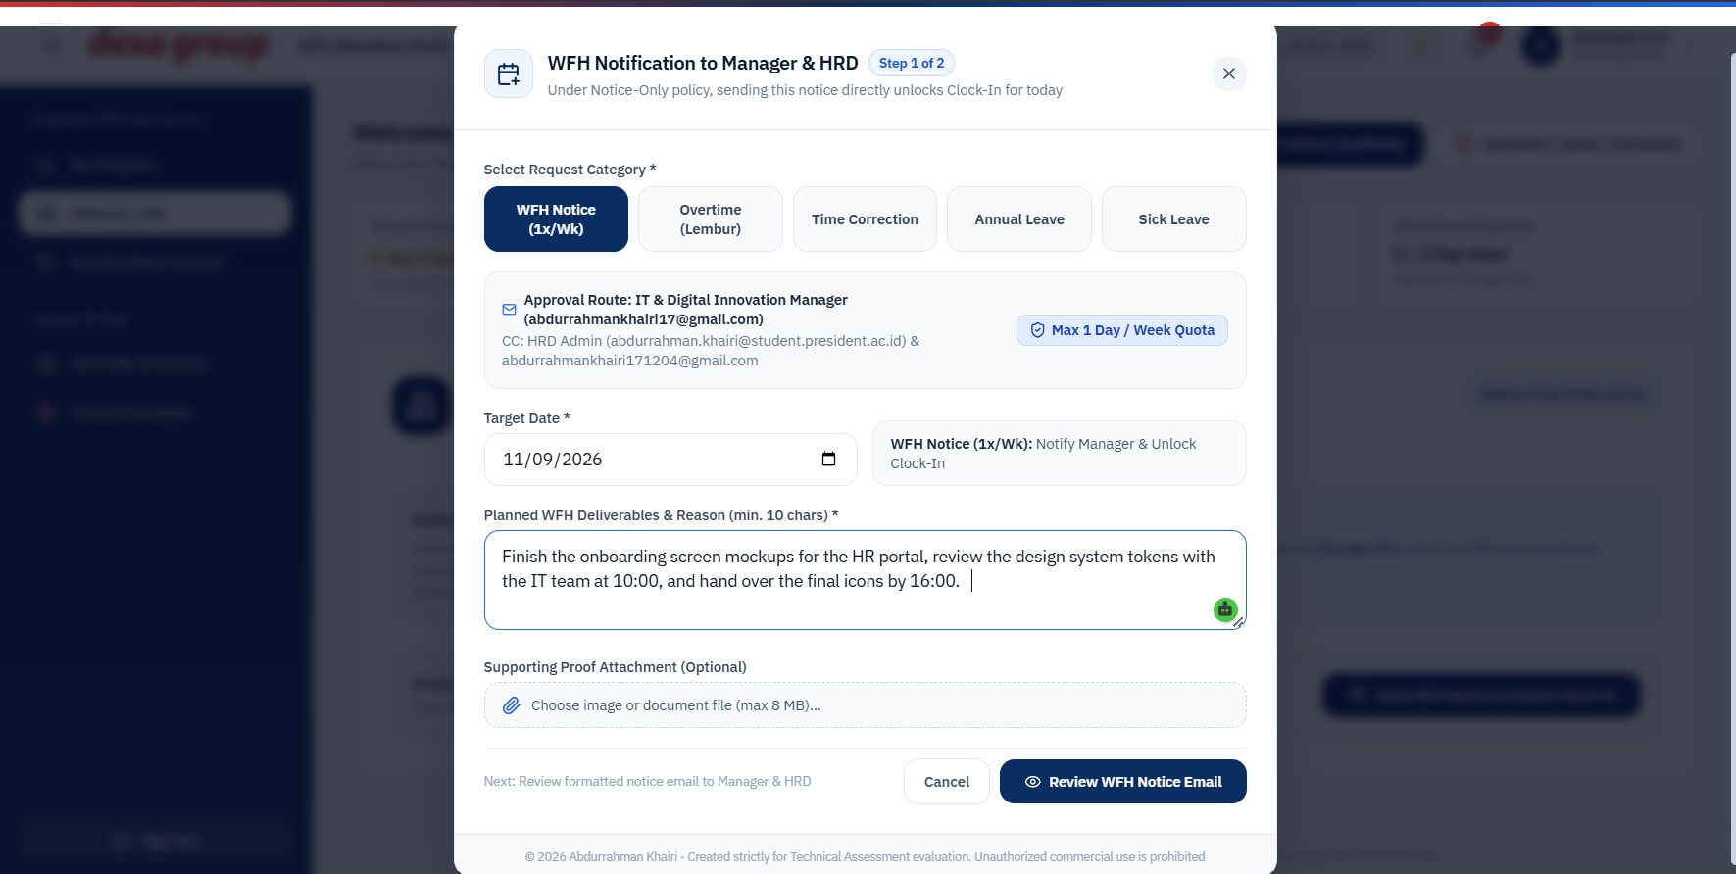
Figure 1.12: Step 1 of the notice: the date and the focus plan.
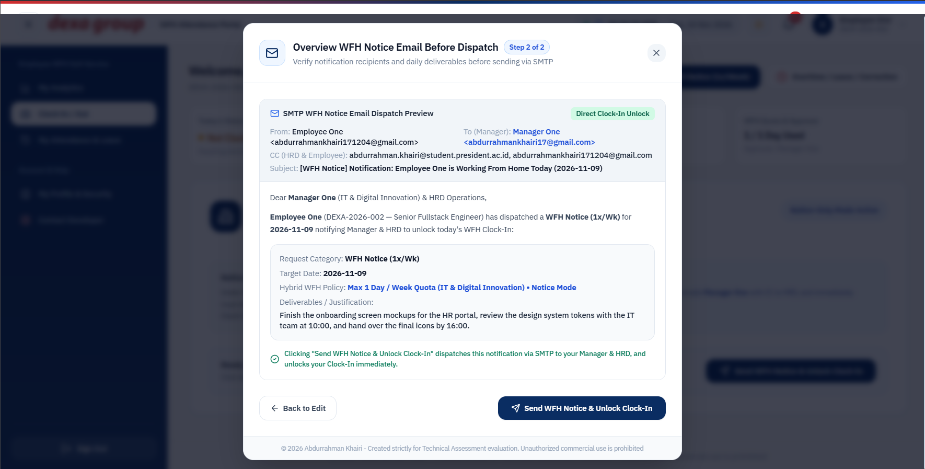
Figure 1.13: Step 2 of the notice: a preview of the email before it is sent.
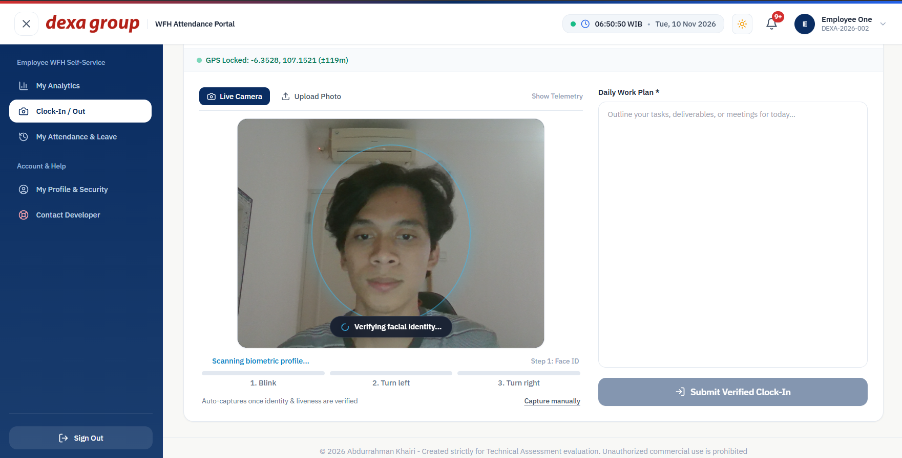
Figure 1.14: After sending, the clock in card is open and the camera starts.
The email goes to your department manager, with a copy to HR and to you. Here it was meant for manager.it@dexagroup.com with copies to admin.hrd@dexagroup.com and employee.four@dexagroup.com. In this test setup it was forwarded to the evaluation inbox, as the yellow banner shows.
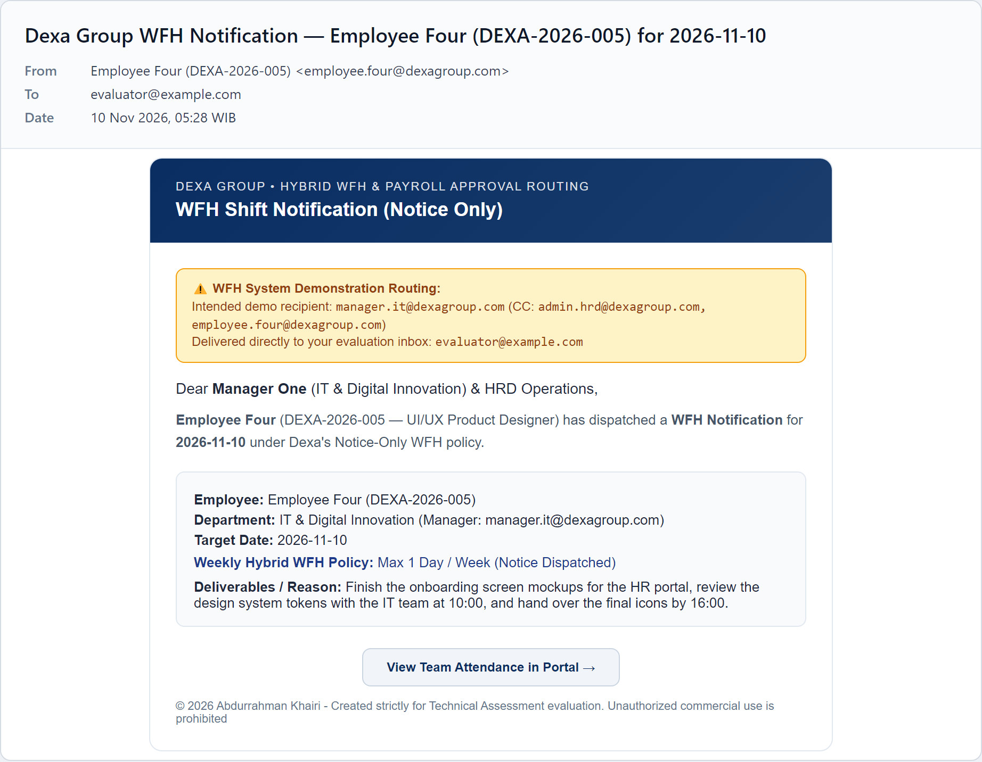
Figure 1.15: The WFH notice email. The yellow banner shows it was meant for the manager, with copies to HR and the employee.
Note: Strict Approval mode
Your company can switch the policy to Strict Approval. In that mode the button reads Request WFH Approval for Today, and the clock in form only opens after your manager approves the request.

Clock-In with the Live Camera
The camera turns on by itself when the clock in card opens. The check runs in two stages, and you can see the progress under the video.
- Look at the screen and keep your face inside the oval. The system compares your face with the one you registered. When it matches, a green badge shows your name and the match score. The screenshot shows 91 percent. A score of 45 percent or more counts as a match.
- Follow the three prompts at the bottom of the video: blink, turn your head to the left, then turn your head to the right. These checks prove a real person is in front of the camera and not a printed photo.
- Look straight at the camera again. The photo is taken automatically.
- The photo now carries a stamp burned into the image: the time in WIB, your NIP, your name and department, and a Biometric and Liveness Verified badge.
- Type your daily work plan in the box on the right and click Submit Verified Clock In.
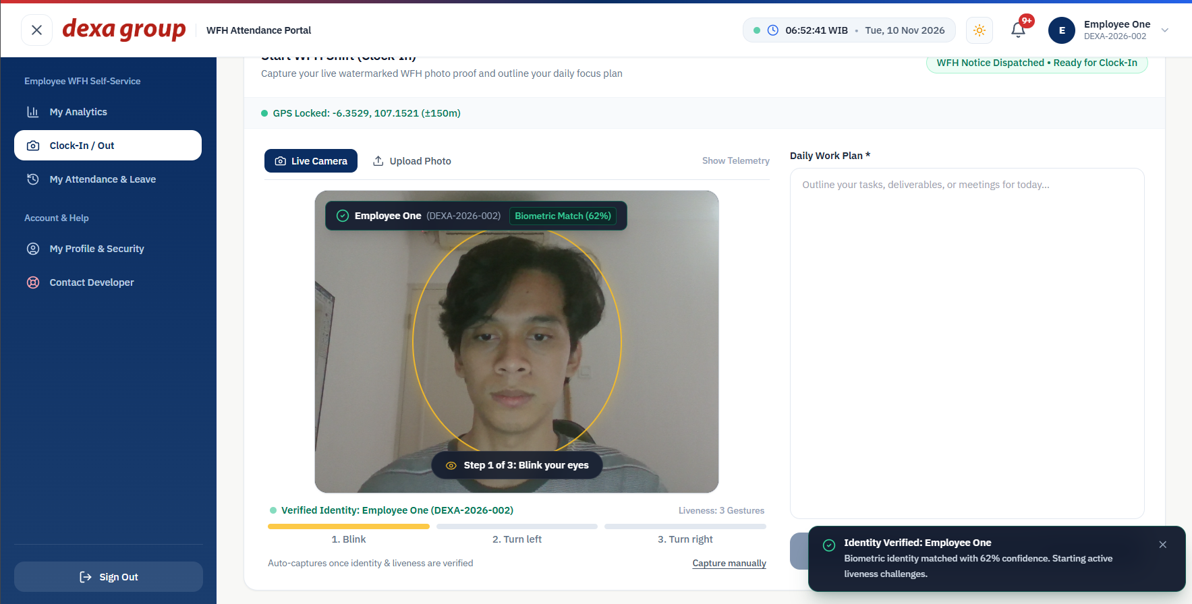
Figure 1.16: The live camera matches the face and shows the match score.
Figure 1.17: Liveness step 1: blink.
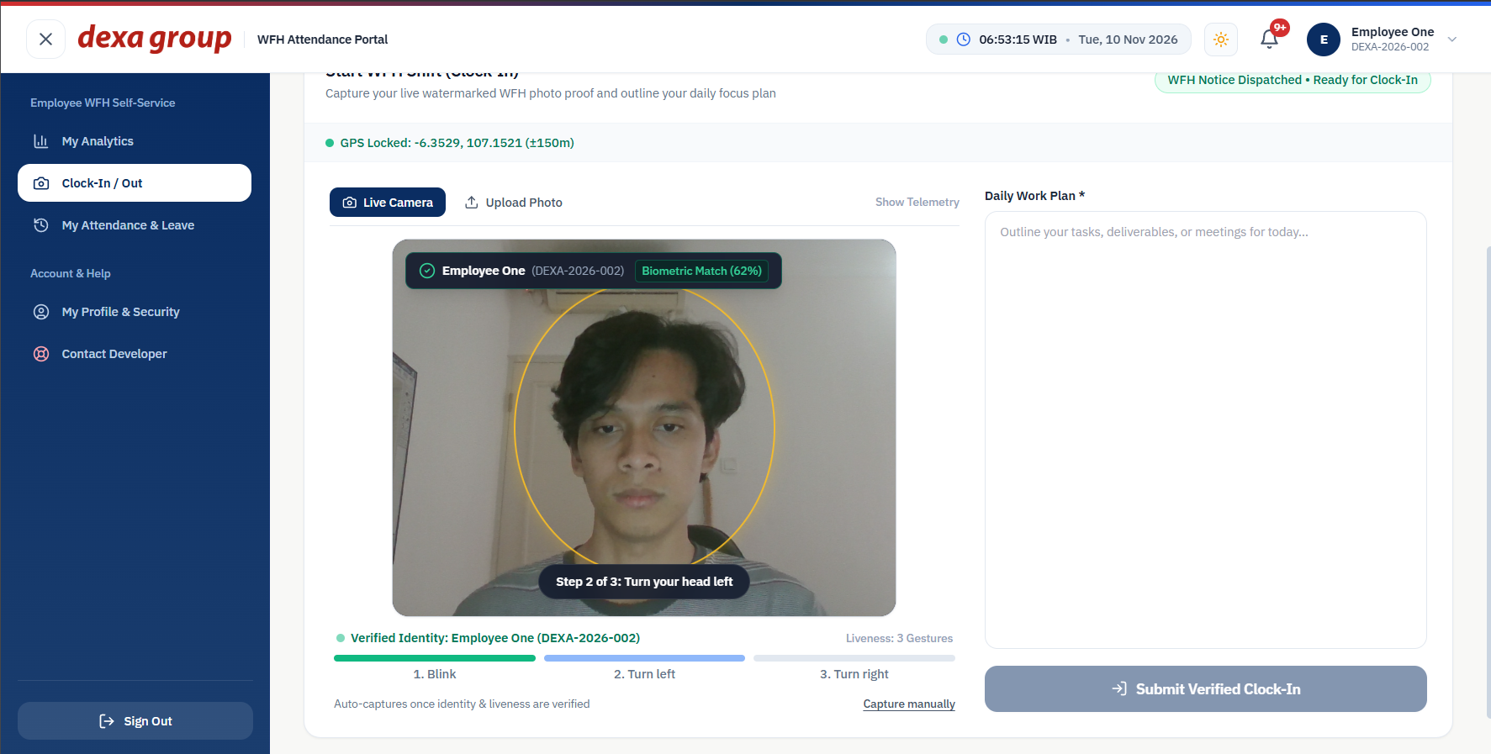
Figure 1.18: Liveness step 2: turn your head left.
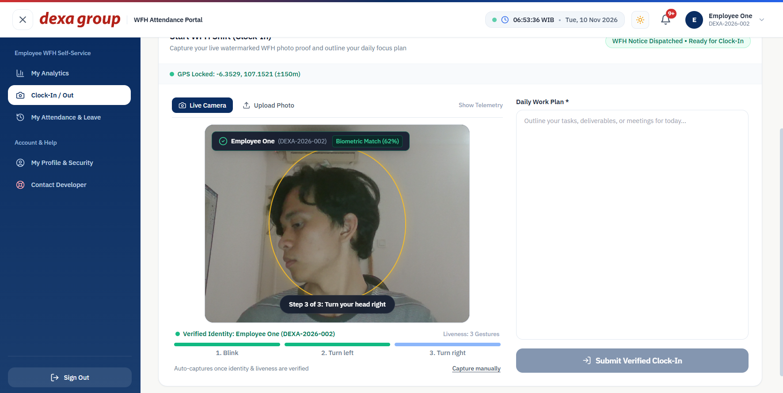
Figure 1.19: Liveness step 3: turn your head right.
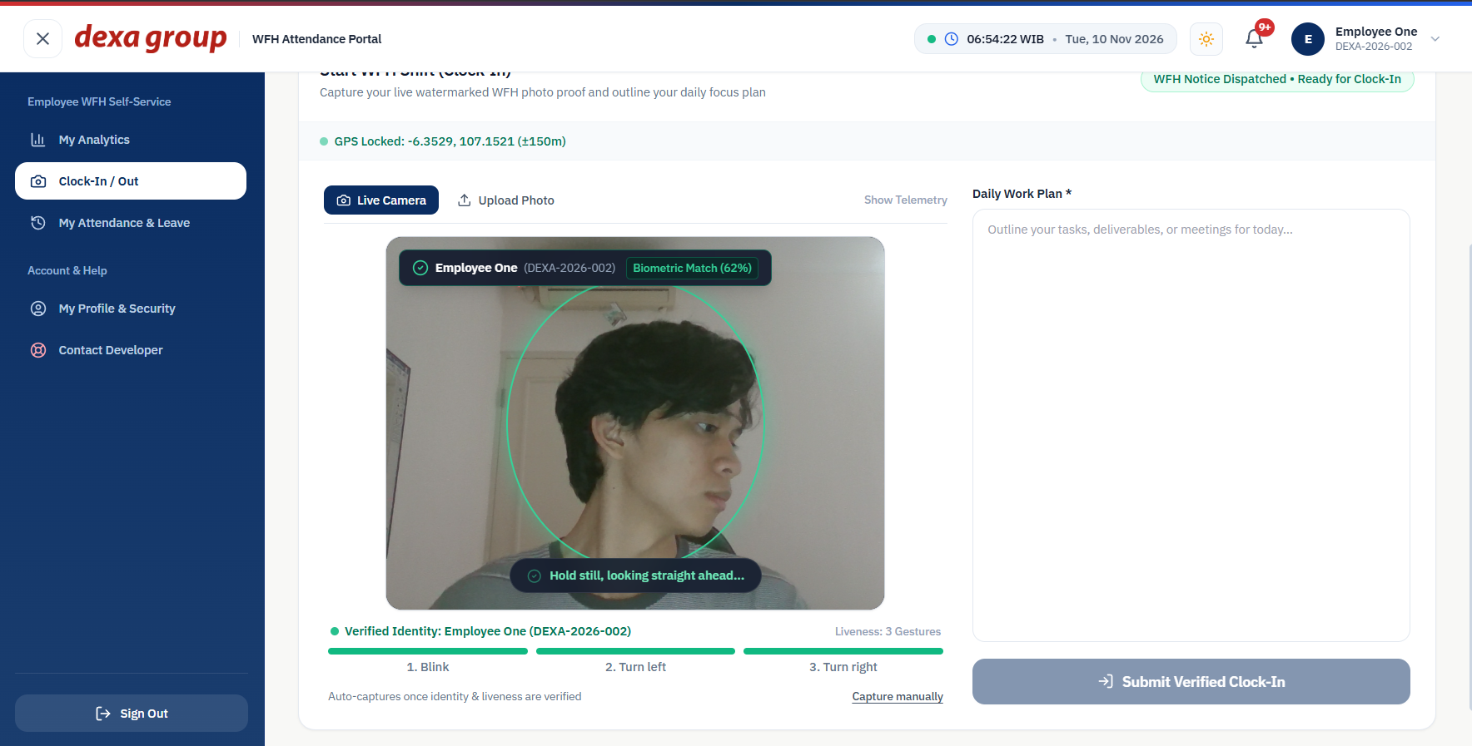
Figure 1.20: The captured photo with the time, NIP, name and verification stamp burned in.
After you submit, the card changes to Active WFH Shift in Progress and a message confirms the time the server recorded. The clock in time always comes from the server, never from your computer, so changing your computer clock has no effect.
The working day starts at 08:30 WIB. You have a 15 minute grace period, so a clock in up to 08:45 still counts as on time. After 08:45 the session is marked LATE, and the late minutes are counted from 08:30.
The page also reads your location from the browser. The bar above the camera shows GPS Locked with your coordinates, or a warning if you blocked location access. The system measures the distance to the home location saved on your profile (section 2.9) and tags the session IN_HOME_RADIUS within 100 meters or OUT_OF_HOME_RADIUS beyond it. Without a saved home location, or without GPS, the session is tagged LOCATION_UNAVAILABLE. The tag never stops you from clocking in. HR sees it on a map (Chapter IV).
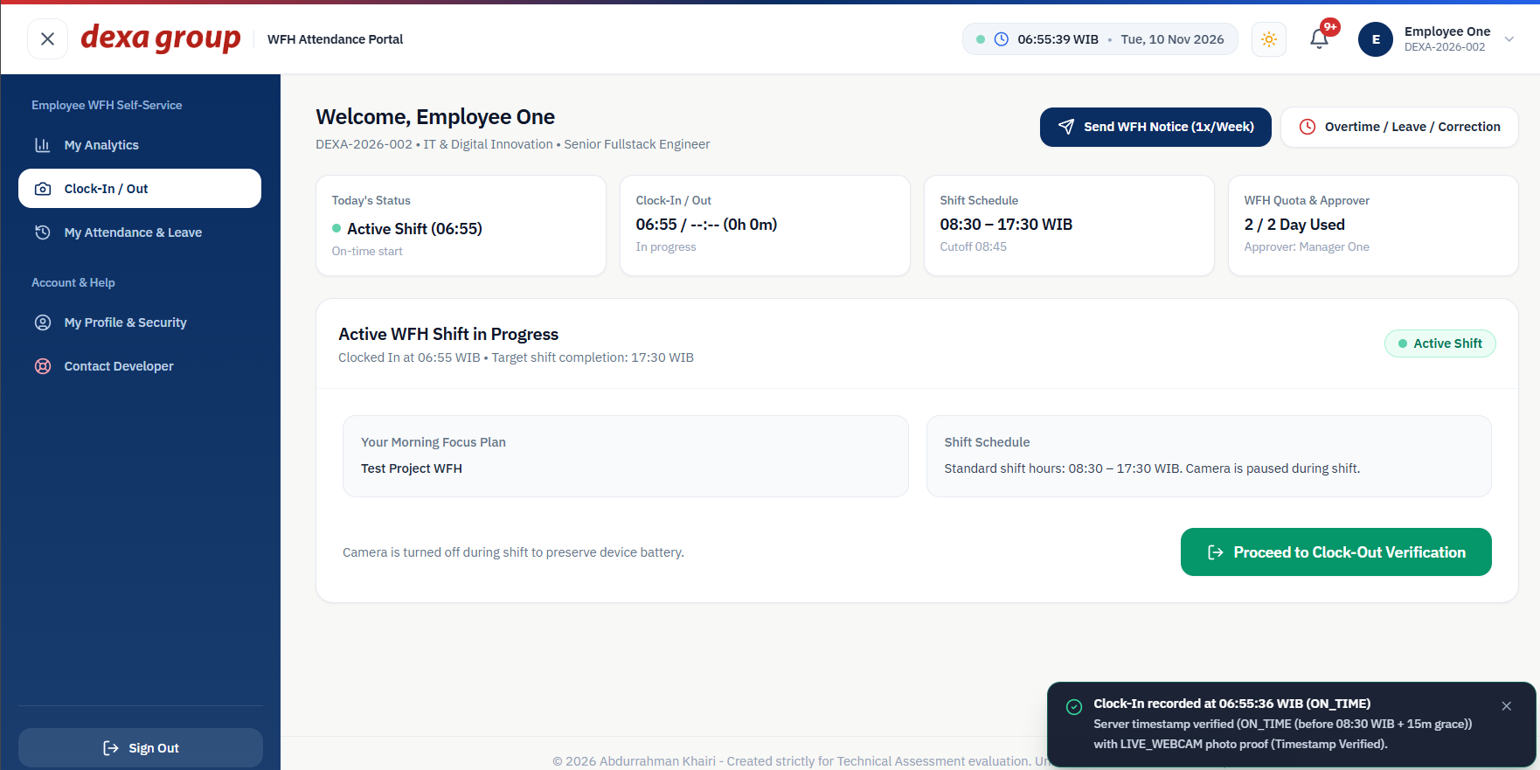
Figure 1.21: The shift is active. This test clock in was at 06:55 WIB, before the 08:30 start, so it counts as on time.

Using a Photo Upload when the Camera does not work
If your webcam breaks, you can switch to Upload Photo at the top of the camera box.
- Type the reason the camera cannot be used, for example a broken webcam driver. The file picker stays disabled until you do.
- Choose a photo of yourself taken today.
- The portal stamps the photo in your browser and sends the time the file was last saved on your computer. The photo is accepted either way, but it is only marked as verified when that time is on the same day in WIB and no more than 12 hours old. Your face is still checked against your registered face.
- The photo is stamped with the file time and the submit time, and saved with the source marked as FILE_UPLOAD so HR can see it was not a live capture.
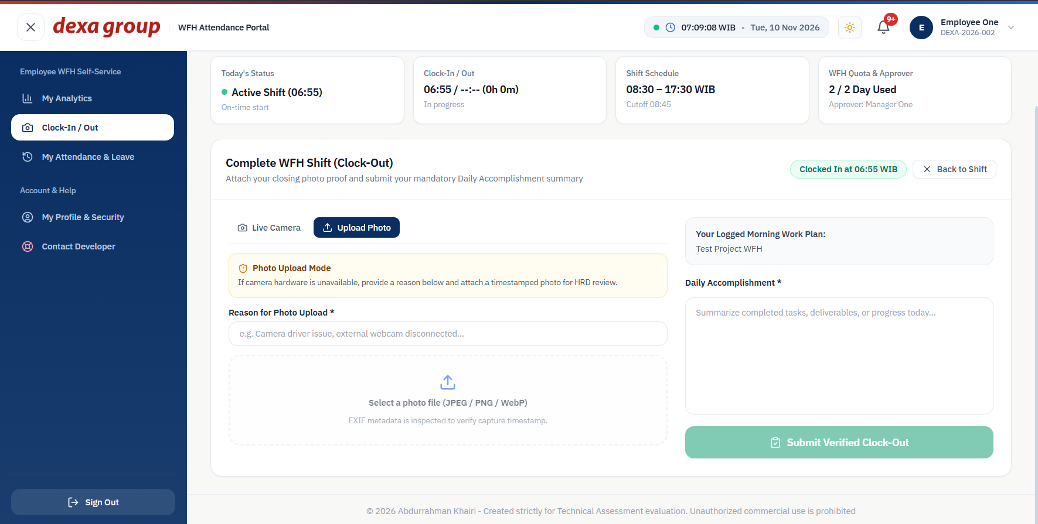
Figure 1.22: Upload mode with a reason typed in and a photo chosen.

Clock-Out at The End of The Day
- On the active shift card, click Proceed to Clock Out Verification.
- Take a live photo as in the morning, or use Upload Photo if the camera fails.
- Write your daily accomplishment summary. This field is required.
- Click Submit Verified Clock Out.
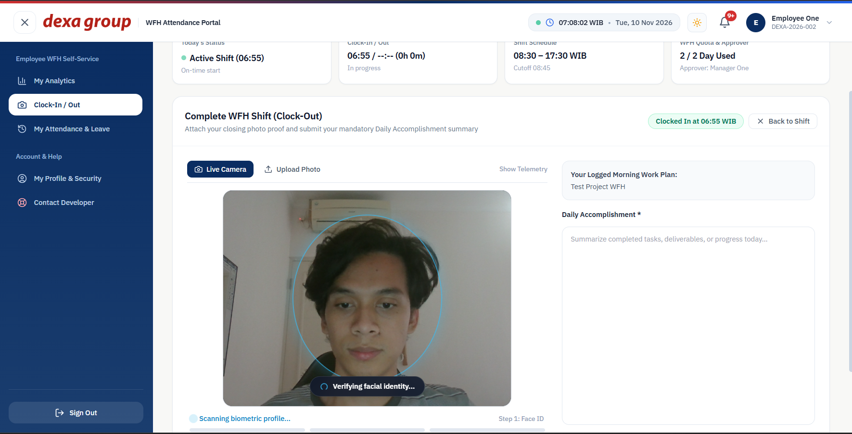
Figure 1.23: The clock out card with an uploaded photo and the accomplishment summary.
The page now shows Today’s WFH Attendance Session is Complete, with both photos and both notes side by side. The system works out the rest by itself:
- Working time is the clock out time minus the clock in time. No lunch break is taken off.
- If you worked less than 4 hours (240 minutes), the day is marked HALF_DAY. Otherwise it is marked COMPLETED.
- Overtime starts counting once your session passes 9 hours (540 minutes), which is 17:30 for an 08:30 start. Less than 30 extra minutes is not counted.
- Overtime pay follows the Indonesian 1/173 rule. Your hourly rate is your monthly base salary divided by 173. The first overtime hour pays 1.5 times that rate, and every hour after that pays 2 times the rate.
Example: with a salary of IDR 12,000,000, the hourly rate is IDR 69,364. If you work from 08:30 to 20:00, that is 690 minutes, so 150 minutes (2.5 hours) are overtime. Pay is 1.5 hours for the first hour plus 3.0 hours for the remaining 1.5 hours, which is 4.5 hours at IDR 69,364, or IDR 312,138.
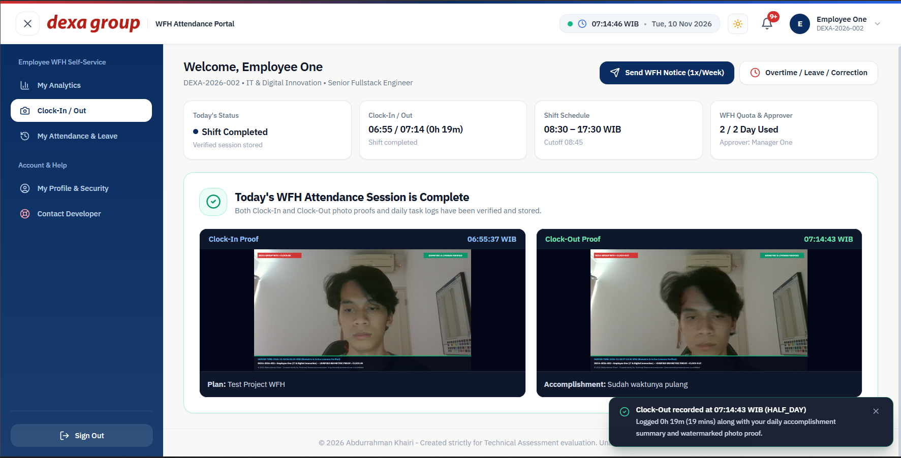
Figure 1.24: The completed session. This test shift lasted only a few seconds, so it is marked as a half day.

WFH Approval, Overtime & Leave Request
- Click Overtime / Leave / Correction at the top of the Clock In / Out page, or New Leave / Correction Request on the My Attendance & Leave page.
- Pick the request type: Overtime, Time Correction, Annual Leave or Sick Leave.
- Fill in the date. For a correction, also enter the clock in and clock out times you want recorded.
- Explain the reason and attach a supporting file if you have one, such as a doctor’s note or a log screenshot.
- Click Review Approval Email to see the email first, then Send Email & Submit Request.
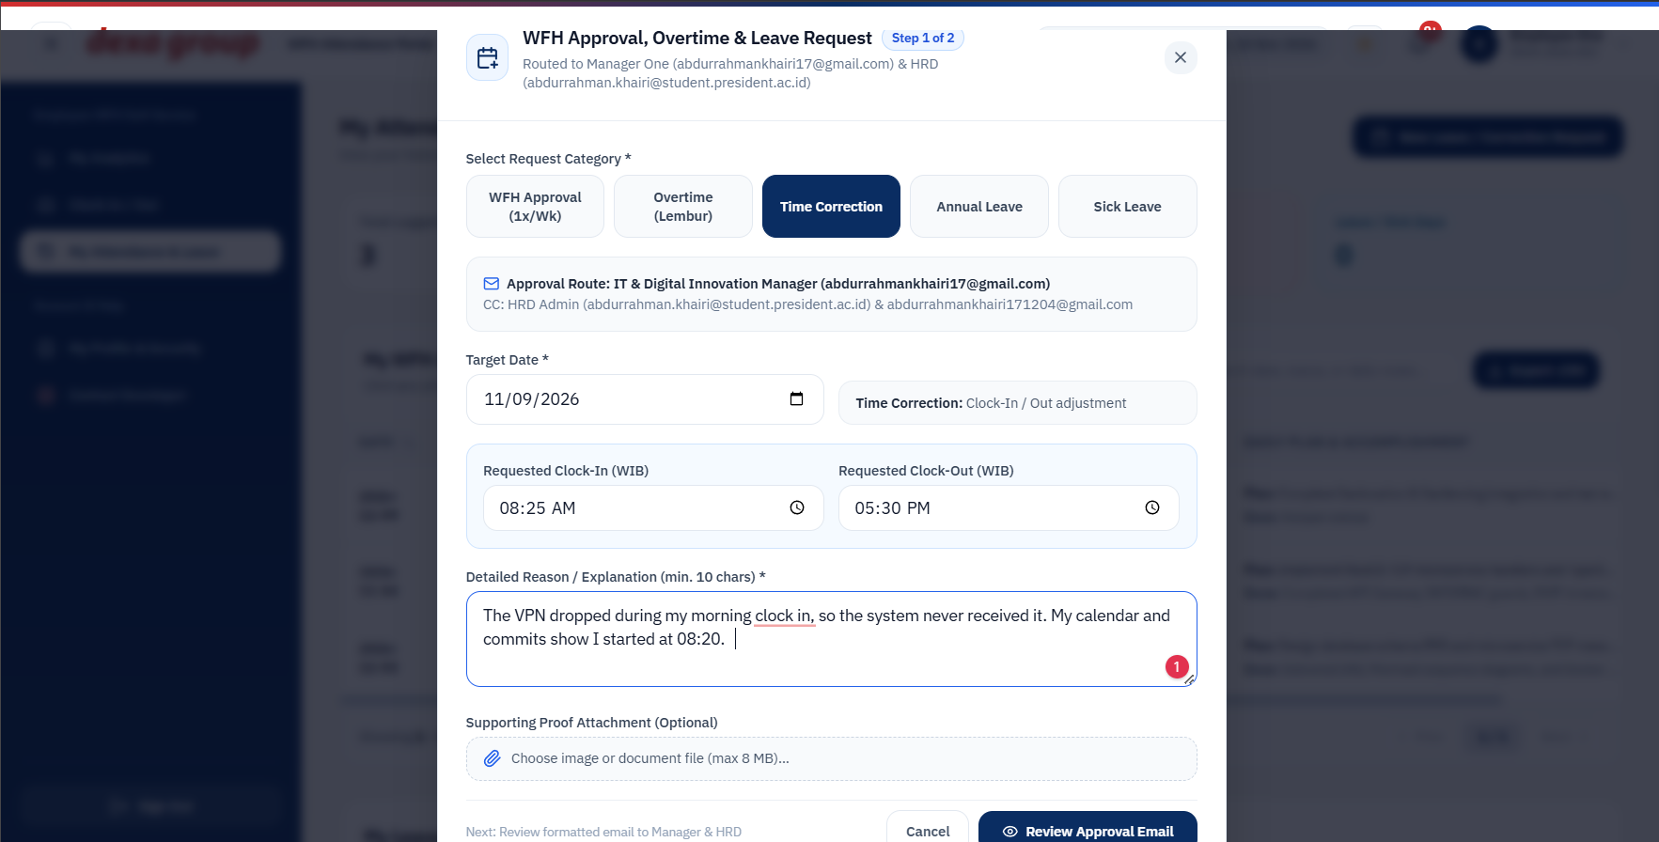
Figure 1.25: A time correction request with the times, the reason and an attachment.
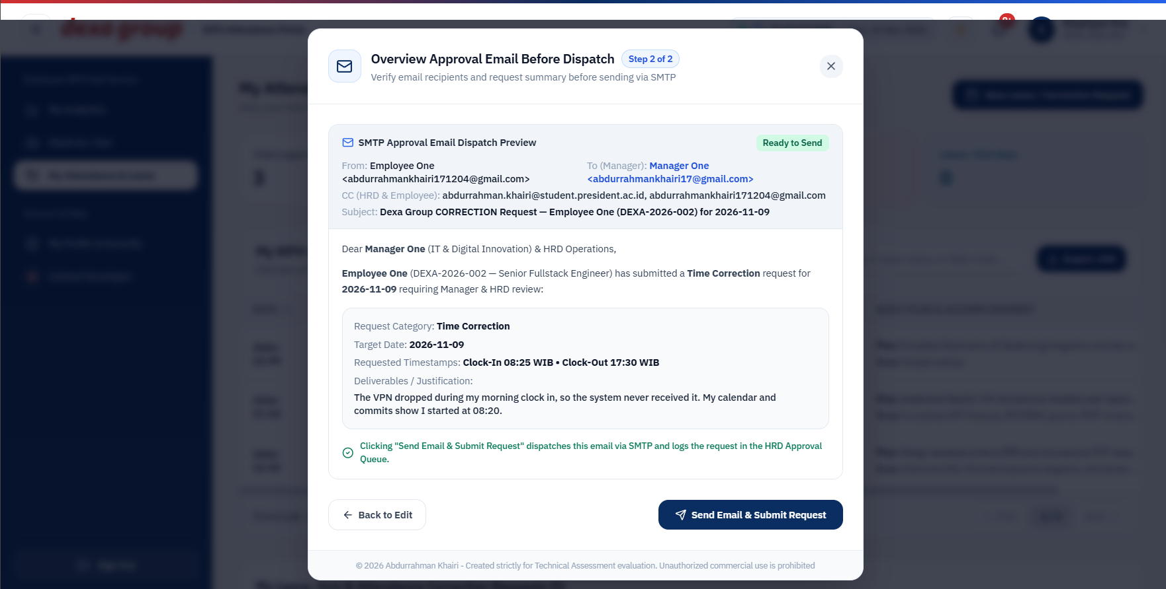
Figure 1.26: The preview of the approval email that goes to the manager.
Open My Attendance & Leave to follow up. Your sessions are listed at the top, and your requests appear at the bottom with a PENDING, APPROVED or REJECTED badge.
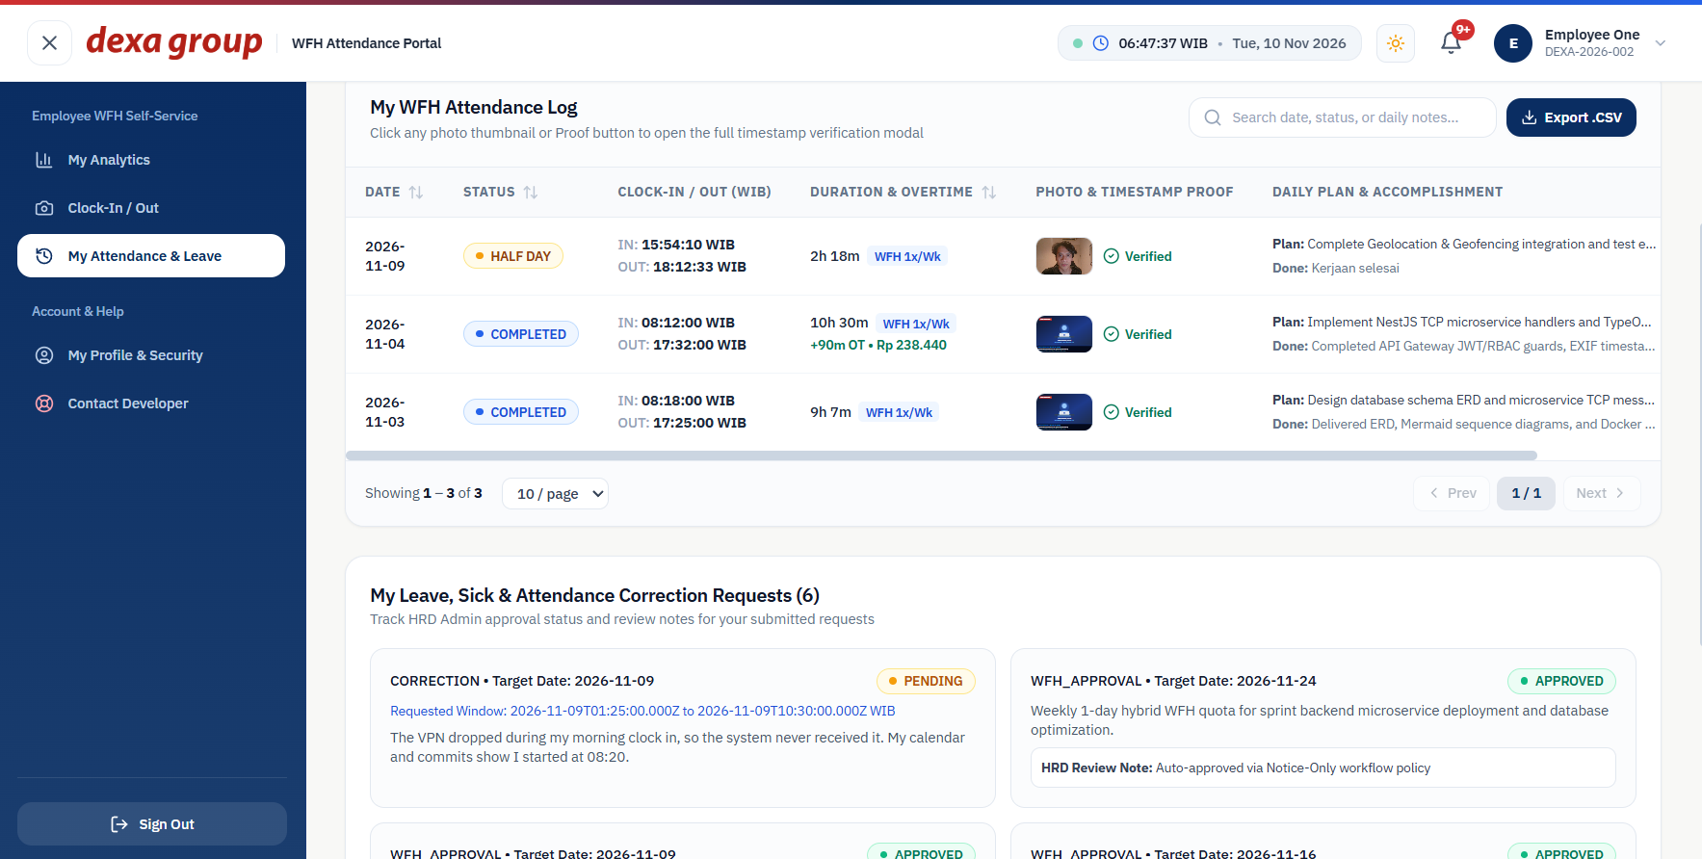
Figure 1.27: The new correction request waits as PENDING. The WFH notice from the morning is already approved.

Contact Developer & Technical Support
- Click Contact Developer in the left menu, or open your name menu at the top right and choose Contact Developer Support.
- Your name and email are filled in for you as the sender. Pick a category, type the page where the problem happened, a short subject and a full description.
- Click the send button. A green message confirms the ticket was sent.
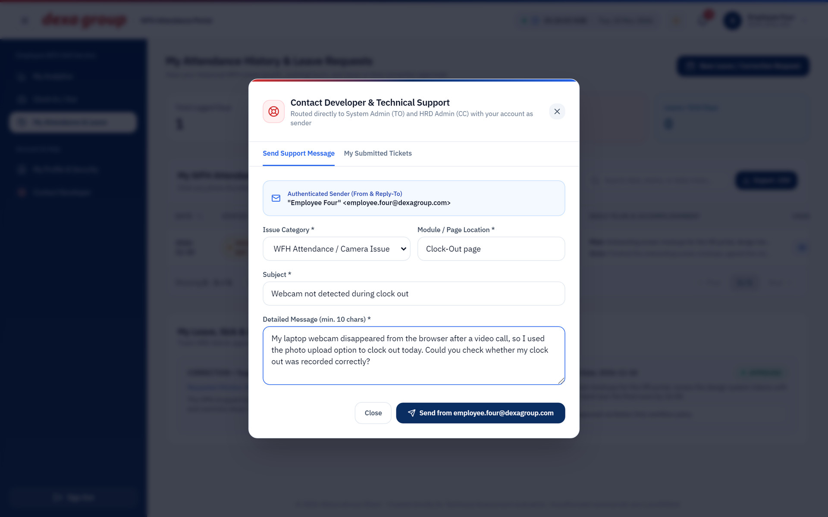
Figure 1.28: The support form filled in by the employee.
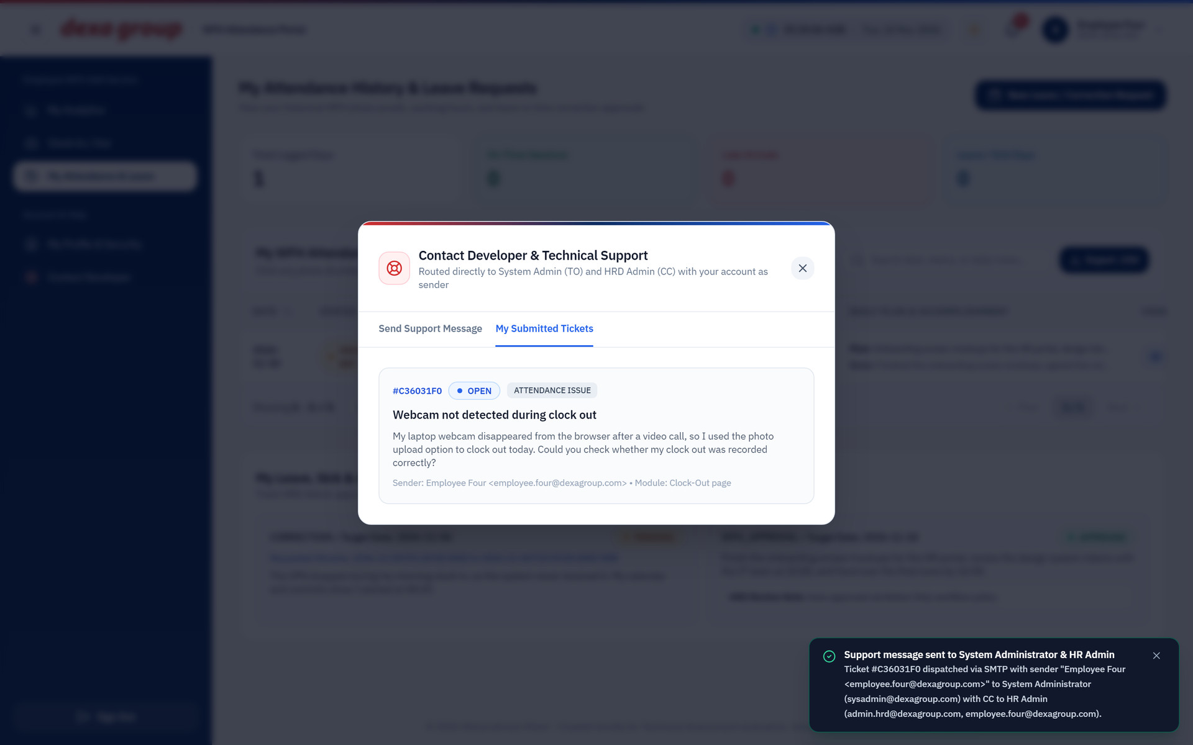
Figure 1.29: The confirmation after the ticket was sent.
The email goes to the System Admin, with copies to HR and to you. The Reply To address is yours, so any answer comes straight back to your inbox.
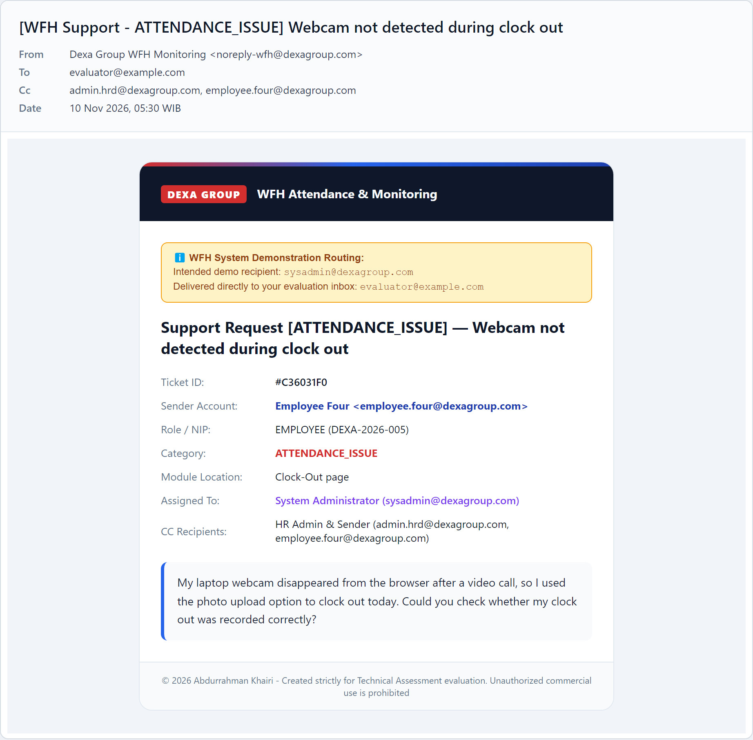
Figure 1.30: The support email. The yellow banner shows it was meant for the System Admin, and the copies to HR and the employee stay on the message.

Your Profile and Home Location
Open My Profile & Security in the left menu, or choose your name at the top right. The page shows your role and NIP, and lets you update your contact details and change your password.
The section Registered WFH Home Residence & Geofence holds the place you work from at home. The system compares every clock in and clock out with it, so save it before your first WFH day.
- Work from the place you normally work from home.
- Click Set Home from Current Device GPS and allow the browser to use your location.
- The coordinates and the address appear under Registered Address, and a green message confirms the save.
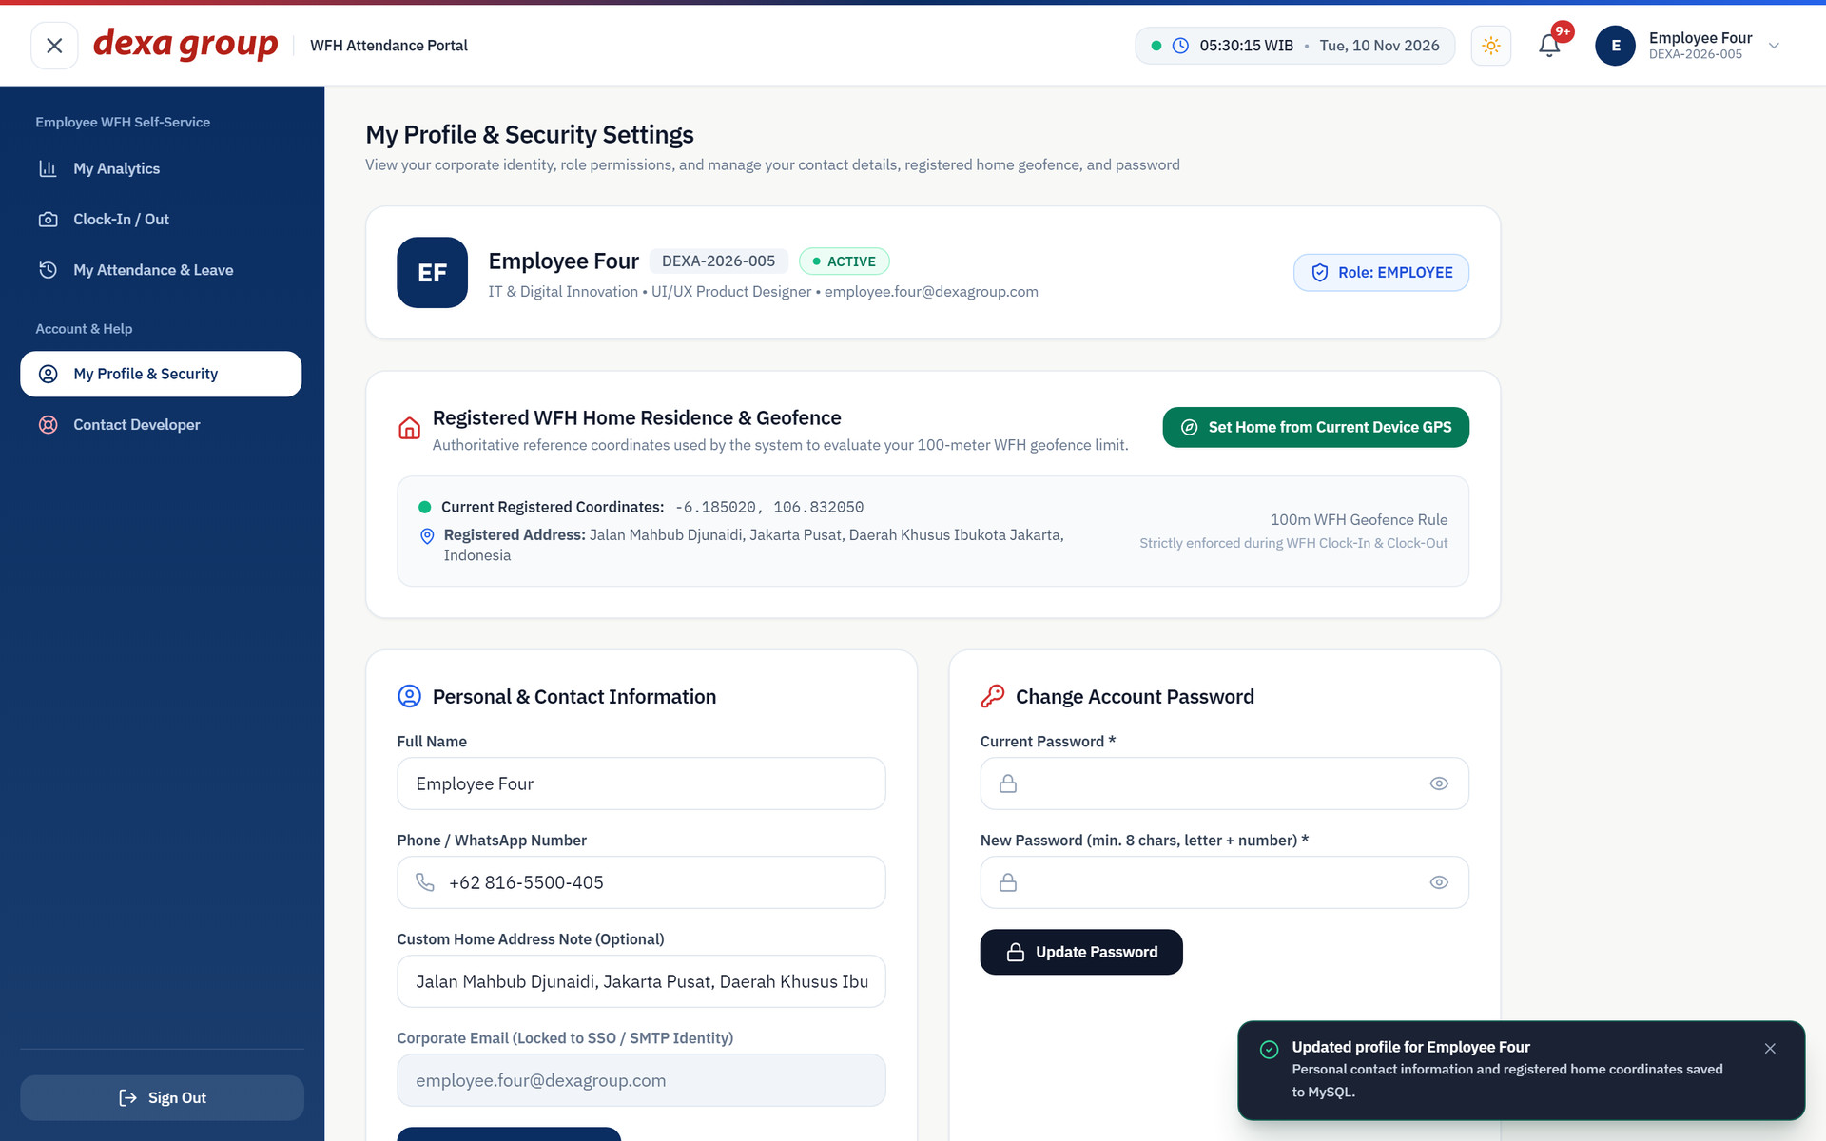
Figure 1.31: The registered home location on the profile page.

CHAPTER III
DEPARTMENT MANAGER MANUAL GUIDE

Managers use the same Clock In / Out, My Analytics and My Attendance & Leave pages as employees. They also get one extra page, WFH & Leave Approvals, for the requests coming from their own department.

Approval Page
After you sign in, the portal opens Department Approvals for your department. ‘
Every WFH notice, overtime claim, leave request and correction from your team is listed with the employee, the type, the date, any proof, and the current status. Use the search box and the status and type filters to narrow the list. Pending items have a dark Review button. Finished items have a Details button.
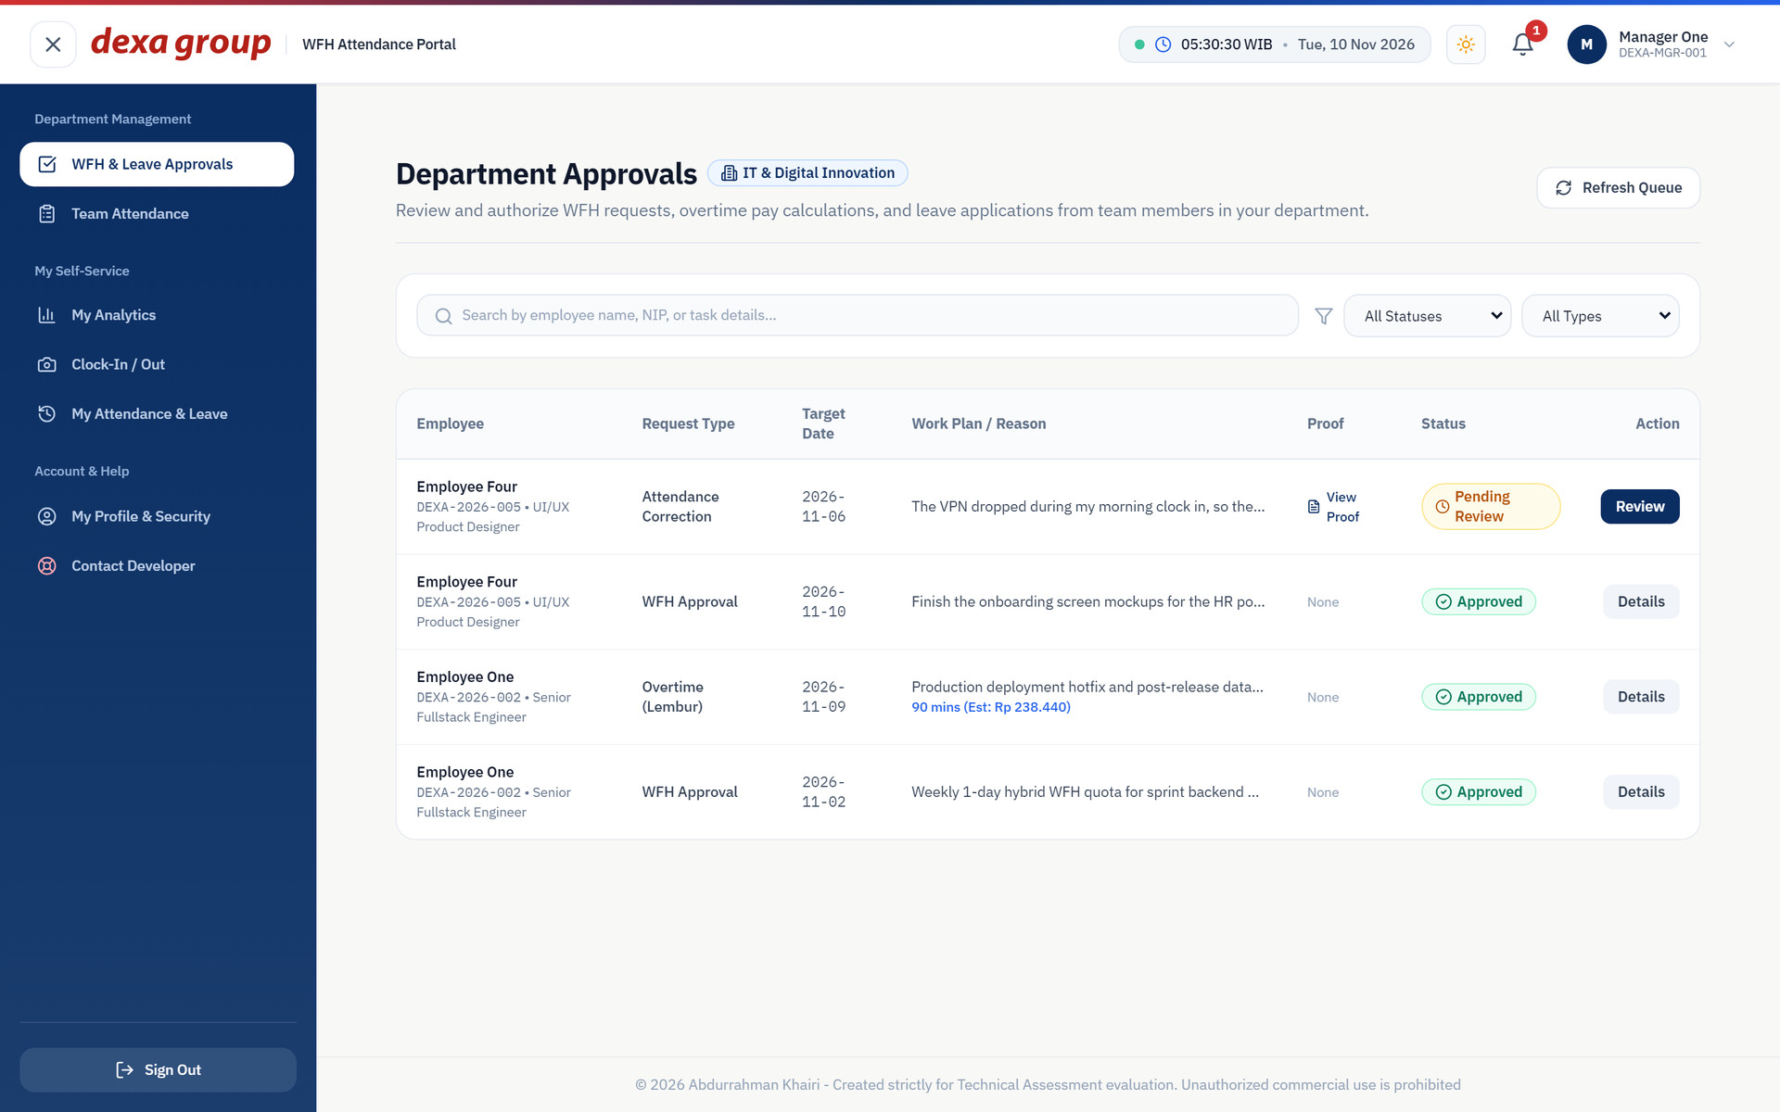
Figure 2.1: Department Approvals for the IT department.

The Manager’s WFH Notice goes to HR
A manager sends a WFH notice exactly the way an employee does (Chapter II, section 2.3). The difference is where the email goes. A manager cannot approve their own notice, so it goes up one level: to HR at admin.hrd@dexagroup.com, with copies to the System Admin, HR and the manager.
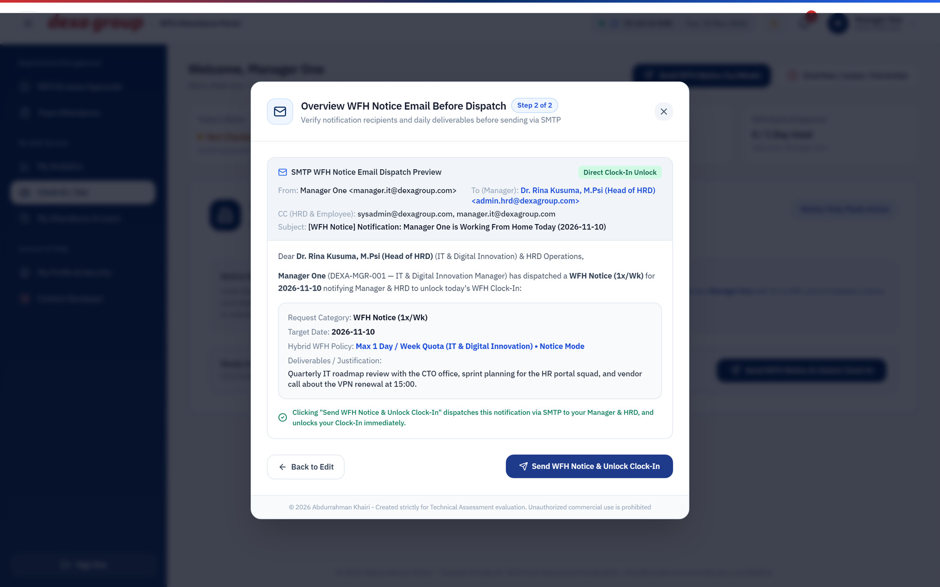
Figure 2.2: The preview of a manager’s WFH notice before sending.
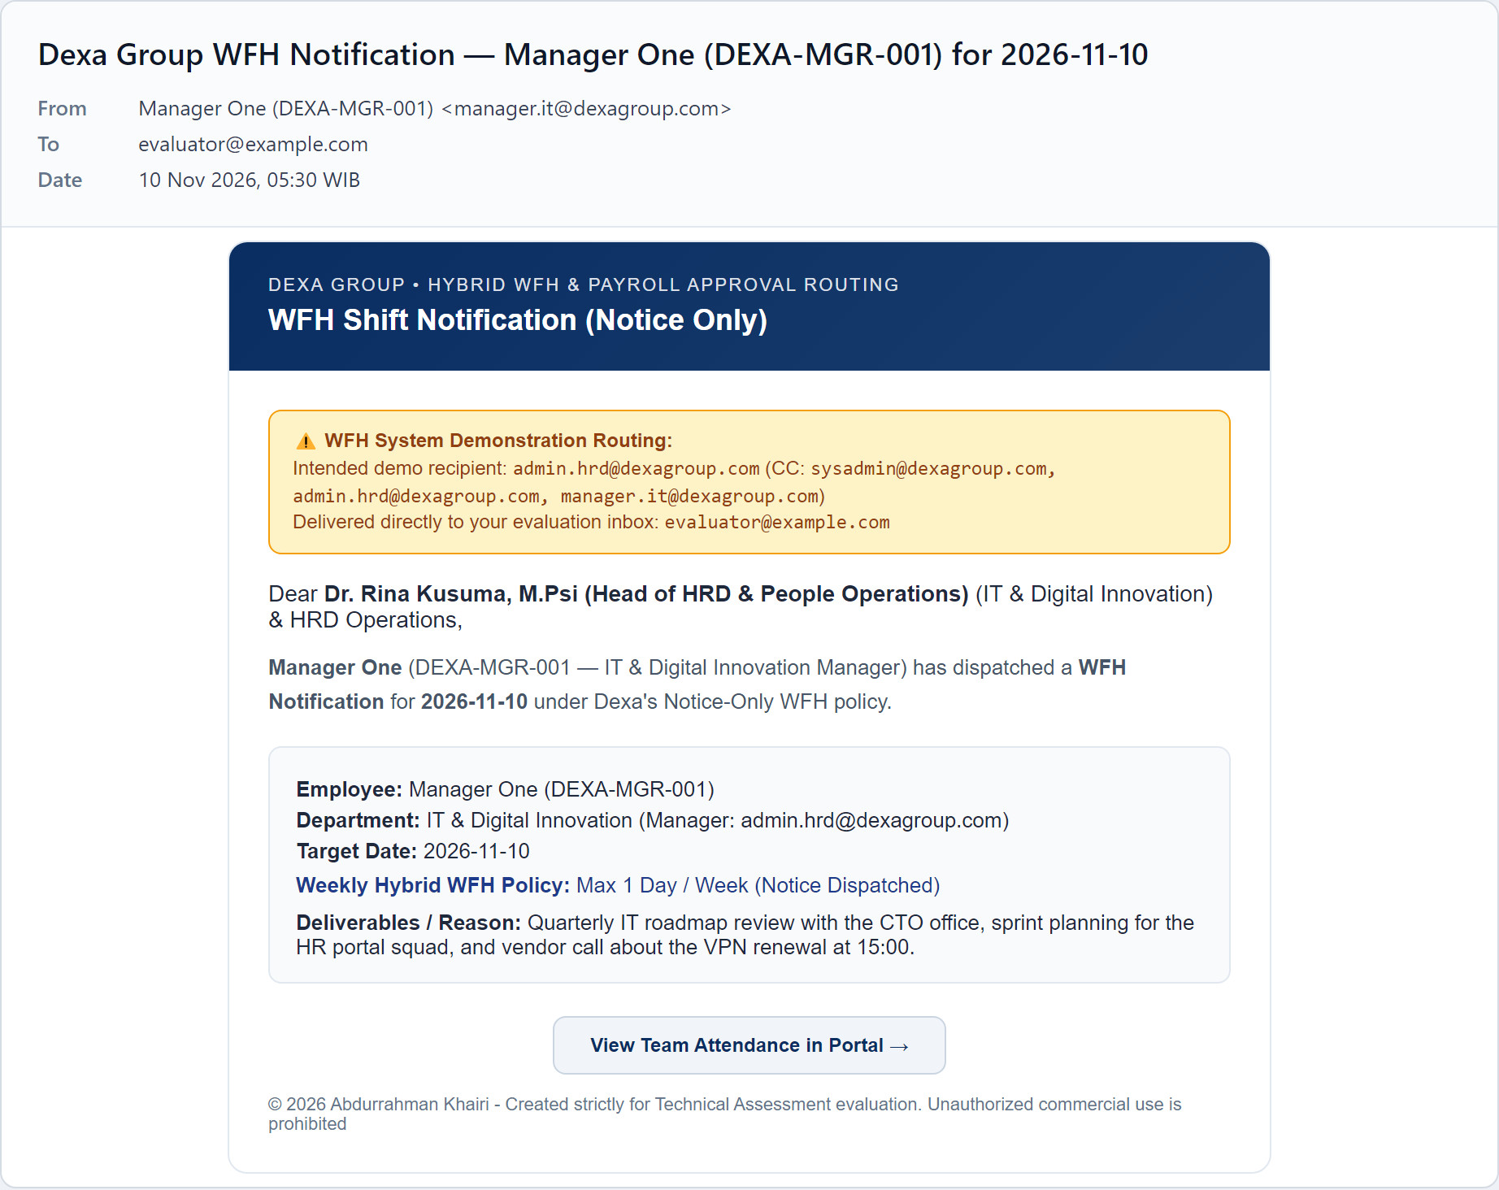
Figure 2.3: The manager’s notice is addressed to HR instead of a manager, as the yellow banner shows.

Monitoring Team WFH Requests
Every morning notice from your team appears on Department Approvals with the employee’s full focus plan.
In Notice Only mode these arrive already approved, so they are there for you to read and follow up on.
Click Details to read the whole plan.
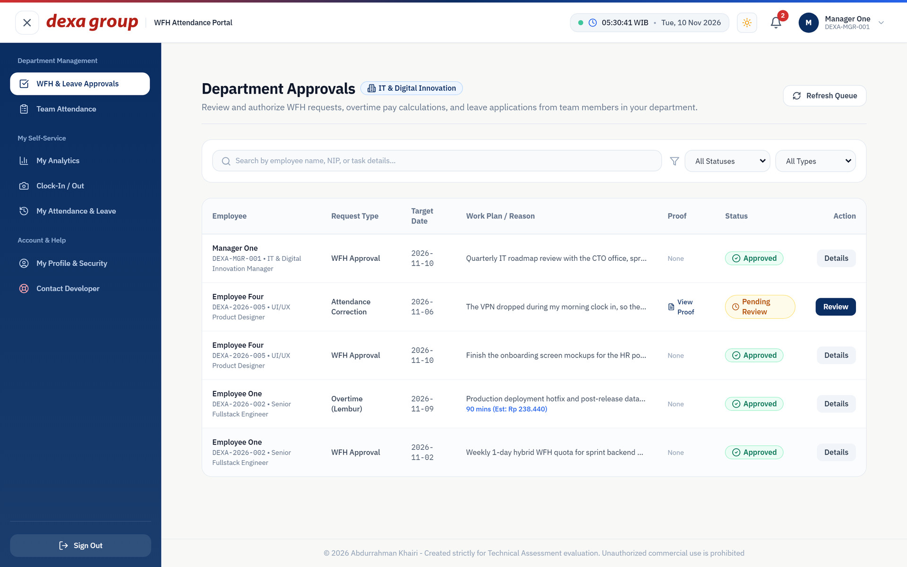
Figure 2.4: Team notices and requests on the approvals page.

Approval Request from the Email Link
- Open the request email in your inbox. It holds the employee details, the reason, and a button to review the request.
- Click the button. It opens http://localhost:5173/manager/approvals?requestId=... in the portal. Sign in first if you are asked to.
- The review window opens on that request straight away. It shows the employee, the target date, the reason, and a link to the attachment.
- Add a review note if you want. A note is required if you reject.
- Click Approve Request or Reject Request.
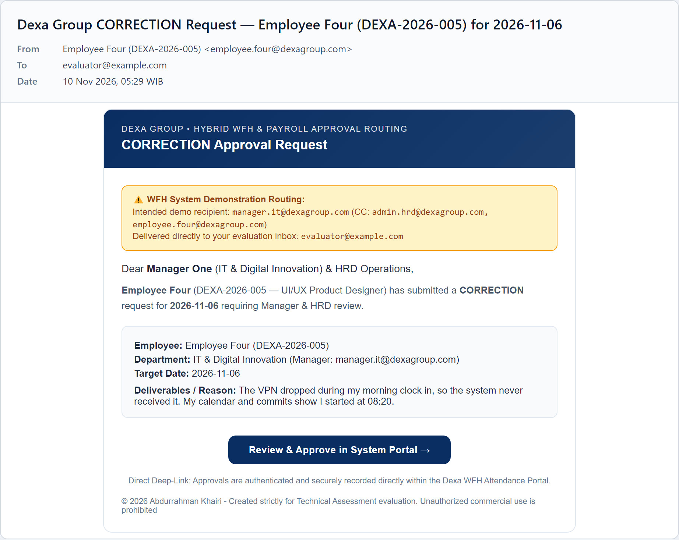
Figure 2.5: The correction request email, with the review button.
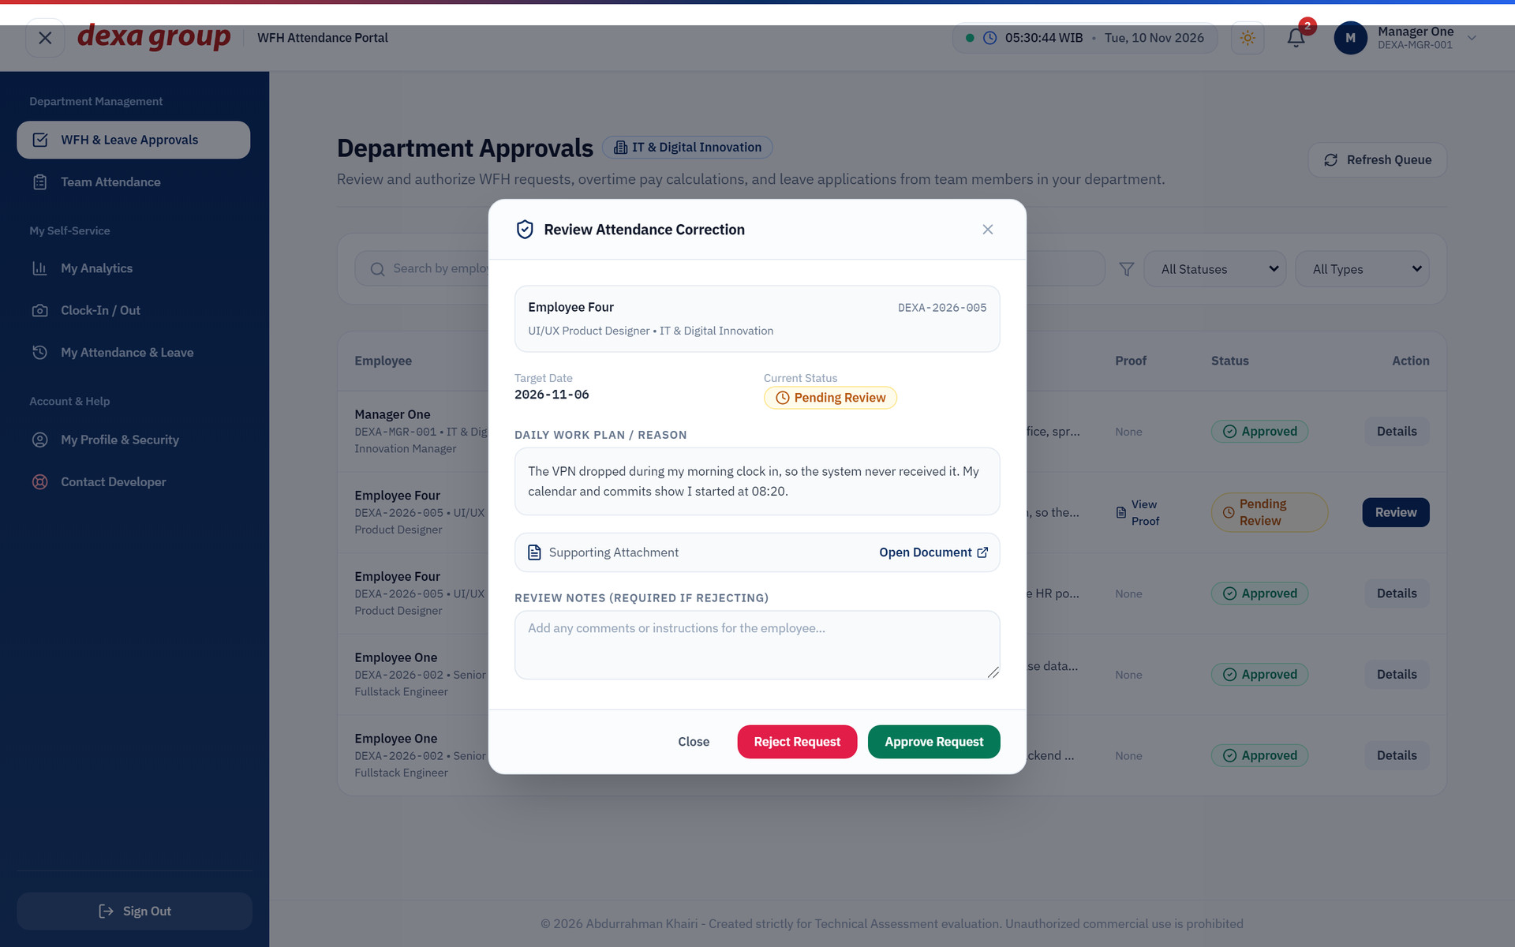
Figure 2.6: The email link opens the review window for that exact request.
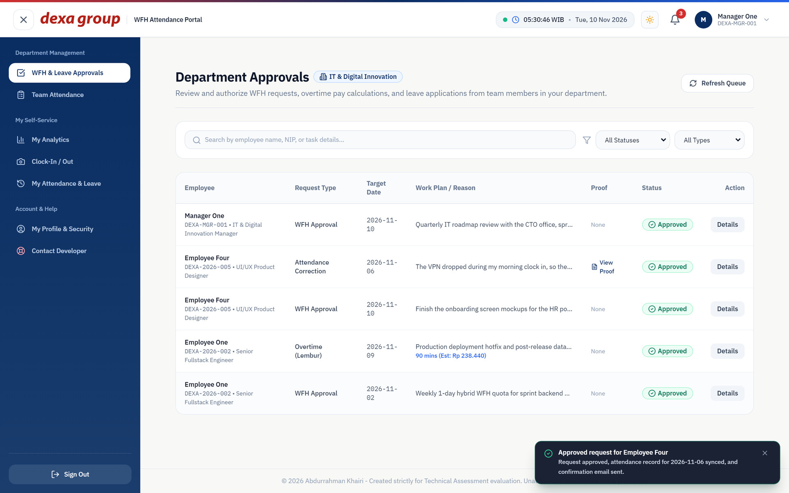
Figure 2.7: After approval, the request shows as approved and a green message confirms it.
The employee receives the decision by email, with copies to the manager and HR.
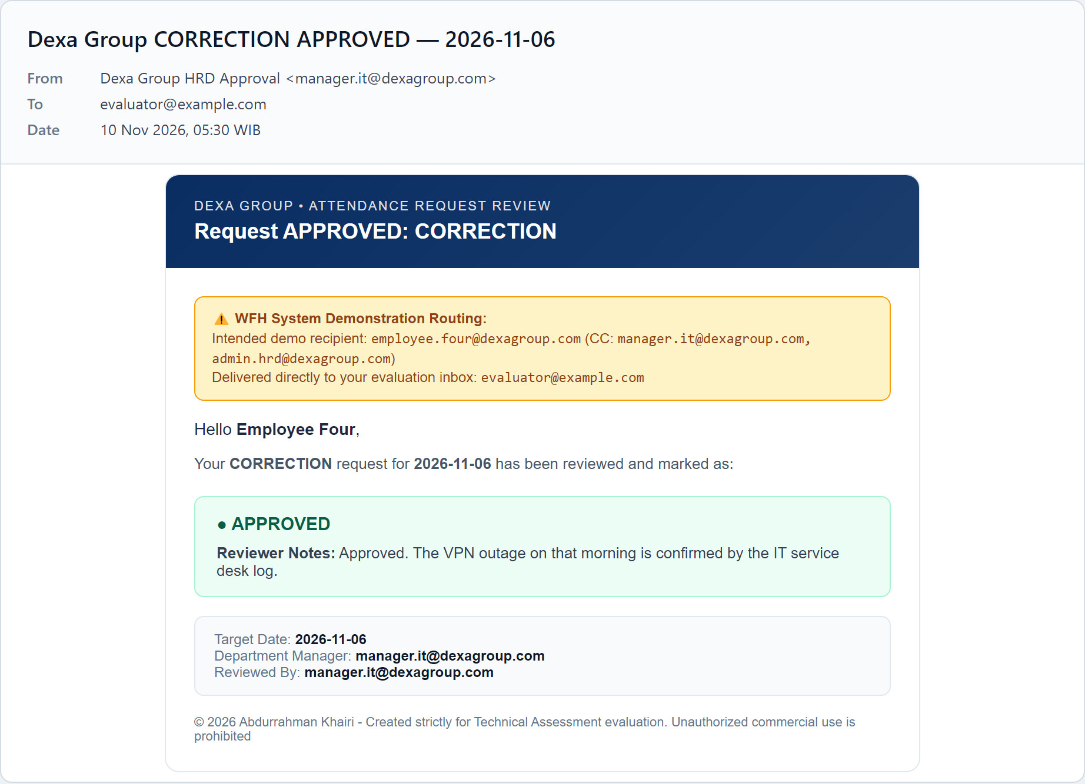
Figure 2.8: The decision email sent after the approval.
When you approve a time correction, the system writes the corrected times into the employee’s attendance record for that date and recalculates the status and duration. The employee can see the new record at once on their history page.
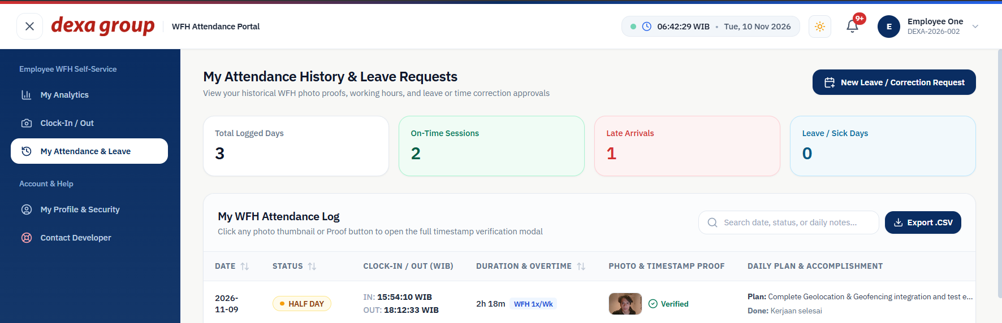
Figure 2.9: On the employee’s side, 6 November now has a completed session from 08:20 to 17:35, and the request is approved.

CHAPTER IV
HR ADMIN MANUAL GUIDE

HR admins see the HRD Dashboard, WFH & Leave Approvals, Attendance Audit & Export and Master Employees pages, as well as the normal employee pages for their own attendance.

Monitoring Attendance Across The Company
Sign in as admin.hrd@dexagroup.com.
The HRD Dashboard opens on today’s date. A yellow banner at the top counts the leave, correction and account requests waiting for HR, with buttons that jump to each list. Six cards show total active employees, people present today, on time arrivals, late clock ins, people on leave or sick, and how many photos passed the timestamp check. Below them you find a bar showing the mix of on time, late, leave and not yet clocked in, a breakdown per department, and a 7 day trend. Pick another date in the date box at the top to look back.
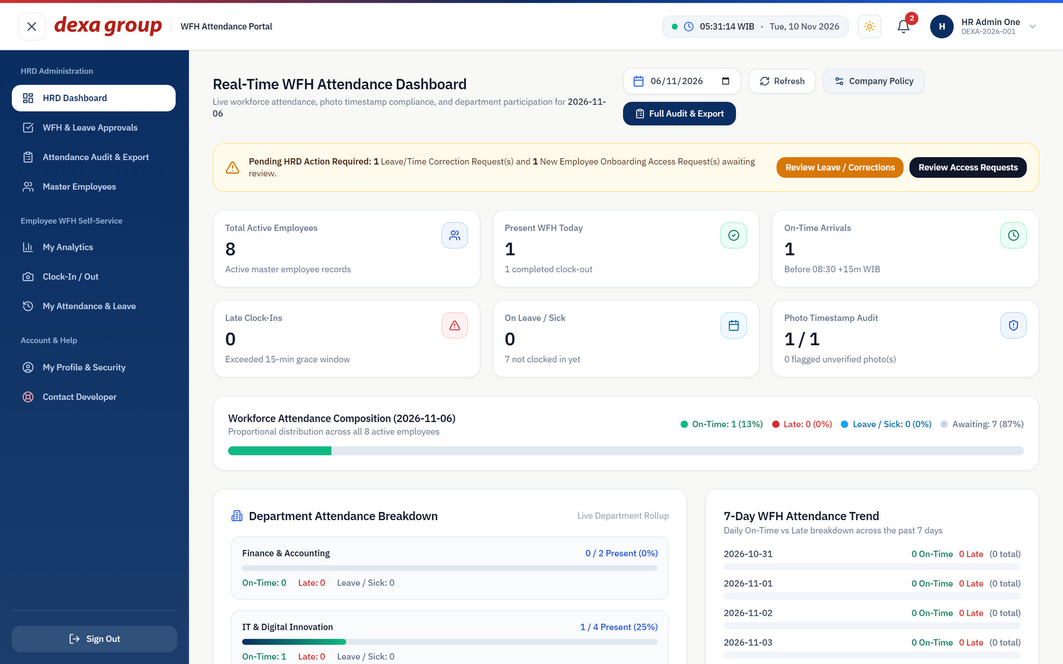
Figure 3.1: The HRD Dashboard.
Open Attendance Audit & Export for the full list of sessions. Use the filter bar at the top to choose a date range, a department, a status such as ON_TIME, LATE, HALF_DAY or COMPLETED, and whether to show only verified photos. Type a name or NIP in the search box above the table to find one person. Click Reset Filters to start over.
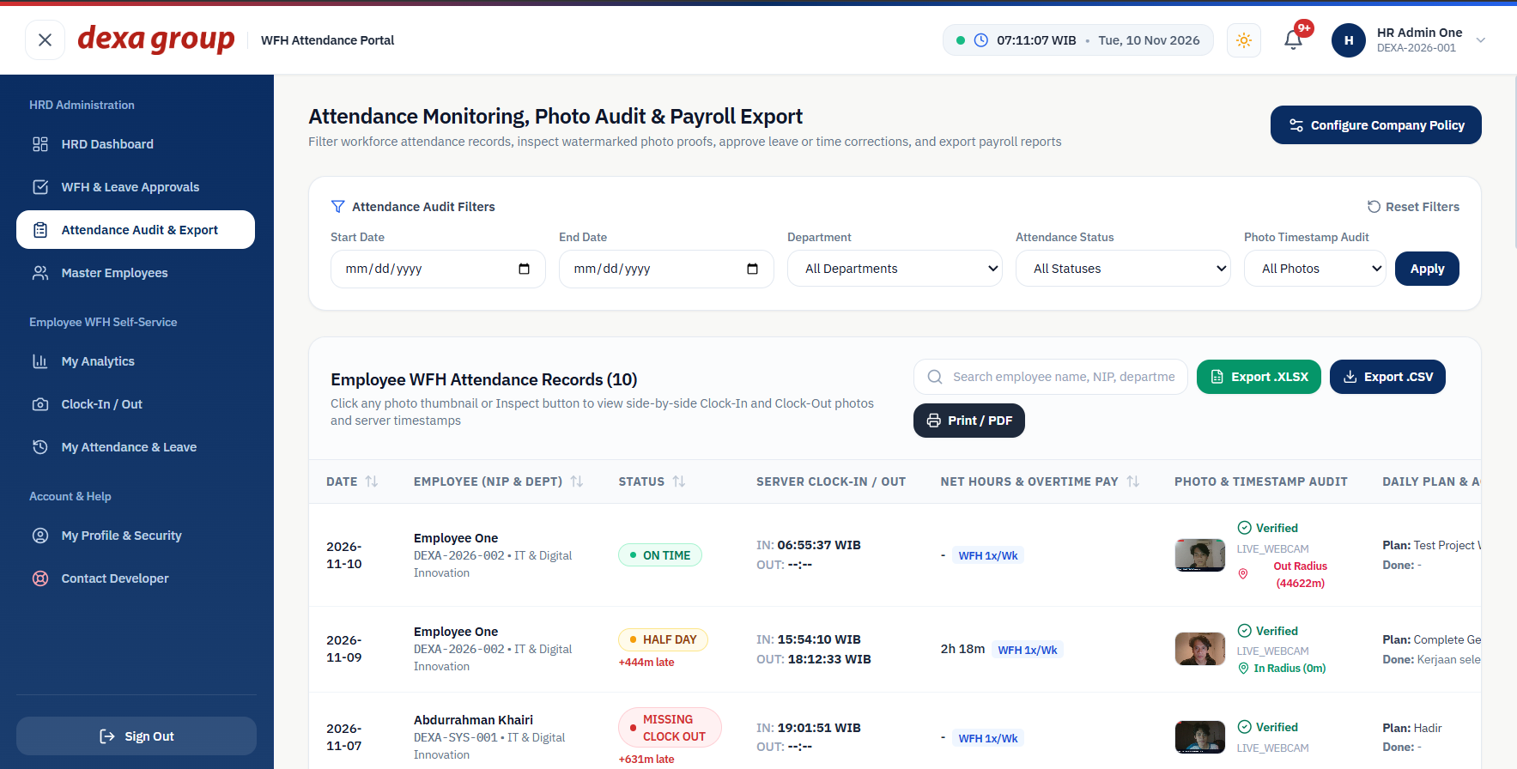
Figure 3.2: The attendance audit page before filtering.
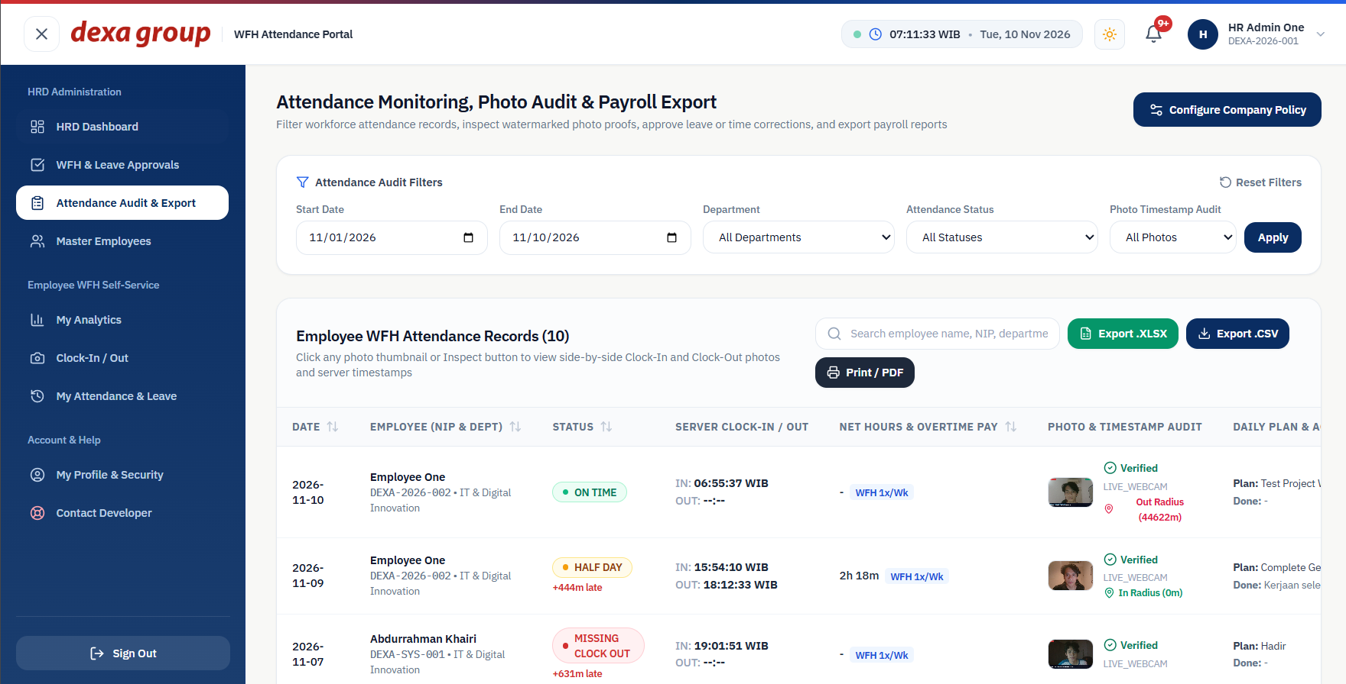
Figure 3.3: Filtered to 1 to 10 November and the IT department.

Checking a photo in the lightbox
Click a photo thumbnail or the Photo button in any row. A large window opens with the clock in and clock out photos side by side. Each photo shows the stamp burned in at capture time, the source (LIVE_WEBCAM or FILE_UPLOAD), the server clock in or clock out time, and the time the photo was taken. A green banner at the top tells you whether the photo time matched the server clock. Scroll down to read the morning work plan and the evening accomplishment summary. The face match score is not shown in this window.
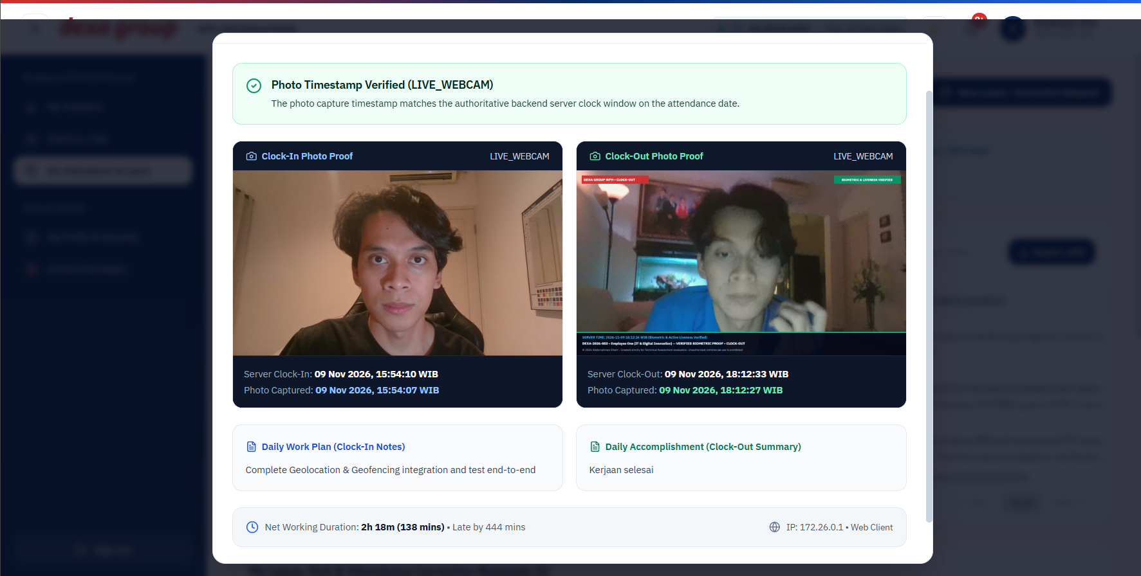
Figure 3.4: The photo lightbox with both proofs, the times and the verification banner.

Checking the Clock In Location
Each row in Attendance Audit & Export has a Map button, green when the clock in was inside the 100 meter home radius and red when it was outside. Click it to open the location window. It shows the clock in point, the clock out point and the registered home with its 100 meter circle on an OpenStreetMap map, plus the street address and the distance. The tabs switch between clock in, clock out and both together, and Open in Google Maps shows the same spot there.
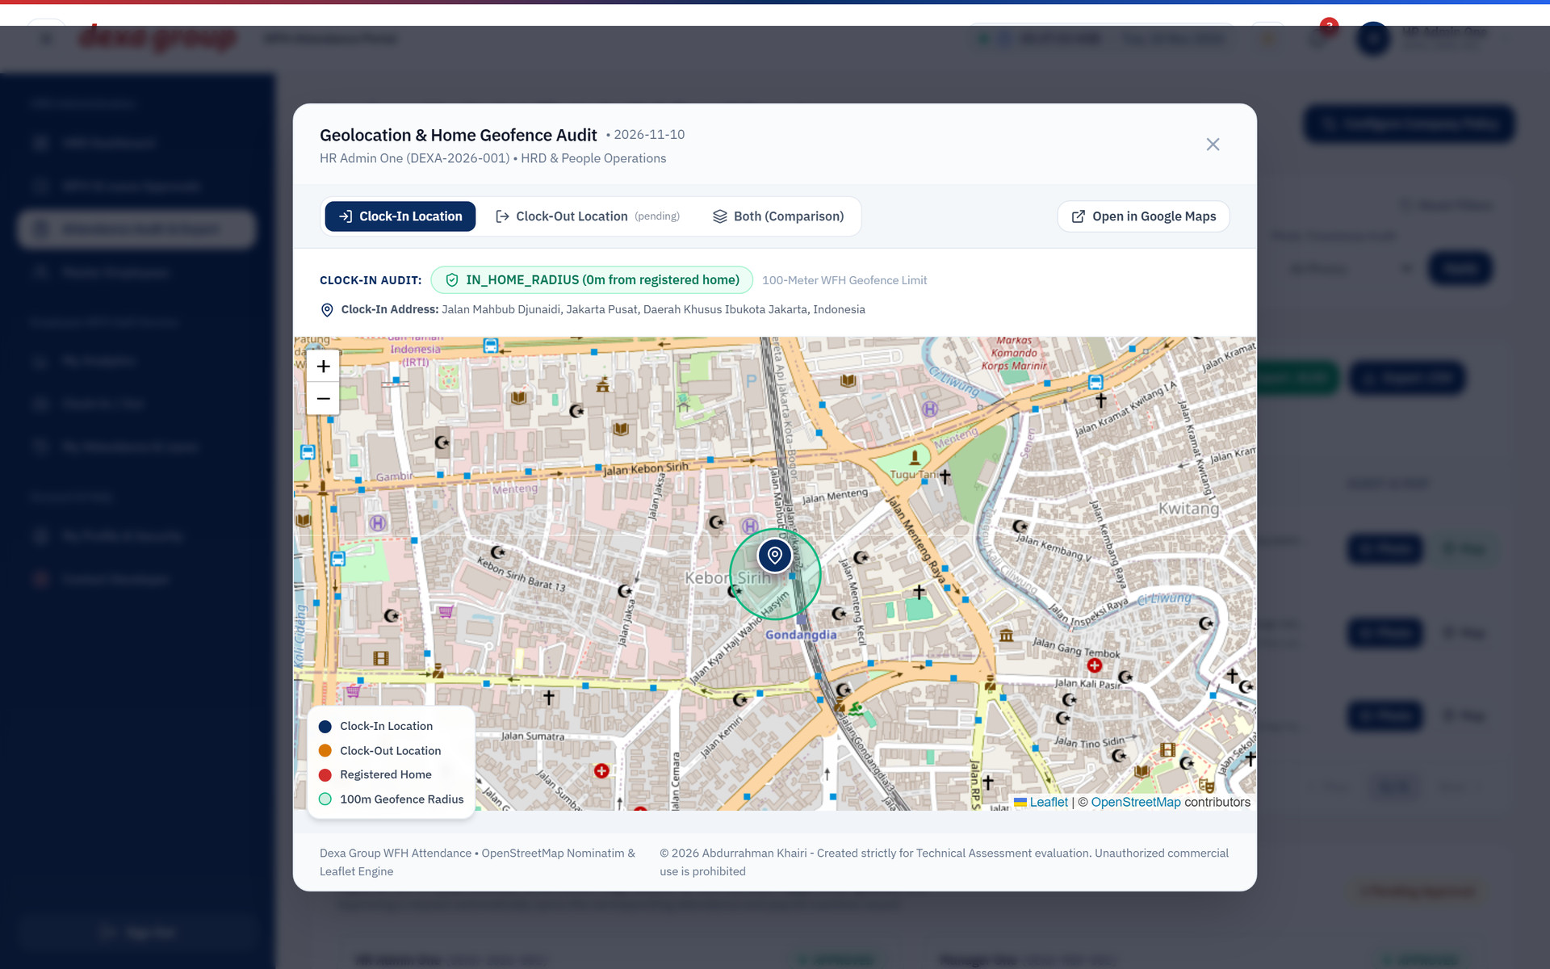
Figure 3.5: The location window for HR Admin One’s clock in: inside the 100 meter radius, 0 meters from the registered home.

Export Payroll and Audit Reports
The export buttons sit at the top right of the attendance table, and they use the filters you have set. Up to 5,000 rows are exported at a time.
- Export .XLSX downloads an Excel workbook with a header row, one row per session, and a copyright footer.
- Export .CSV downloads the same columns as plain text for other payroll software.
- Print / PDF opens the browser print window with a clean, print friendly layout. Choose Save as PDF there to get a PDF file.
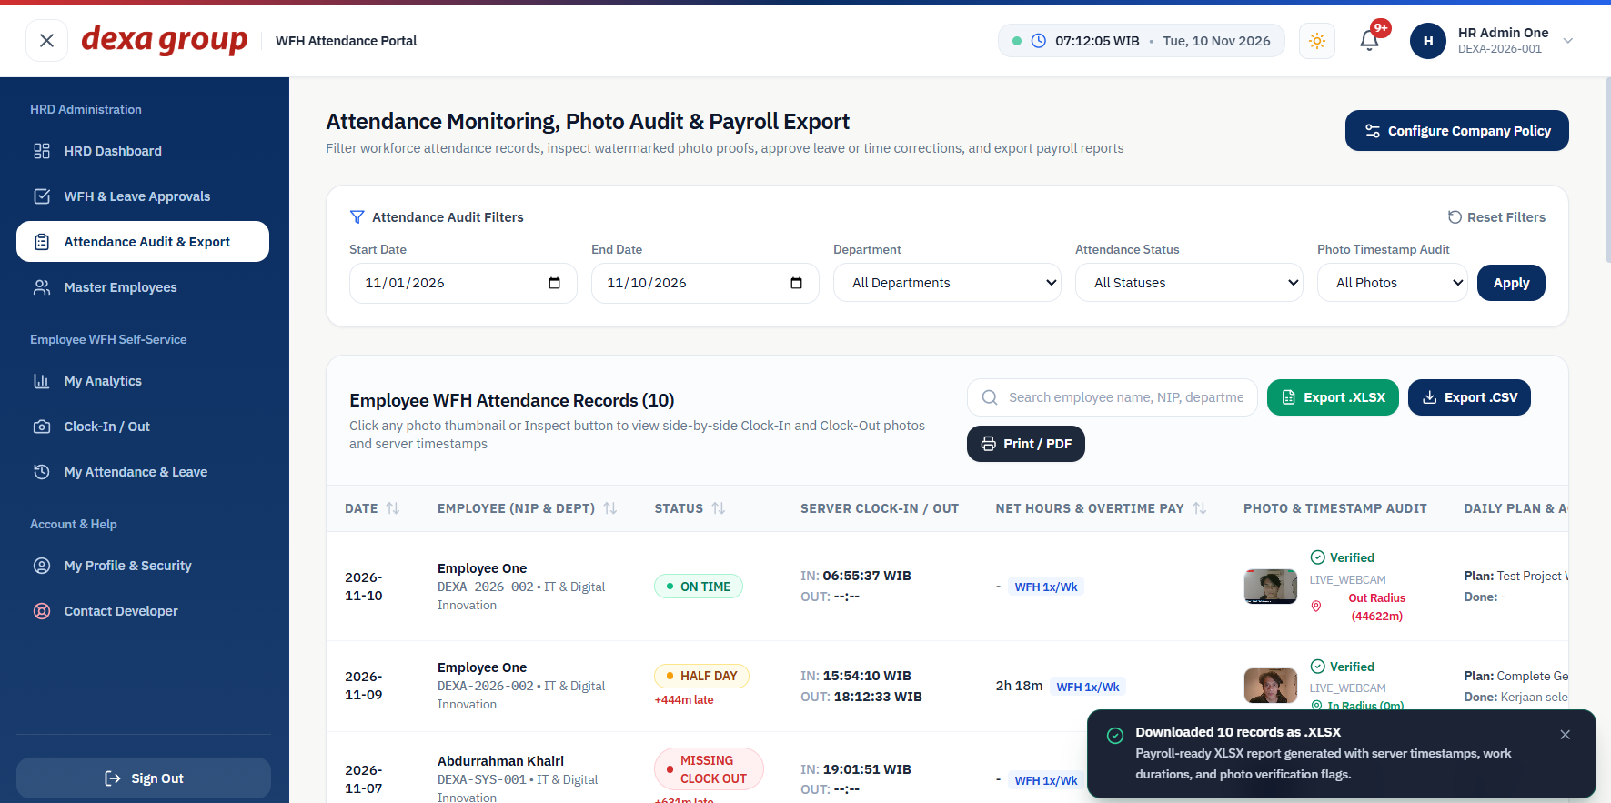
Figure 3.6: The Excel download is confirmed with a green message.
These are the columns of the downloaded file, with the first row of real data from this test:
Column | Example value
Date (WIB) | 2026-11-10
Employee NIP and Full Name | DEXA-2026-005, Employee Four
Department and Position | IT & Digital Innovation, UI/UX Product Designer
Base Salary (IDR) | 12500000
Clock In and Clock Out (WIB) | 2026-11-10 05:29:37 WIB and 2026-11-10 05:29:50 WIB
Duration (Mins) and Duration (Hrs) | 0 and -
Overtime (Mins), OT Multiplier (Hrs), Overtime Pay (IDR) | 0, 0, 0
WFH Approved | APPROVED (1x/Wk)
Late (Mins) and Status | 0 and HALF_DAY
Photo Source and Timestamp Verified | LIVE_WEBCAM and VERIFIED
Daily Plan and Daily Accomplishment | The two notes written by the employee

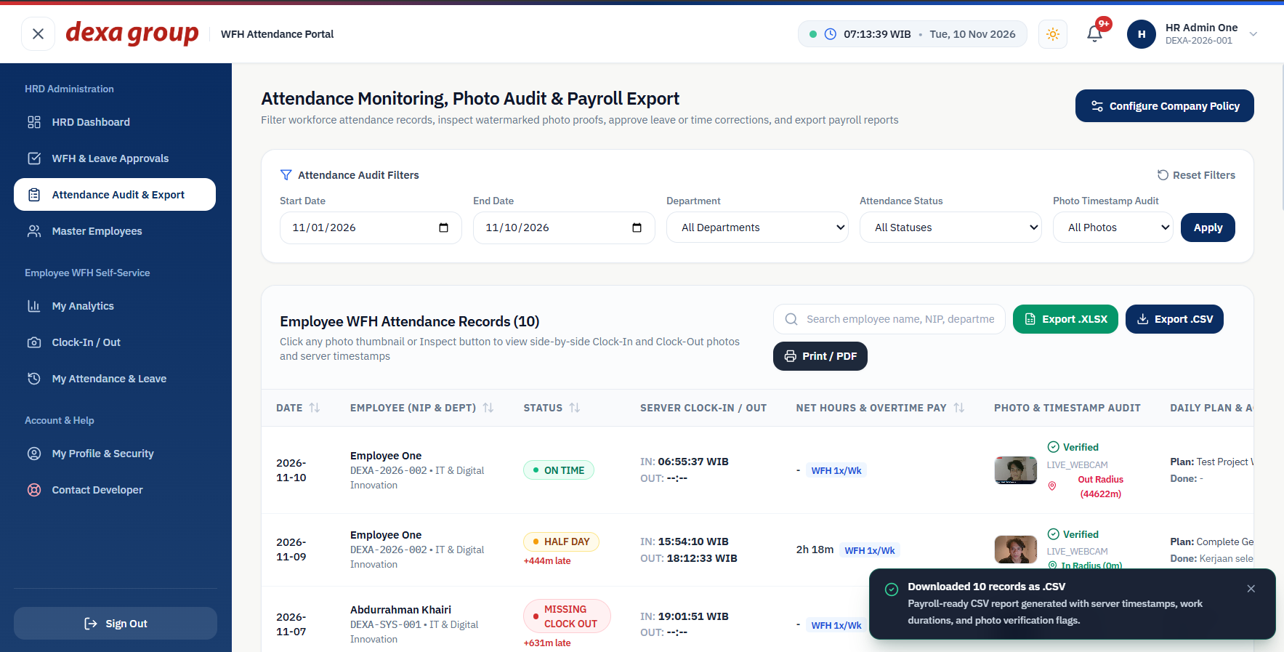
Figure 3.7: The CSV download is confirmed the same way.
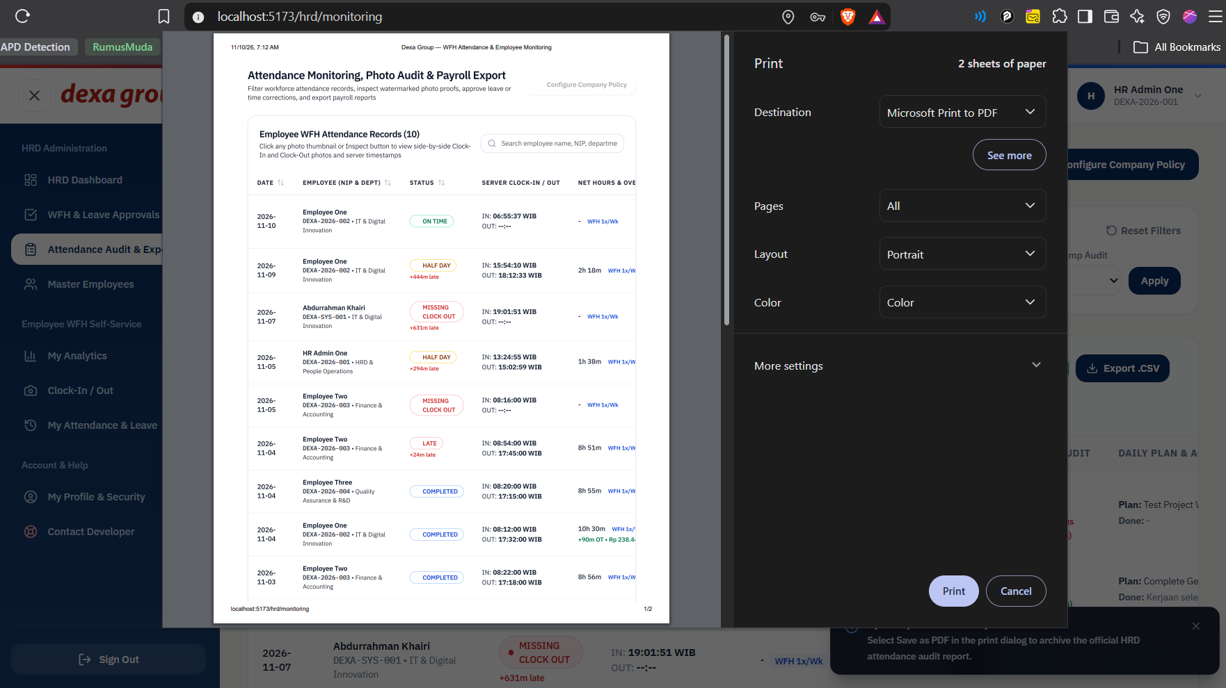
Figure 3.8: The print layout. The menus are hidden so only the report is printed.

Manage The Employee Directory
Open Master Employees.
The table lists everyone with their NIP, department, position, monthly salary, hourly overtime rate, role and status. Use the search box to find someone, and tick Show Inactive to include deactivated people.
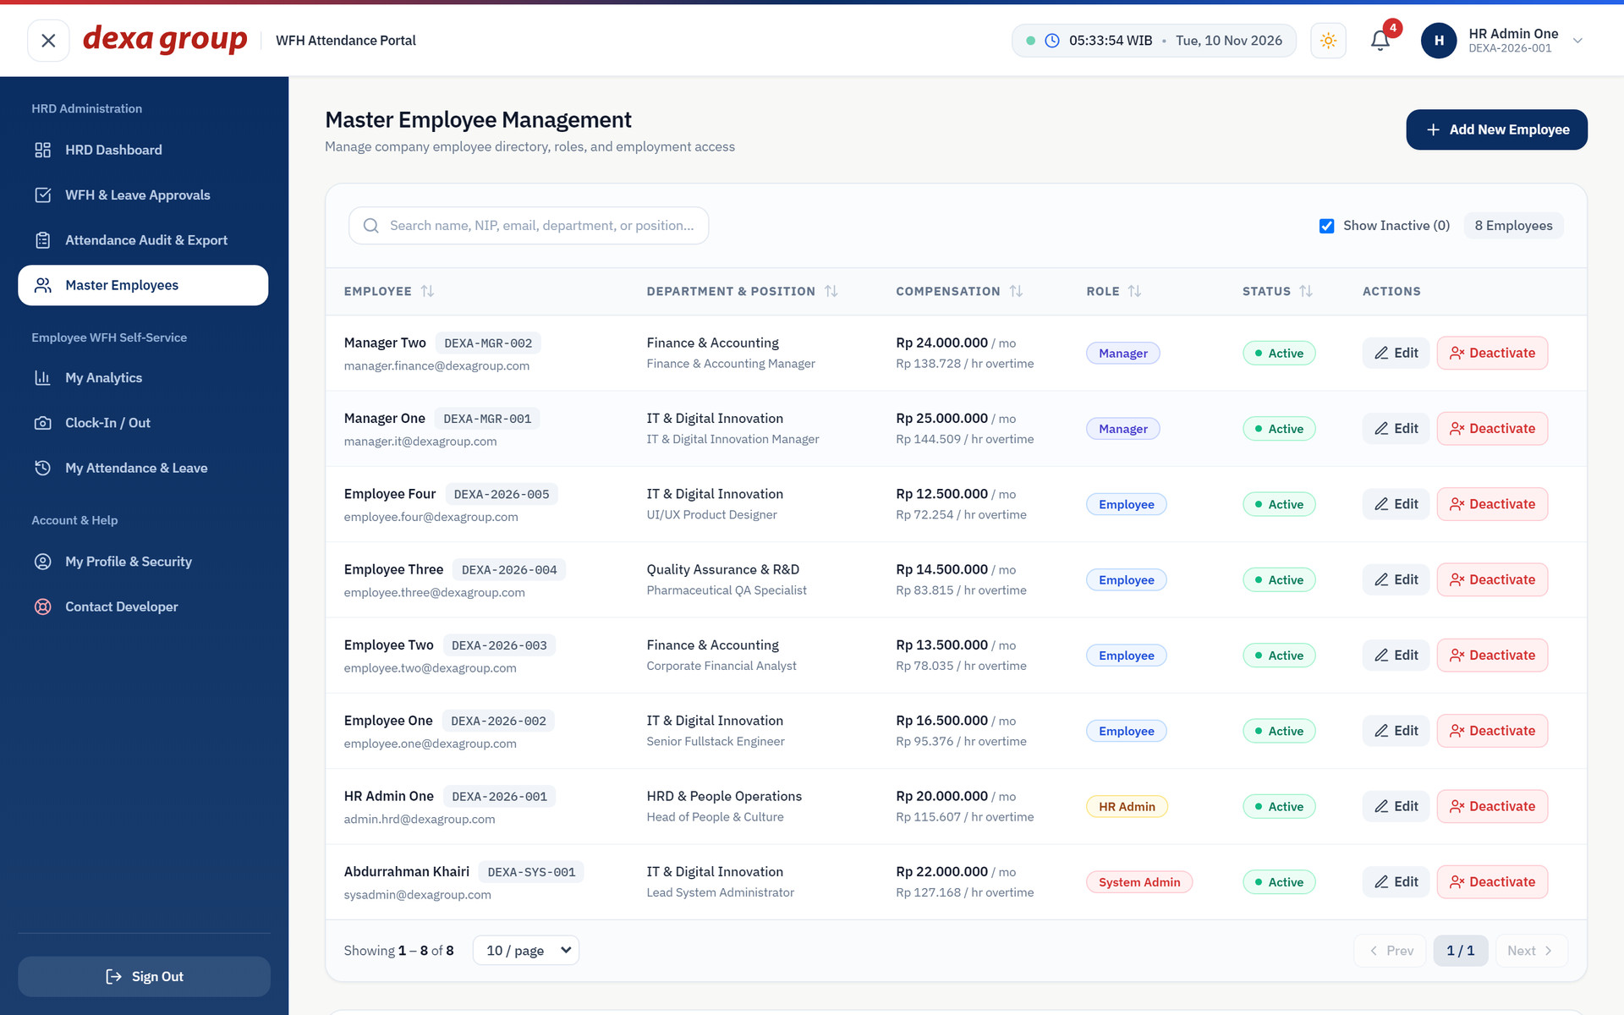
- Figure 3.9: The Master Employees table.
- Click Add New Employee.
- Fill in the full name, email and NIP. The NIP is required and must be unique. The form will not save without it.
- Choose the role (Employee, HR Admin or System Admin), then type the department, position, phone number, join date and base salary.
- Leave the password empty to use the default EmployeeDexa2026!, or type a starting password.
- Save. The new person receives a 6 digit verification code by email, the same way as in Chapter II.
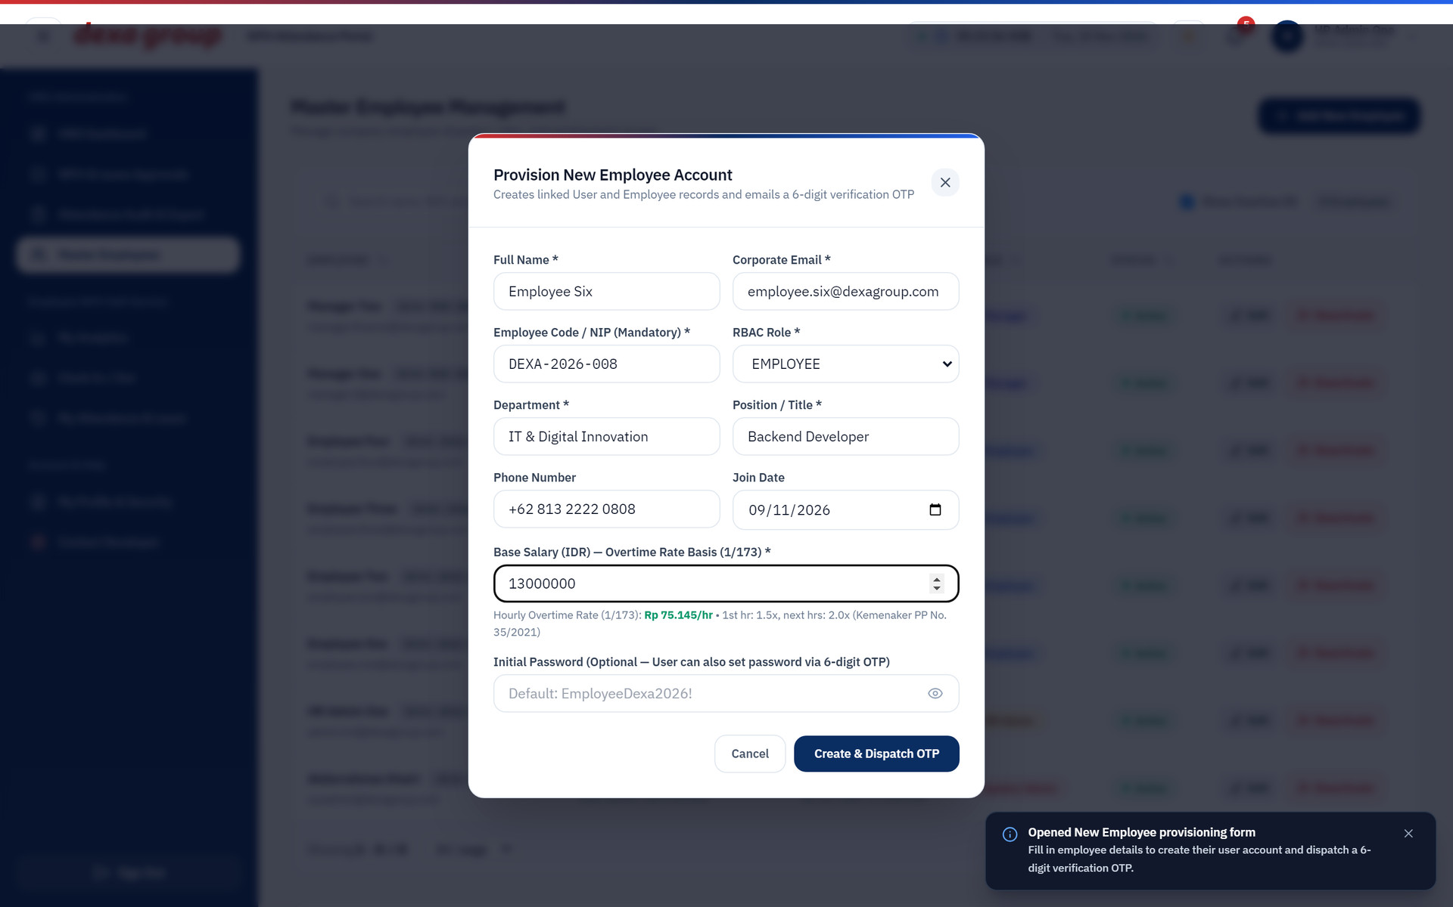
Figure 3.10: The Add New Employee form with the required NIP field.
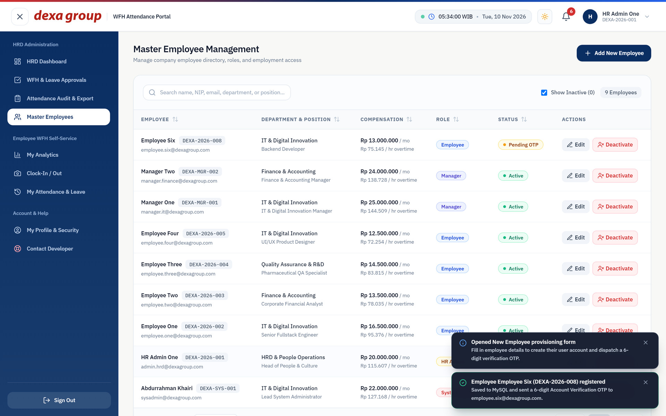
Figure 3.11: Employee Six appears in the table with a Pending OTP status.
To change someone’s details, click Edit on their row, update the fields, and save. Here the position of Employee Three was updated.
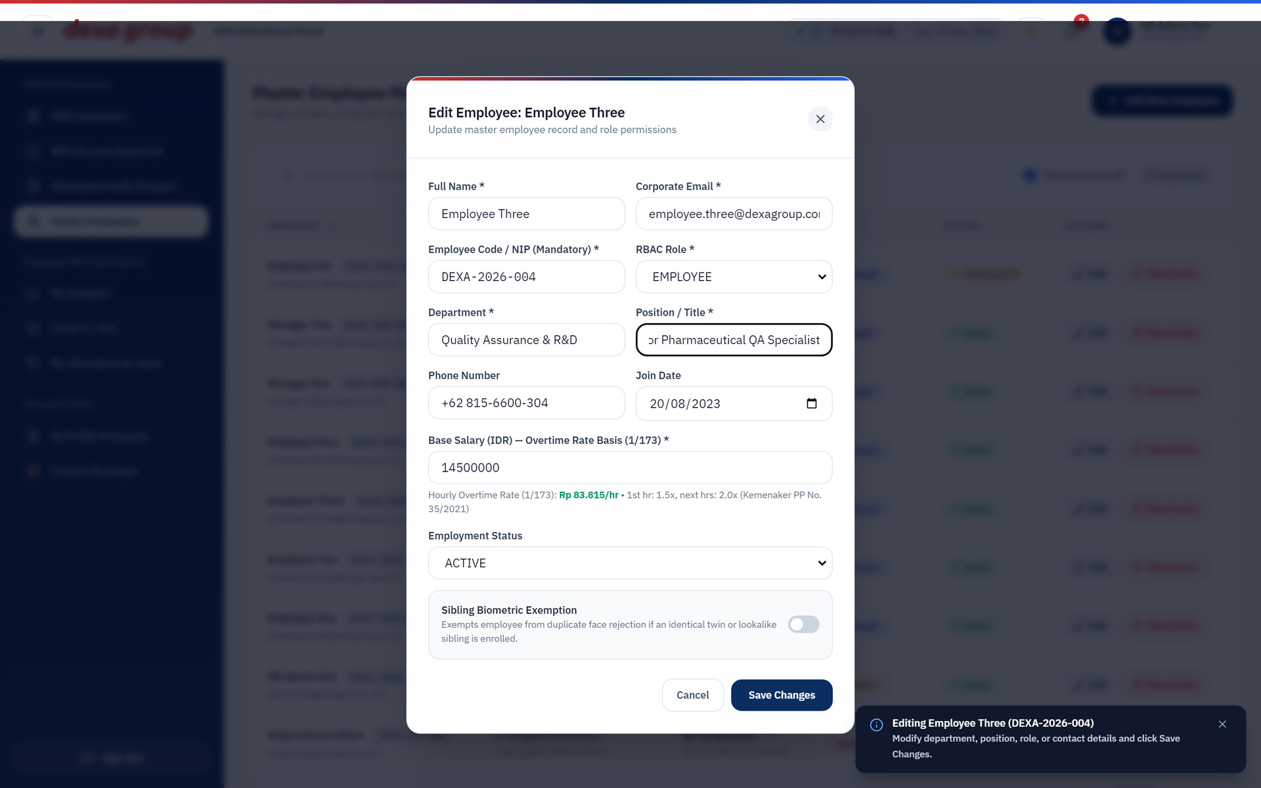
Figure 3.12: Editing an employee’s position.

Sibling Biometric Exemption
When two employees are siblings or twins, the second one cannot register a face that is between 50 and 90 percent similar to the first (Chapter II). HR can allow it after checking the relation.
- Click Edit on the row of the employee whose registration was refused.
- Switch on Sibling Biometric Exemption near the bottom of the form. The change is saved at once, and the form shows who approved it.
- Close the form. The row now carries a small blue badge, and the employee can register the face again.
- Switch it off again if the exemption is no longer needed. It never allows a face that is 90 percent or more similar.
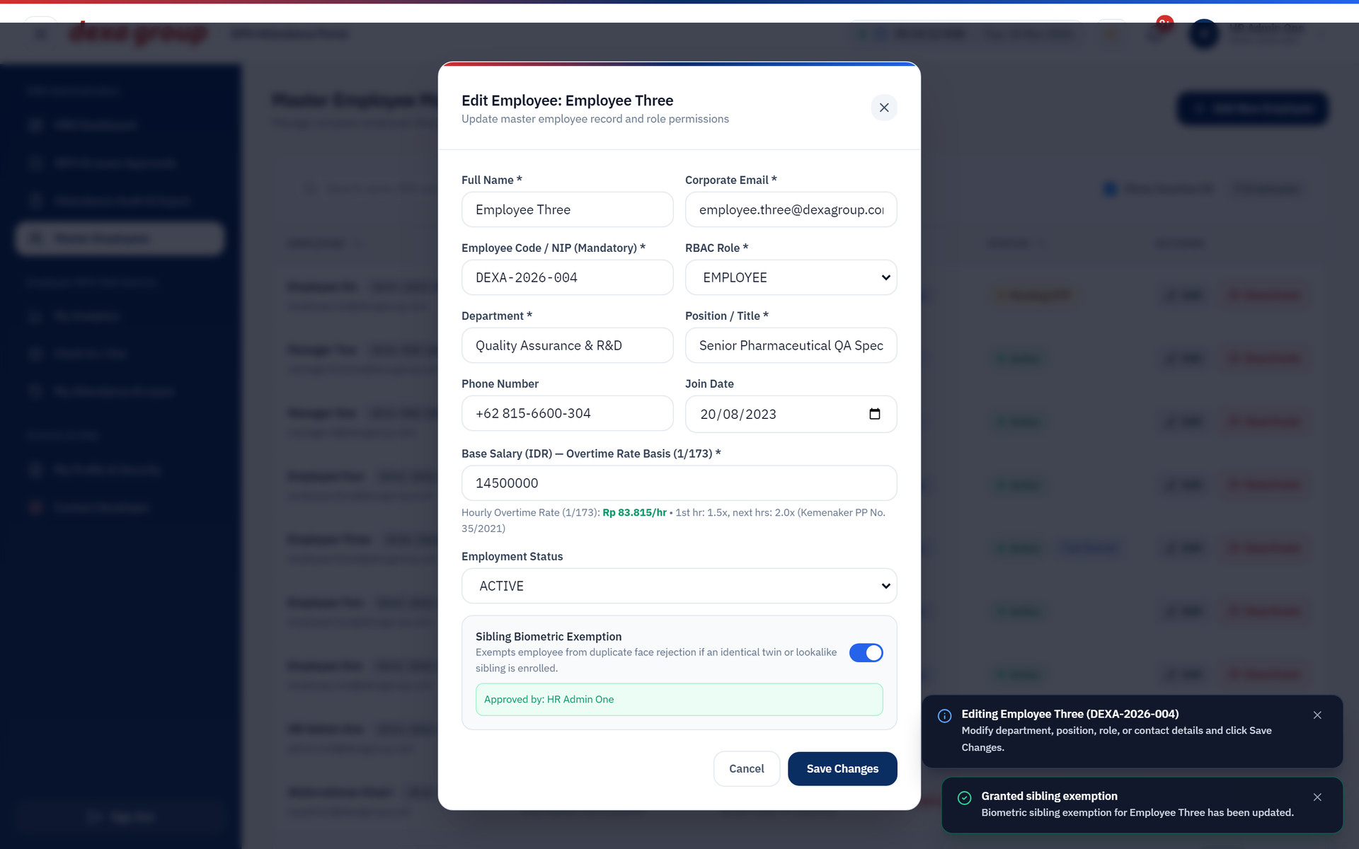
Figure 3.13: The exemption switched on for Employee Three, with the name of the approver.
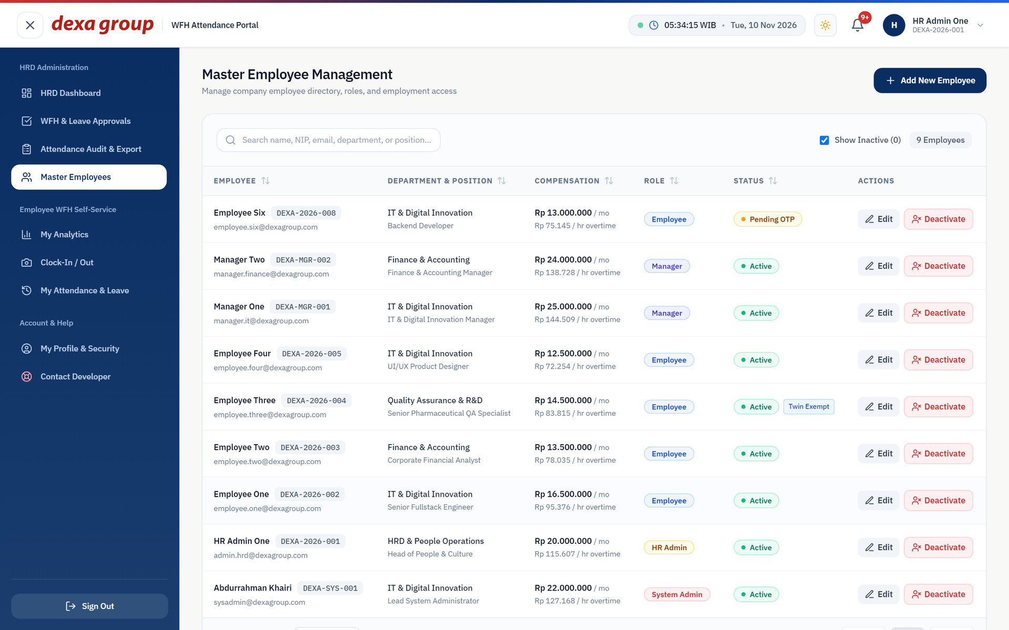
Figure 3.14: The exemption badge on Employee Three’s row.

Deactivating and restoring an employee
Click Deactivate on a row to remove a person’s access.
The record is not erased. The system marks it inactive and stores the date, so all past attendance and payroll history stays in place. The person can no longer sign in.
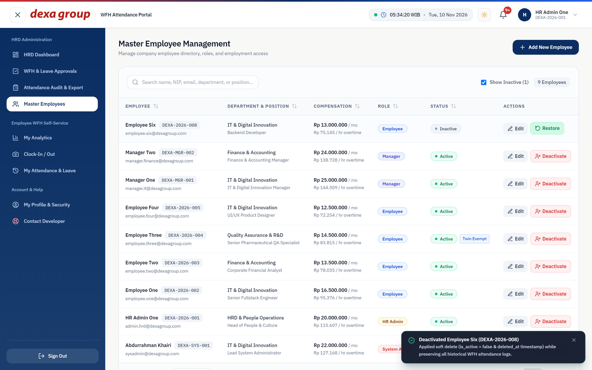
Figure 3.15: Employee Six is now Inactive and has a Restore button.
To bring the person back, tick Show Inactive if needed and click Restore. Their access returns with all history intact.
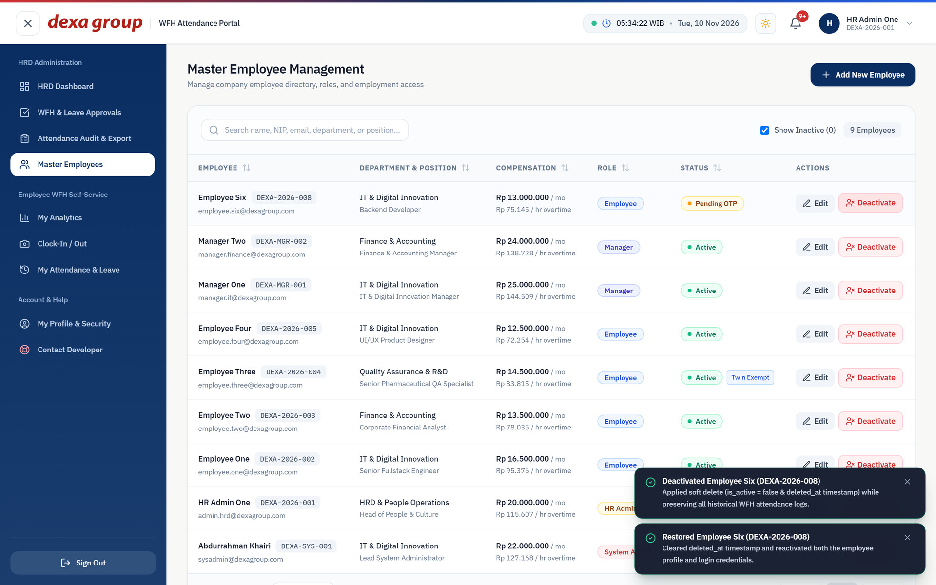
Figure 3.16: Employee Six is active again.

Reviewing Account Requests and Leave Requests
Requests for new accounts (see Chapter I) appear at the bottom of Master Employees under Employee Onboarding Access Requests.
Each card shows the person’s details and note, with Reject and Approve & Send 6 Digit OTP buttons.
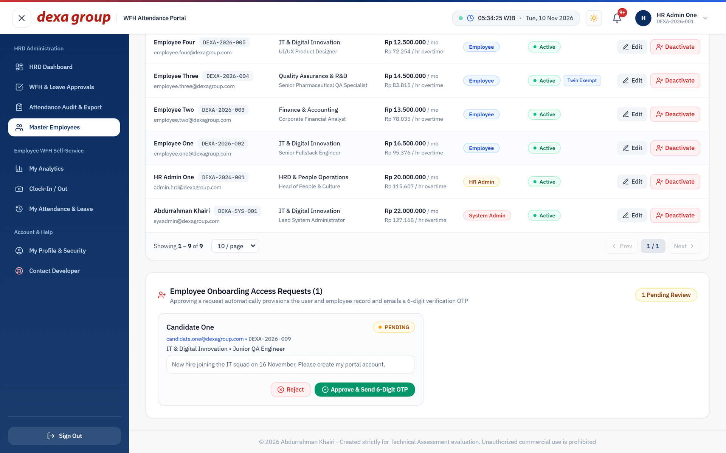
Figure 3.17: A pending account request from Candidate One.
Warning: Known issue in this build
Clicking Approve or Reject on an account request currently shows a Request failed message, and the request stays pending. The page calls a server address that does not exist. Until this is fixed, create the person with Add New Employee instead.

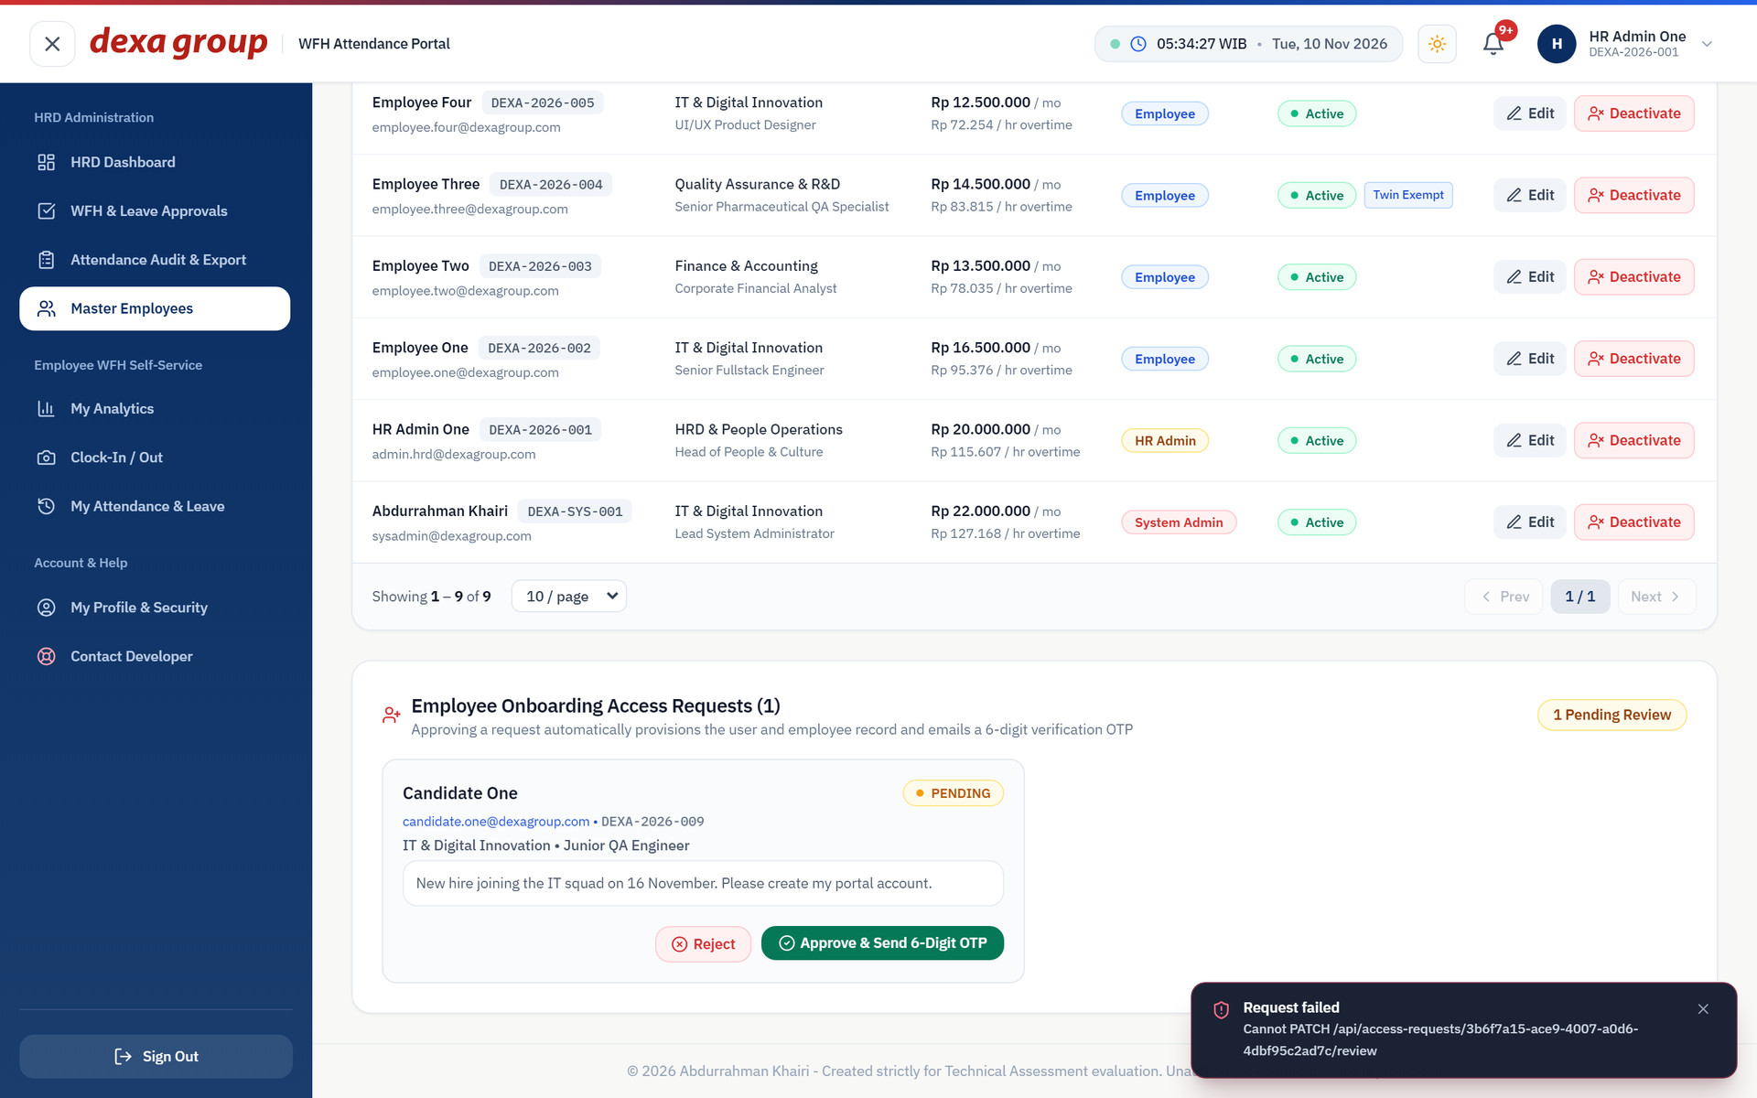
Figure 3.18: The Request failed message after clicking approve.
Leave, sick, overtime, correction and WFH requests from every department appear in the approval queue at the bottom of Attendance Audit & Export. HR can approve any of them with Approve & Sync Attendance, which also updates the attendance record and the overtime pay.
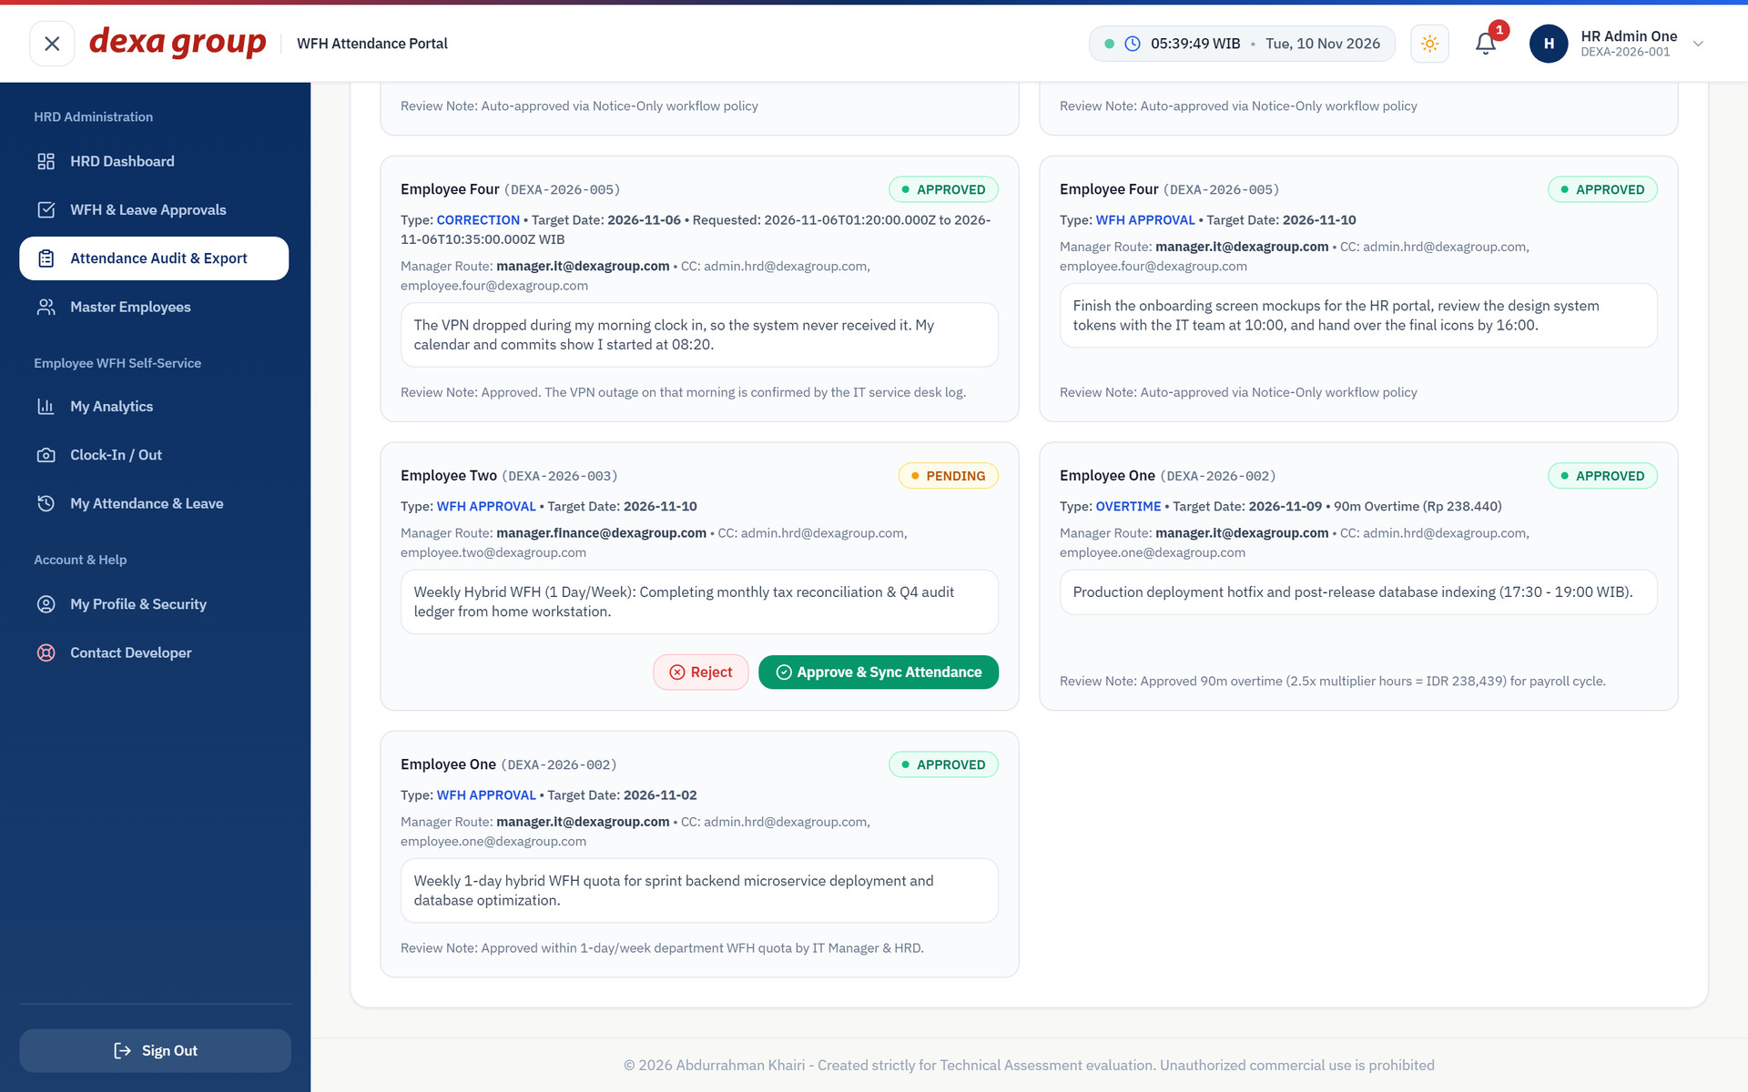
Figure 3.19: The company approval queue, with one pending WFH request from the Finance department.
The same requests also appear on WFH & Leave Approvals in the left menu. For HR the page is titled Company Wide Review and lists every department. HR opens a request there and approves or rejects it in the same window a manager uses (Chapter III).
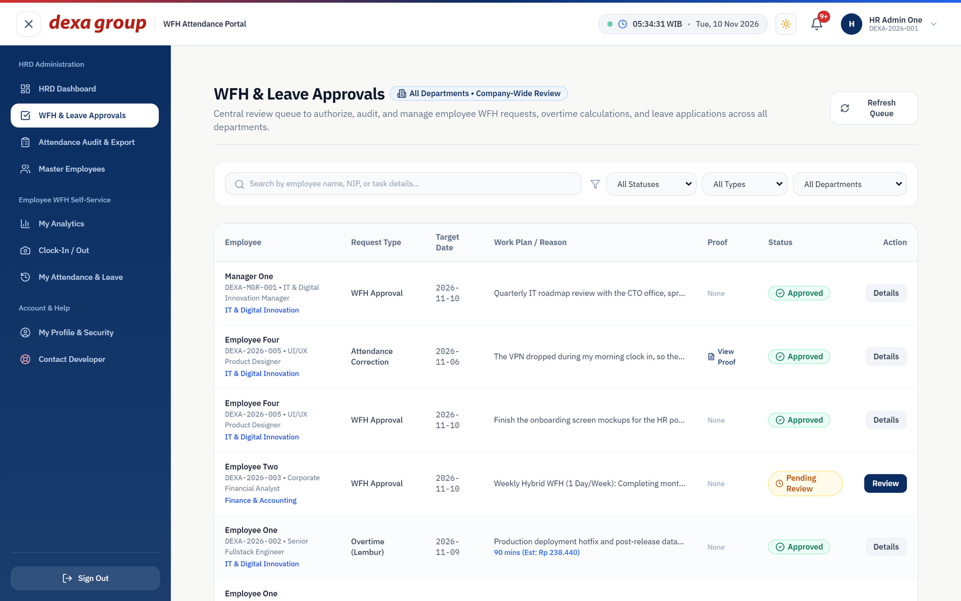
Figure 3.20: WFH & Leave Approvals for HR, with requests from every department.

CHAPTER V
SYSTEM ADMIN MANUAL GUIDE

Sign-In Sytem Admin
Sign in as sysadmin@dexagroup.com.
The portal opens Database Management. The left menu holds Database Management, HRD Dashboard, WFH & Leave Approvals, Attendance Audit & Export and Master Employees, plus your profile and Contact Developer.
The System Admin has no Clock In / Out, My Analytics or WFH notice pages, and is never asked to register a face. This is on purpose: the person who runs the system and the database does not record their own attendance in it. Keeping the two jobs apart means nobody can quietly adjust their own records.
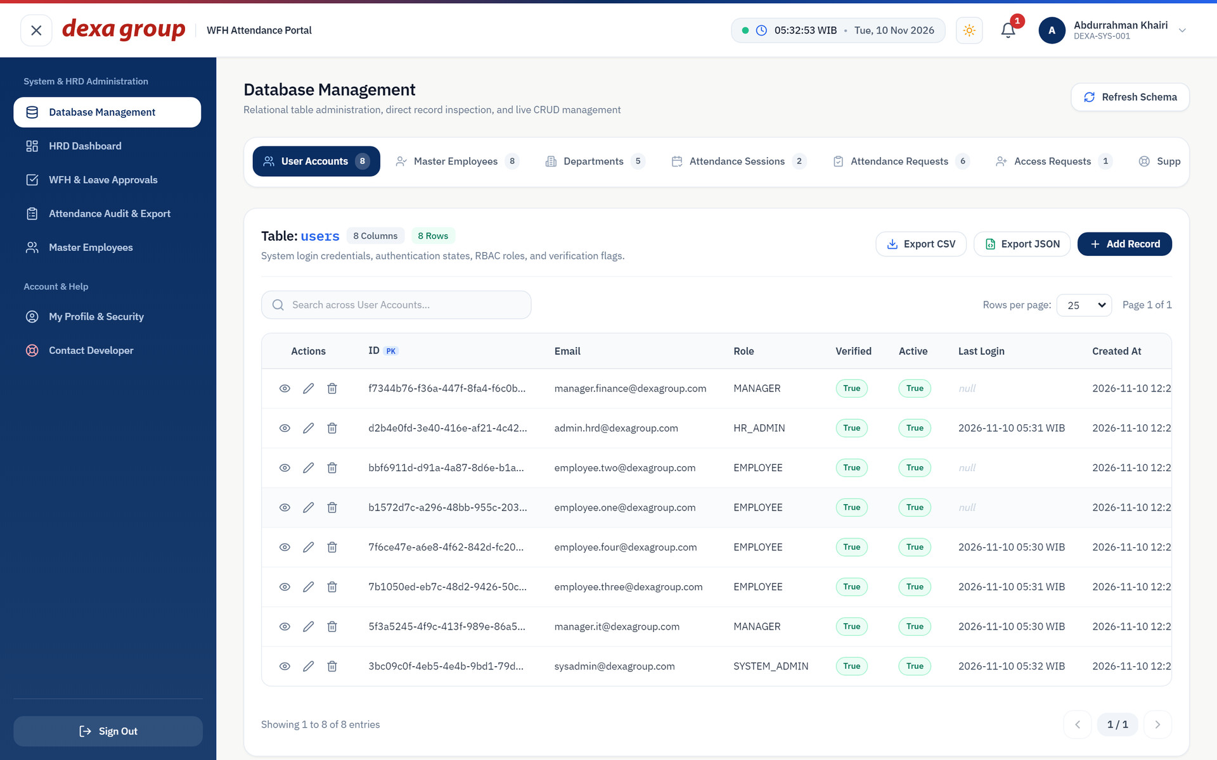
Figure 4.1: The System Admin layout with Database Management open.

Database Management
The tabs across the top list the nine tables the portal uses, each with its live row count: User Accounts, Master Employees, Departments, Attendance Sessions, Attendance Requests, Access Requests, Support Tickets, System Settings and OTP Security Codes. Click a tab to open that table.
The page shows how many columns and rows it has, a search box, and the rows themselves with paging. Storage size figures are not shown.
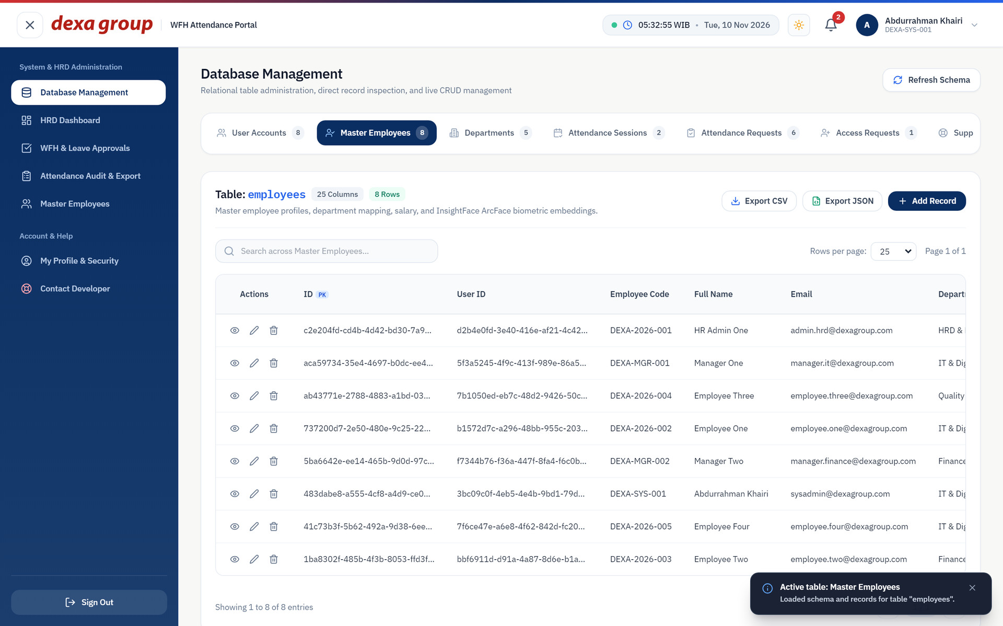
Figure 4.2: The employees table opened in Database Management.
Each row has three buttons: an eye to inspect the full record, a pencil to edit it, and a bin to delete it. Export CSV and Export JSON download the table, Add Record creates a new row, and Refresh Schema reloads the table list.
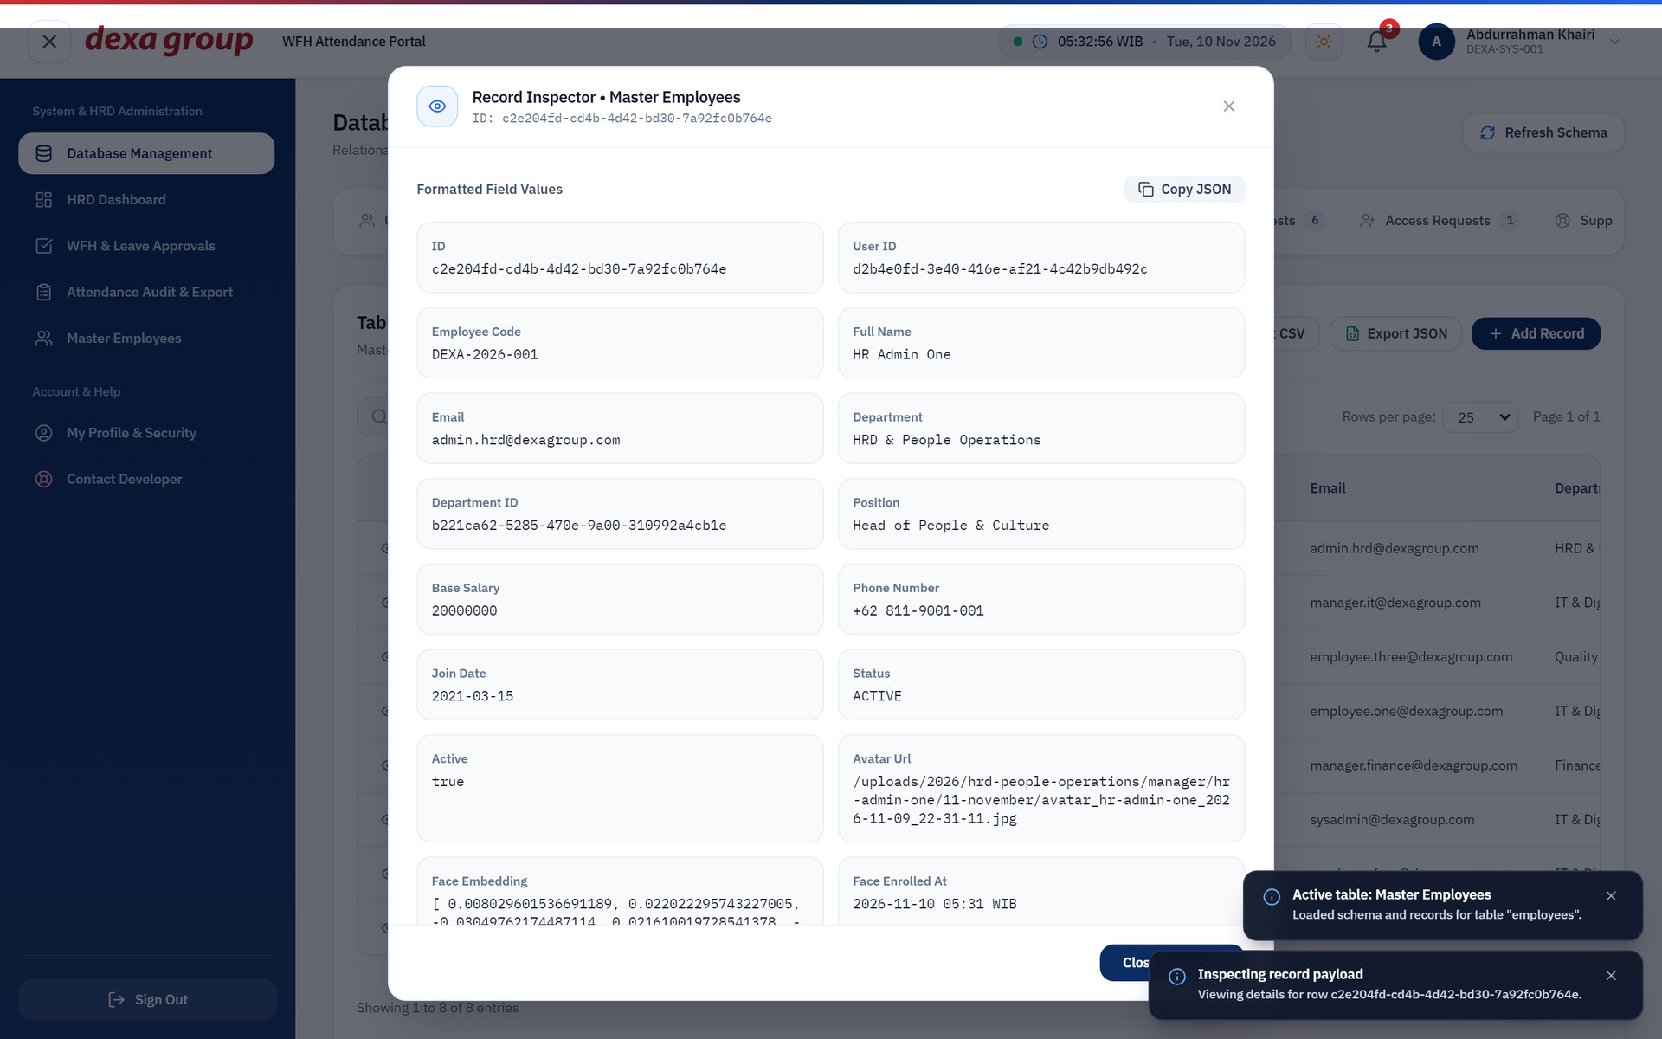
Figure 4.3: Inspecting one full employee record.

Editing records
There is no free text SQL window in this build. All changes go through the record form, which shows every column as a labelled field and marks required fields with a star. Close the form with the cross if you only wanted to look. Treat this screen with care: a change here skips the normal business rules, and a delete cannot be undone.
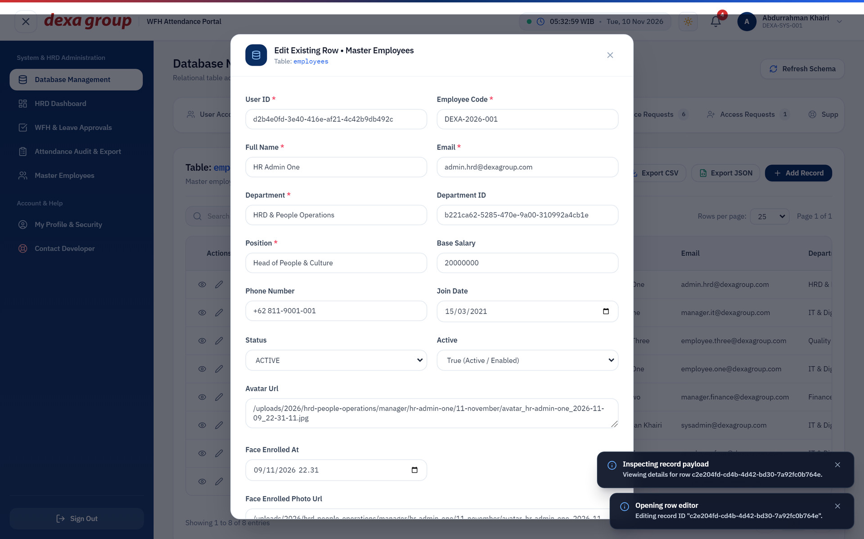
Figure 4.4: The edit form for an employee record.

Company policy, users and support tickets
Open HRD Dashboard and click Company Policy to set three rules for the whole company:
- WFH mode: Strict Approval, where the manager approves first, or Notice Only, where sending the notice unlocks clock in.
- Overtime pay: on or off.
- The number of WFH days allowed per week.
Click Save Company Policy. The change applies at once. The screenshots in Chapter II were taken after switching to Notice Only here.
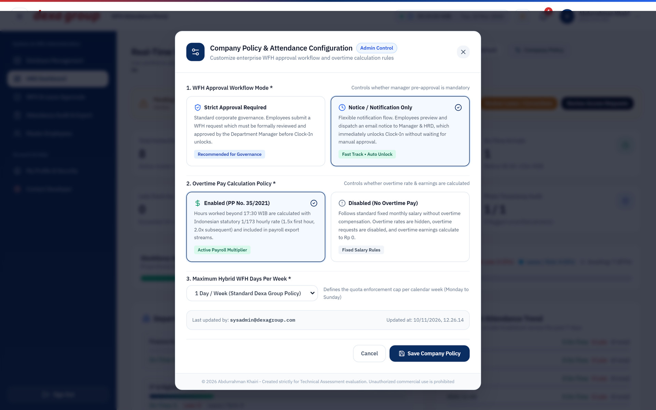
Figure 4.5: The Company Policy window with Notice Only selected.
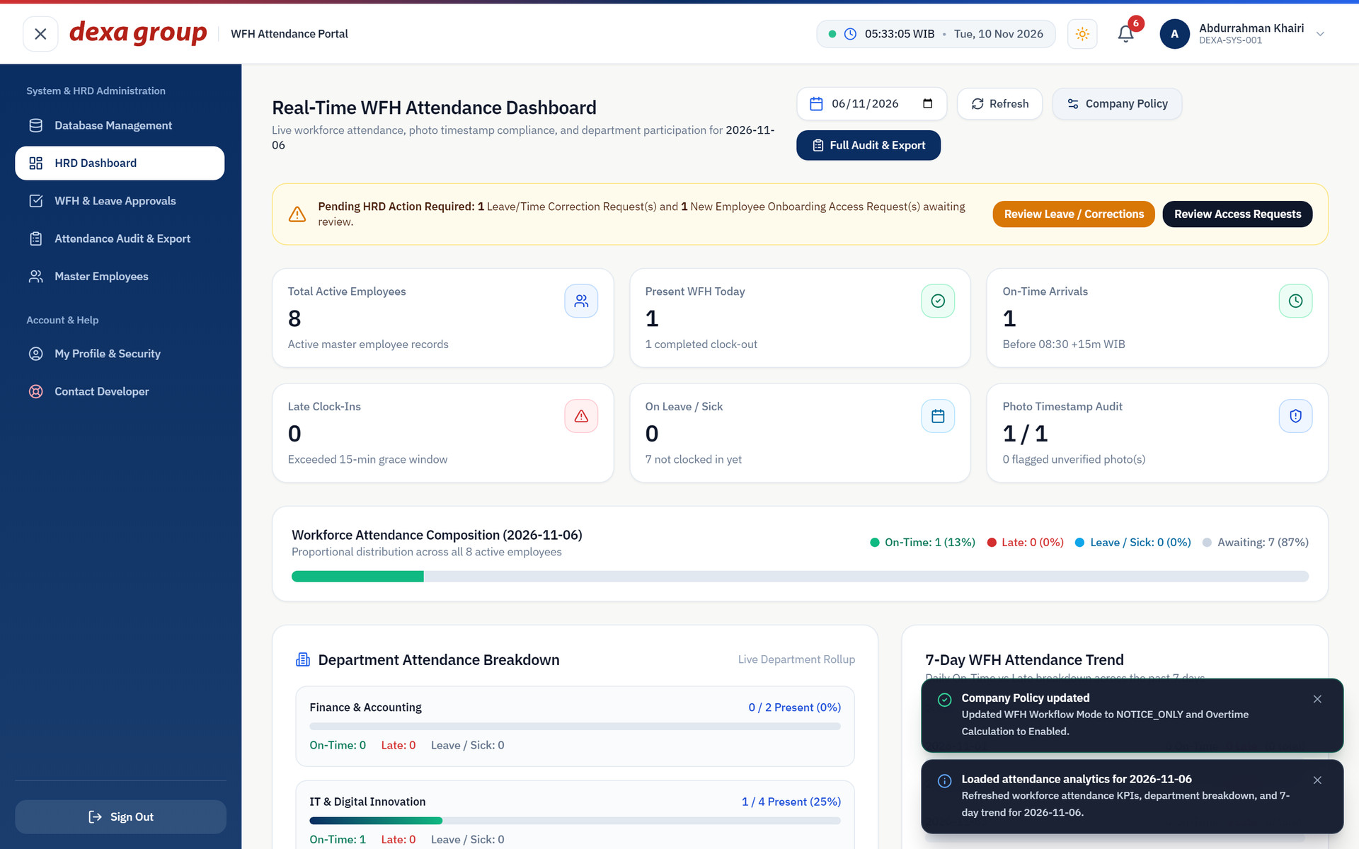
Figure 4.6: The policy is saved and confirmed.
The System Admin can also use Master Employees like HR to add, edit, deactivate and restore people, and can give someone the HR Admin or System Admin role there.
Support tickets are addressed to you. Open Contact Developer and choose the All Support Tickets (Admin) tab to see every ticket, its sender and its status, and mark tickets resolved. The same tickets arrive in your email inbox.
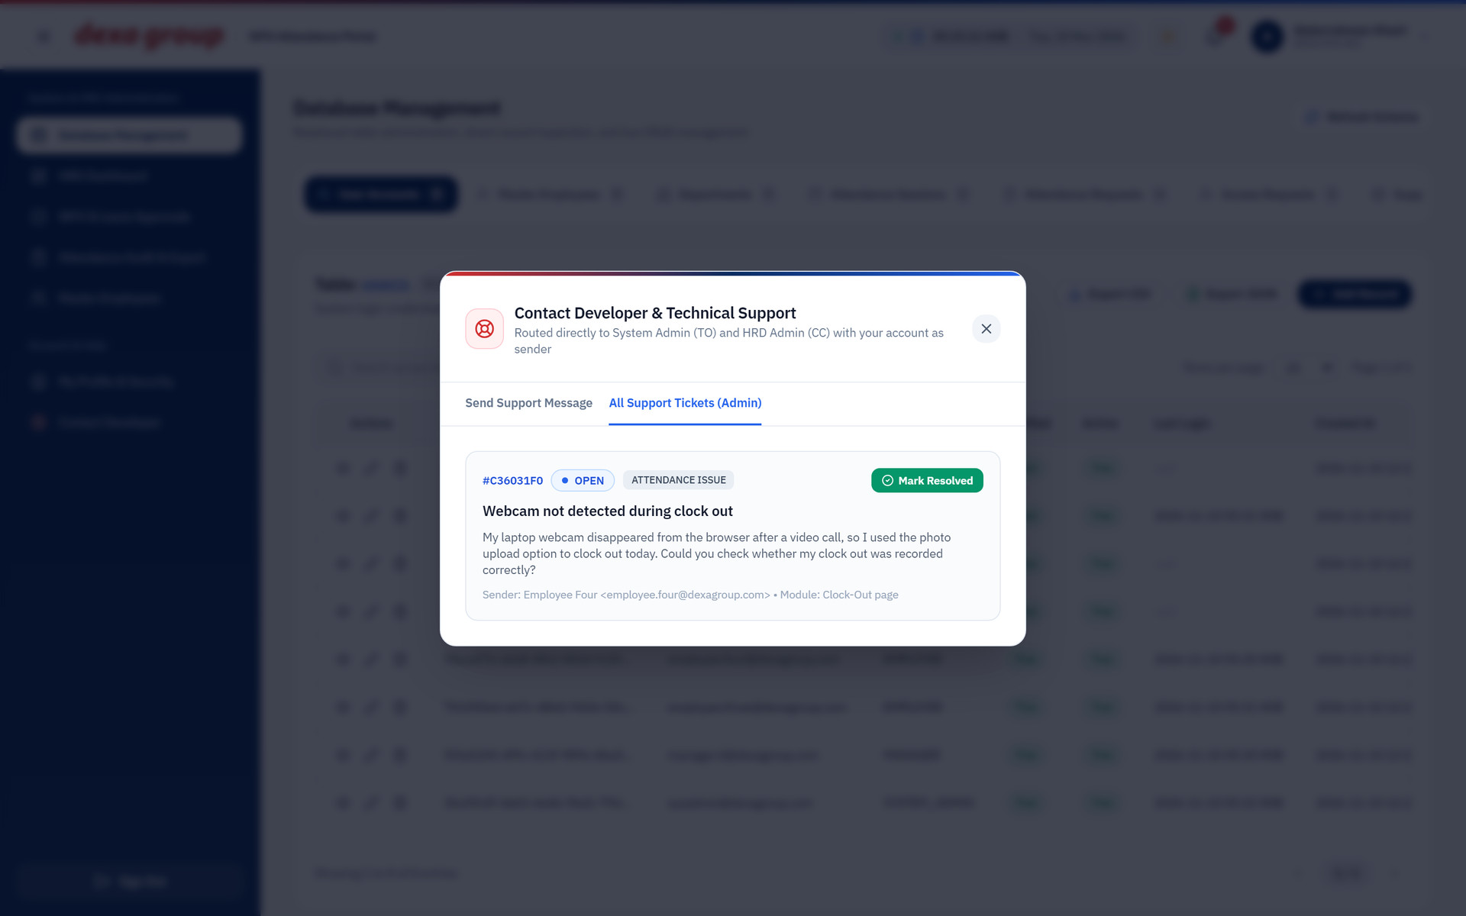
Figure 4.7: The support ticket list for the System Admin.

CHAPTER VI
PRACTICAL TROUBLESHOOTING

The browser blocks the camera
- Open the portal at http://localhost:5173 exactly. Browsers block the camera on plain network addresses such as an IP number.
- Click the camera or lock icon at the left of the address bar, set Camera to Allow, then reload the page.
- In Windows, open Settings, then Privacy & security, then Camera, and make sure your browser is allowed.
- Close Teams, Zoom or any other app that may be holding the camera.
- If nothing works, use Upload Photo with a photo taken today, as described in Chapter II, section 2.5.

The face match keeps failing
- Sit facing a window or a lamp, not with the light behind you. Shadows across half the face are the most common cause of a failed match.
- Take off a cap, mask or dark glasses, and keep only one face in view.
- Sit at the same distance as when you registered. A match needs a score of at least 45 percent.
- Make the blink and head turns clear and slow during the liveness check.
- If it still fails every day, ask the System Admin to clear your registered face so you can register again in better light. If the room is simply too dark today, use Upload Photo.

Why the portal uses the server clock
Your clock in and clock out times are stamped by the server in Jakarta time (WIB), not by your laptop. Anyone can change the clock on their own computer, but nobody can change the server clock from the browser. Lateness, overtime and payroll all depend on these times, so they must be the same for everyone. If your taskbar clock is a few minutes off, your record is still correct.

Where Photos are Stored
Every photo and attachment is saved on the server disk in a fixed folder pattern: year, department, role group, person, then month. A clock in photo from this walkthrough was saved here:
uploads/2026/it-digital-innovation/employee/employee-four/11-november/clock-in_employee-four_2026-11-09_13-10-21.jpg
Managers, HR admins and system admins share the role folder named manager, and everyone else is in employee. The time in the file name follows the server’s internal clock, which runs seven hours behind WIB, so 13:10 in the file name matches 20:10 WIB on the record.

Face Registration is Refused
- Read the percentage in the red message. From 50 up to 90 percent, ask HR to switch on the Sibling Biometric Exemption for you, then register again.
- At 90 percent or more the system sees the same face on two accounts. Check that you signed in to your own account. HR can deactivate an old duplicate account, because only active employees are compared.

An Email Does Not Arrive
- Look in the spam or promotions folder of the evaluation inbox.
- In a test setup, every message goes to the address in SMTP_OVERRIDE_RECIPIENT, not to the @dexagroup.com address on the account.
- A verification or reset code is only valid for 15 minutes. Ask for a new one if it expired.
- If nothing arrives at all, ask the System Admin to check the SMTP settings. The Installation Guide explains the logs to look at.

Known Issues in this build
- The Team Attendance link in the manager menu shows Access restricted to Administrator and sends the manager back to Clock In / Out.
- Approving or rejecting an account request on Master Employees shows Request failed. Use Add New Employee instead.
- A time correction request shows its requested times in UTC on the history card, for example 2026-11-06T01:20:00.000Z for an 08:20 request. The saved attendance record uses the correct WIB times.
- The Company Policy window says overtime starts after 17:30. The system actually counts overtime after 9 hours of work, which is the same thing only for an 08:30 start.
- Between 00:00 and 07:00 WIB the WFH notice and request forms suggest yesterday’s date, because the date box is filled with the UTC date. Change it to today before sending, or the notice is filed for the wrong day and clock in stays locked. Export file names show the UTC date for the same reason.
- The profile page says the 100 meter home radius is strictly enforced. In this build a clock in or clock out outside the radius is still saved, and is only tagged OUT_OF_HOME_RADIUS for HR to review.
- When an employee has no saved home location, the map window says No Clock In GPS submitted, even though the coordinates were saved. The real reason is the missing home location.

